MINISTRY OF CONSTRUCTION  ------- | THE SOCIALIST REPUBLIC OF VIETNAM  Independence– Freedom – Happiness  ---------------
No.: 09/2008/QĐ-BXD | Ha Noi, June 06, 2008

DECISION
ISSUING THE VIETNAM BUILDING CODE “DWELLINGS AND PUBLIC BUILDINGS - LIFE SAFETY AND HEALTH”
MINISTRY OF CONSTRUCTION
Pursuant to Decree No. 17/2008/ND-CP dated February 04, 2008 of the Government regulating the functions, duties, powers and organizational structure of the Ministry of Construction;
At the proposal of the Director of Department of Science, Technology and Environment, the Director of Vietnam Institute for Building Science and Technology at the official Dispatch No. 322 / VKH-VNCCB on dated March 02, 2008.
DECIDES
Article 1. Issuing together with this Decision the Vietnam Building Code QCXDVN 05: 2008/BXD
" Dwellings and Public Buildings - Life safety and health "
Article 2. This Decision shall take effect after 15 days from the date of publication on official Gazette.
Article 3. Chief of the Ministry Office, Director of Department of Science, Technology and Environment and the Heads of the units concerned are liable to execute this Decision./.

PP. MINISTER
DEPUTY MINISTER
Nguyen Van Lien

QCXDVN 05 : 2008/BXD
VIETNAM BUILDING CODE
DWELLINGS AND PUBLIC BUILDINGS - LIFE SAFETY AND HEALTH

INTRODUCTION

QCVN 05: 2008/BXD is compiled by the Vietnam Institute for Building Science and Technology and submitted for approval by the Department of Science and Technology under the Decision No. 09/2008/QD-BXD June 6, 2008 of the Minister Construction.
Chapter 1:
GENERAL REGULATION
1.1. Scope of application
This code specifies the technical requirements (minimum or maximum) to be achieved for dwellings and public buildings to ensure life safety and health of users.
Life safety and health regulated in this regulation include: prevention of water, moisture and other hazardous substance, protection from falling, thrust and shock; use safety of glass; lighting; ventilation; anti-noise.
Life safety and health related to bearing capacity of dwelling and public works; electrical systems, elevators; fire and explosion control system, water supply and drainage, access for use of disabled people in dwelling and public works referenced in other regulations respectively.

This code does not regulate the technical requirements to ensure the life safety and human health in the process of preparation and performance of buildings and due to factors not derived from the buildings itself (pollution due to the process of production, impact of floods or from the external buildings).
1.2. Subject of application
The types of dwellings and public buildings subject to the application of this Code stated in Table 1.1
Table 1.1. Types of dwellings and public buildings subject to the application of this Code
No | Type of building
 | Dwellings
1 | Apartment
2 | Separate dwellings (recommended application)
 | Public building
3 | Cultural building: Libraries, museums, exhibition buildings, cultural houses, clubs, performance houses, theaters, cinemas, circuses, radio and television stations
4 | Kindergartens, nursery schools, preschools, general high schools at all levels, general technical - vocational centers, professional intermediate schools, vocational training establishments, universities and other types of schools.<0}
5 | Medical building: Health stations, general hospitals, specialized hospitals at central and locality, general clinics, specialized clinics in the areas, maternity homes, nursing homes, rest houses, nursing homes for elderly, the health and disease prevention agencies.
6 | Commercial building: Markets, shops, commercial centers, supermarkets, eating and refreshment shops, public service stations.
7 | Working dwelling: Office and head office
8 | Hotel and guest house.<0}
9 | Traffic service house: Railway station and vehicles station
10 | Communication service house: Post office, communication equipment installation house; air traffic control tower
11 | Stadium
12 | Sports building
In addition to the subjects mentioned in Article 1.2.1 some chapters of the Code also have separate limits on the subjects of application for that chapter.
Chapter 2:
PREVENTION OF WATER, MOISTURE VAPOR AND HAZARDOUS SUBSTANCE
2.1. General requirements
2.1.1. Prevention of water and moisture vapor;
a) The floor and part of the wall in contact with the ground must prevent water and moisture vapor absorbed from the ground upward of the floor and wall;
Walls, roofs, balconies, loggia, outside corridor of the house must ensure no stagnant water and prevent the infiltration of rain water;
Floor areas with water must ensure that no stagnant water and prevent water infiltration.
There must be preventive measures to avoid the risk of toxic substances on the ground surface or in the ground of the building harmful to human health.
In the area with the users, the building materials must not emit toxic substances at concentration adversely affecting human health.
2.2. Explanation of terms
2.2.1. Toxic substances: Substances that cause present or long-term health decline immediate for the users.
2.2.2. The separate radioactive degree of activity (Cj) of the radionuclide j: is the natural radioactive degree of activity of radionuclide j in the sample divided by the volume of that sample, measurement unit is Bq / kg. The separate radioactive degree of activity C_{j} for the building materials including the radioactive degree of activity of radionuclide Radium, thorium and potassium (C_{Ra} , C_{Th} và C_{K})
Index of safe radioactive degree of activity (I): Is the index reflecting the general radioactive degree of activity of the separate natural radioactive degree of activity C_{Ra}, C_{Th} and C_{K} of the materials. Index of safe radioactive degree of activity is the non-dimensional quantitive.
The average concentration allowable for exposure during 8 hours (TWA¹ concentration): The average concentration to which people are exposed during 8 hours are not affected to their health. Measurement unit: ppm or mg/m³ air (1 ppm = 10⁻⁶ mg/m³ air).
The limited concentration for short exposure (STEL¹ concentration):
The concentration to which people are exposed during 15 minutes are not affected to their health. Measurement unit: ppm or mg/m³ air (1 ppm = 10⁻⁶ mg/m3 air)
2.3. Specific requirements
2.3.1. Index of safe radioactive degree of activity (I) of the building materials must meet the requirements stated in Table 2.1.
Table 2.1 Level of safe radioactive degree of activity of the building materials<0}
No. | {Subject of application | Value of index of safe radioactive degree of activity(I_{1 ,} I₂ và I₃)
1 | Used for house building
1.1 | The buiding material product with great volume used for house building | I₁ ≤ 1
1.2 | Ground leveling materials of house floor and floor nearby house<0} | I₁ ≤ 1
1.3 | The materials used for house building with the limited surface or volume (for example thin wall or floor boarding, wall cladding) | I₁ ≤ 6
2 | Buiding works outside the dwelling
2.1 | Using boarding and cladding materials for the works | I₂ ≤ 1,5
3 | Used for ground leveling
3.1 | Materials are used for ground leveling (not under Section 1) | I₃ ≤ 1
3.2 | Materials are not used for ground leveling and need to be contained
Note: C_{Ra} , C_{Th}, C_{K} is the separate natural radioactive degree of activity of the building materials proportional to radionuclides Radium-226, thorium-232 and potassium-40.<0}
I₁=C_{Ra}/300 +C_{Th}/200 + C_{K}/3000 ; I₂=C_{Ra}/700 +C_{Th}/500 + C_{K}/8000;
I₃=C_{Ra}/2000 +C_{Th}/1500 + C_{K}/20000
Building materials containing asbestos:
Do not use the building material made ​​from amphibole asbestos.<0}
Only use building materials containing cryzotyl asbestos in the form of products without dispersal of loose asbestos fibers<0}
The building materials contain tar with the TWA concentration of not greater than 0.2 mg/^{m3}.<0}
2.3.4. Coating materials, construction pigments must meet the following requirements:<0}
The benzene content with the TWA concentration not greater than 1 ppm TWA; STEL concentration not greater than 5 ppm;<0}
The inorganic arsenic content with the TWA condensation not greater than 0.01 mg/m³
The cadmium content with the TWA condensation not greater than 0,005 mg/m³
The methyl chloride content with the TWA concentrations not greater than 25 ppm; STEL concentration not greater than 125 ppm;
The chromium VI content in the anti-corrosion of metal coating material must have the TWA concentrations not greater than 0.005 mg/m3.<0}
2.3.5. Caulking materials must meet the following requirements:<0}
Fomaldehyt content with the TWA concentration not greater than 0.75 ppm; the STEL concentrations not greater than 2 ppm.<0}
The methyl chloride content with the TWA concentrations not greater than 25 ppm; the STEL concentration not greater than 125 ppm.
Chapter 3:
PROTECTION FROM FALLING, THRUST AND SHOCK
3.1. General requirements
3.1.1. Staircase and ramp
There must be staircase, step and ramp to ensure the safe travel for walkers between floors, the height difference from 380mm or more.
3.1.2. Banister
There must be banister or barrier able to prevent walkers from falling on the floors with the height difference from two stairs ( or 380mm if without stairs) or more and at the positions:
a) Staircase, step and ramps, floor, balcony, loggia, corridor and roof for walker;
b) Skylight, basement area or similar underground areas connecting works where people walk.
3.1.3. Vehicle barrier, loading and unloading areas
3.1.3.1. The ramps and floors where vehicles travel shall be barriered to protect people at necessary places.
3.1.3.2. Loading and unloading area for motorized vehicles must have the exit or way to avoid vehicles for people inside the area.
3.1.4. Avoid thrust, shock or sticking
3.1.4.1. Persons traveling in or around a building must be guaranteed not to be thrust into the ventilation intake door or light intake door.
3.1.4.2. Doors and gates must ensure:
a) Not to bump into people when slid or opened forward;
b) Not to confine people inside when door and gate closed and opened by motor.
3.1.4.3. Door or gate closed and opened by motor must be opened by hand in case of motor breakdown.
3.1.4.4. Swing door or swing gate must not block visibility on both sides;
3.2. Limit of application
3.2.1. 0 requirement only apply to the ramp as part of the house.
3.2.2. 0 and 0 requirement does not apply to door or gate as part of the elevator.
3.3. Explanation of term
3.3.1. Stairscase: is the part with the steps, stairs and landing for people to move between high levels.
3.3.2. Spiral staircase: Staircase built around a column or spaces in between.
3.3.3. Flight of stair: part of staircase with continuous steps in one direction.
3.3.4. Beveled tread: tread with nosing unparallel with nosing or side of stair or landing above it
3.3.5. Step height: height between adjacent steps
3.3.6. Width of step: Horizontal size from front to rear of step minus the parts the above step covers it
3.3.7. Ramp: line with ramp greater than 1:20 is designed to let people and vehicles move between floors and foundation with different height.
3.4. Specific requirements
3.4.1. Staircase
3.4.1.1. Slope of staircase – width and height of step.
a) The height and width of steps must meet requirements on size in Table 3.1, and the sum of two times of the height plus the width of step (2H + B) not less than 550mm and not more than 700mm (except staircase mentioned in point b) below).
b) Staircase in early childhood education facilities have a maximum height of step of 120 mm.
c) Step size is determined by Figure 3.1.
d) Maximum slope of the aisle to seat rows or sitting step is 350 sat.
Table 3.1. Limit of the height and width of step
STT | Type of staircase | Maximum height (mm) | Minimum height (mm)
1 | Staircase of public building | 180** | 280*
2 | Staircase of dwelling | 190** | 250
Note:
* If a floor area of a building is less than 100m2, a minimum width of steps of 250mm is permitted.
** The maximum height of step for disabled persons must meet the requirements of works building Regulation to ensure access for disabled people to use.
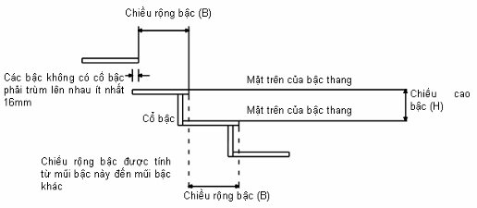
Fig. 3.1. Measurement of height and width of step
3.4.1.2. Structure of step
a) The tread must be horizontal and flat. Step can be open but the tread must cover each other at least 16mm
b) For the staircase with open steps, if there are children under 5 years old, the opening must not be higher than 100mm
3.4.1.3. Clear height
The clear height for staircases and aisle is at least 2 m. The way to determine the clear height is shown in figure 3.2
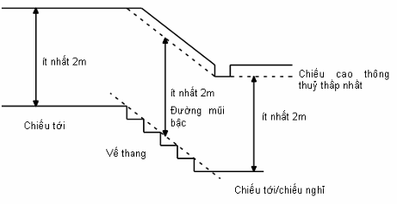
Figure 3.2. Measurement of clear height of staircase
3.4.1.4. Stair and landing
a) The width of each stair and landing must be at least equal to the minimum width of flight of stair.
b) Stair and landing must be horizontal and flat.
3.4.1.5. Special types of staircase
a) Staircase with bevelved tread
The width of the beveled tread is measured as follows”
- If the width of the flight of stair is less than 1m, measure in the middle of step
- If the width of the flight of stair is from 1m or more, measure at 270 mm to either side.
Staircase is considered to guarantee the set requirements if the height and width of the step meet the requirements 3.4.1.1.0
The minimum width of the beveled tread is 50mm (See figure 3.3)
If the staircase includes the straight and beveled tread, the width of the beveled treads must not be less than the width of the straight treads. The straight treads must also meet requirements 3.4.1.1.
b) Spiral staircase
For staircase in the narrow area not used for more than a room with the user, then the staircase is permitted to have the width of step smaller than that as required by this Regulation.
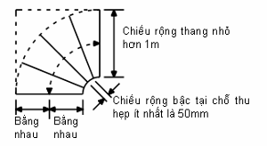
Measure the width of stairs at the center of the step; measure along the curved line of the stairs even it has rectangular shape.

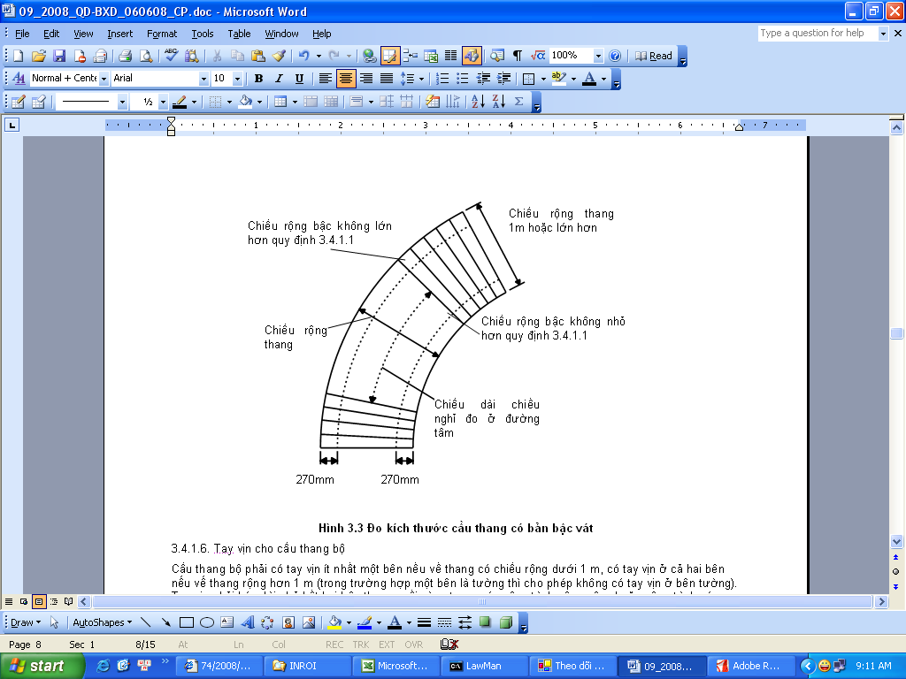
Figure 3.3. Measure size of stairs with beveled tread
3.4.1.6. Handrail for staircase
The staircase must have handrail at least on one side if the flight of stair has a width under 1 m, with handrail oon both sides if the flight of stair has a width over 1 m (in case one side has wall, no handrail required on that side). The handrail must extend to the end of the last two steps in public buildings or works with disabled people to use.
3.4.1.7. Staircase banister
a) Flight of stair, stair and landing must have protection banister at the opening sides
b) For works with children under 5 years old frequenting, the banister should ensure the following requirements:
+ The opening of banister cannot be put through with 100mm diameter sphere;
+ There’s no structure to make it easy for children to climb over the banister
c) The minimum height of banister is regulated in Table 3.2
Table 3.2. Minimum height of banister
Works | Location | Minimum height (mm)
Dwelling, agency, workplace and public buiding | Loggia and terrace at positions high from 9 storeys or more | 1400
Dwelling, agency, workplace and public buiding | Flight of stair and ramp | 900
Dwelling, agency, workplace and public buiding | Other positions | 1100
Place where people concentrate | 530mm before fixed seat | 800
Place where people concentrate | Flight of stair and ramp | 900
Place where people concentrate | Other positions | 1100
3.4.2. Ramp
3.4.2.1. The maximum degree of ramp must not exceed 1:12 for public building and 1:10 for condominium.
3.4.2.2. All ramp, stair and landing must have clear height of 2 m minimumly.
3.4.2.3. There must not be fixed obstruction, the surface of ramp must be designed against slip.
3.4.2.4. Ramp with the width less than 1 m must have handrail at least on one side. If larger, there must be handrailing on both sides. The ramp connecting two heights under 600mm apart is not required to have handrail.
The height of handrailing must be from 900mm to 1000mm. Handrailing must be a firm bearing and allows strong grip.
Handrailing of the ramp for disabled people needs to comply with the works building Regulation to ensure access for disabled people to use.
3.4.2.5. Ramp, stair and landing must have banister at the opening edges as for the staircase.
3.4.3. Banister and barrier
3.4.3.1. Banister for walker
a) There must be banister at the clearance edge of floor, balcony, loggia, roof (including skylight and other opening) and other places with walkers. There must be banister in garage, places with walkers but not required on the ramps used only for vehicles traveling and loading and unloading area.
b) The minimum height for the barnister given in Table 3.2. The barnister must be able to withstand the effects of lateral forces specified in the relevant Regulation. The barnister must not have large upper part to avoid sitting or lying down. If using glass in the balustrades, Chapter 4 of this Regulation must be complied with.
c) For works with children under 5 years old to use, the barnister structure must not be easy for children to climb over and there must be no opening for 100 mm diameter sphere put through.
3.4.3.2. Barrier for motor vehicles
a) Barriers should be arranged at the sides of the aisle, at the floor, deck roof with motor vehicles to travel.
b) Barrier must have the minimum height of 375 mm for the floor edge or roof, 600mm for the edge of ramp. Barrier must be able to withstand the effects of lateral forces specified in the relevant Regulation.
3.4.3.3. Loading and unloading areas
Loading and unloading area must have at least one exit in the lower pitch. The wide loading area for two cars or more should allocate at least two exits, each exit on one side.
3.4.4. Anti-thrust into ventilation intake door or light intake door.
3.4.4.1. The protruding parts
If the ventilation intake door or light intake door have any parts protruding into traveling space exceeding 100 mm in and around the building, including directions to the house or outside, must meet the following requirements :
- Fixed part protruding not lower than 2 m from the floor or ground surface;
- The door opened outside must have barrier or railing at least 900 mm high to prevent people walking into; if not there must be very clear and different signs compared to other areas on the floor or ground to note to users keeping away from that area.
3.4.4.2. The space used only for purposes of maintenance of works
For areas not used frequently but only used for maintenance purposes, it is necessary to arrange clear and visible signs to note the protruding parts.
3.4.5. Anti-shock into door and anti-clamping
3.4.5.1. Doors and gates at the main entrance, types of door or gate possibly opened from both sides must have panes looked through unless they are low enough to be looked over the top (about 900 mm so that a person sitting on wheelchair can look through).
3.4.5.2. The sliding door and gate must have a block or appropriate parts to prevent slipping off the rails, and must not fall down when the suspension system breaks down or the roller deviates from the rail.
3.4.5.3. Doors and gates opened upwards must not fall down themselves causing injury to the users.
3.4.5.4. Doors and gates opened and closed an engine need:
a) Safety parts to avoid casualties for people clamped or locked;
b) Stop switch is installed in plain view and easy to turn it on
c) can be opened automatically or manually in case of power failure.
3.4.6. Signs
3.4.6.1. There should be signs indicating the information at the necessary positions such as entrances, exits, place at risk of fire or explosion, electric shock, place banned from fire, the toilets, place of phone, communication equipment and fire protection equipment.
3.4.6.2. Signs must be legible and put at visible places. In dangerous areas, signs should be in the appropriate location so people can recognize them before they go into that area.
3.4.6.3. The content of signs should be understandable, specific and consistent with international conventions.
3.4.6.4. The escape road and emergency evacuation signs must be lighted with the illumination on the surface of the signs not less than 1 lux.
Chapter 4:
SAFE USE OF GLASS
4.1. General requirements
4.1.1. Safety for shock impact
Glass in places frequented by people in or around a building must meet one of the following minimum requirements:
a) Are protected from shock;
b) Can withstand the shock impact without being broken;
c) Not causing danger to the users If broken due to shock
4.1.2. Signs of glass identification
The transparent glass located in areas where people frequent must be mounted signs to identify the presence of glass.
4.1.3. Safe door closure and opening.
Window, louver and air door must be closed, opened or adjusted the opening safely.
4.1.4. Window, skylight, walls, ceiling or glass roof must ensure the safety upon access for cleaning.
4.2. Specific requirements
4.2.1. Safe for shock impact
4.2.1.1. Safe upon break due to shock
Upon shock experiment, the result must meet one of the following requirements:
a) Only causing a small hole;
b) Glass not breaking apart but losing continuity with the small pieces still sticking together.
c) Glass breaking into pieces without sharp edges.
4.2.1.2. Glass is protected by a fixture
When using fixtures (banister, wall, ...) to protect the glass in the danger zone, these objectsl must:
a) Have no opening for a 75mm diameter sphere put through;
b) Be firm;
c) Be difficult to climb over to prevent anti-falling
4.2.1.3. Safe door closure and opening
a) The control part of door closure and opening must be placed at a position not higher than 1.9 m above the floor or the place to stand to close and open the door.
b) The control part must be placed lower than 1,7m when there is obstacle 600mm wide and lower than 900mm (see Figure 4.1);
c) When failing to meet the requirements a) and b) above, there must be tool for remote opening and closing, such as electronic control system or manual control.
d) For the room built to ensure the access and use for disabled people must comply with the provisions of the works building Regulation to ensure the access and use for disabled people.
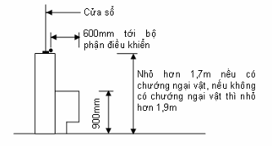
Fig.4.1 – Distance to position of door opening and closure
4.3. Safe access for window cleaning
Where the glass cannot be cleaned safely by standing directly on the ground, floor or other fixed surfaces, there should be one of the following measures:
a) Arranging the windows with the size and shape to ensure the surface is cleaned safely from the inside of the building. A structure should be installed to keep the windows fixed at a predetermined position for the windows like those.
b) Arranging a flat, fixed and firm area at the position permitting the use of portable ladder with the length not exceeding 9 meters from the foot of the ladder to the ladder fulcrum. With a ladder whose length is less than 6 meter, it can put on the floor or ground; with ladder longer than 6 meter, there must be a place to fix the ladder into the works;
c) Arranging the travel approach way with the minimum width of 400 mm, banister with a minimum height of 1000 mm or there are part to fix the tool for slipping prevention.
d) Arranging appropriate fixing points to safely hang rope.
e) If no application of one of the above measures, there should be a place for placing scaffold in the form of pyramid or suspension scaffold with the safety equipment provided.
Chapter 5:
LIGHTING
5.1. General requirements
Inside and outside the house must be lighted consistent with intended use.
5.2. Explanation of terms
5.2.1. Natural Lighting: Lighting of the room (directly or indirectly) by sky light through light intake door placed at covering structures.
5.2.2. Artificial lighting: Lighting by artificial light.
5.2.3. Lighting of work: Lighting ensure that all normal activities of people at the works
5.2.4. Emergency lighting: lighting to ensure easy exit in case of incidents.
5.2.5. Protection lighting: Lighting limited in the area (or works) should be protected during the night.
5.3. Specific requirements
5.3.1. Natural Lighting
5.3.1.1. The rooms in the house, especially the habitable rooms, the toilets should be prioritized for natural lighting through the window opening directly to outer space.
5.3.1.2. For workplace, natural lighting shall ensure more than half the day time with the value of the minimum natural illumination consistent with visual activity, specified in Table 5.1.
Table 5.1 Coefficient of minimum natural illumination
Category of visual activity |  | Lateral lighting |  | Upper lighting
Degree of accuracy | Discrimination object size (mm) | Indoor natural illumination (lux) | Coefficient of minimum natural illumination (%) | Indoor natural illumination (lux) | Coefficient of average natural illumination (%)
Particularly accurate | d ≤ 0,15 | 250 | 5 | 350 | 7
Very accurate | 0,15< d ≤ 0,3 | 150 | 3 | 250 | 5
Accurate | 0,3< d ≤ 1,0 | 100 | 2 | 150 | 3
Average | 1,0< d ≤ 5,0 | 50 | 1 | 100 | 2
Rough | d> 5,0 | 25 | 0,5 | 50 | 1
5.3.2. Artificial lighting
5.3.2.1. Lighting of work
Indoors, artificial lighting must be sufficient for the absence or no natural lighting while ensuring normal operation of all users.
5.3.2.2. Emergency lighting
There must be emergency lighting in the following cases:
i) Urgent Lighting: Set along the escape path in areas where at risk of fire, explosion, poisoning.
ii) Continuous lighting: Implemented in places if lighting is stopped, it will affect safety, social security, economic loss or harm to human life (such as operating room, emergency room).
iii) Protection lighting: Lighting outside the home, along the house boundary or the works area needs protecting the security and property.
5.3.2.3. Exterior lighting of the building must not adversely affect traffic and urban beauty.
5.3.2.4. Illumination requirements of artificial lighting indoors and outdoors are specified in Table 5.2 and Table 5.3.
Table 5.2 Artificial lighting indoors - the minimum illuminance on the working surface or objects need distinguishing
Type of room | Minimum illumination (lux) in the case of observance
Type of room | Regular |  | In cycles |  | Transitory
Type of room | Fluorescent light | Incadescent light | Fluorescent light | Incadescent light | Fluorescent light | Incadescent light
Working offices, offices, classrooms, design and experiment rooms | 400 | 200 | 300 | 150 | 150 | 75
Dining rooms; sales stalls; pavilions | 300 | 150 | 200 | 100 | 100 | 50
Conderence room, theatres, cinemas | 150 | 75 | 100 | 50 | 75 | 30
Table 5.3 Emergency lighting and artificial lighting outdoors
Type of lighting | Minimum illumination (lux) |  | Note
Type of lighting | Indoors | Outdoors | Note
1. Emergency lighting:  - On working surface  - Operating room  - On escape way | 2  150  1 | 1  -  2  (on the floor of aisle and stair) | Incadescent  Light must be used
2. Protection lighting |  | 1  (on the ground)
3. Outdoors:  - Entrance gate  - Walking way and yard  - Playground, exercise yard |  | 3  2  4
Chapter 6:
VENTILATION
6.1. General requirements
6.1.1. The ventilation system of dwelling and public building must ensure that:
a) Exhausting water vapor from places generating sources of water vapor ( kitchen, bathroom) before it spread to other areas
b) Exhausting contaminants from places generating sources of many pollutants (such as room with activities generating pollutants) before it spread to other areas;
c) Maintaining supply of fresh air at a minimum, and diluting concentrations of contaminants and water vapor generated;
d) Convenience in operation, waste generated by excess heat in the work and not affecting human health.
6.1.2. The ventilation system must comply with the related provisions in the regulations on fire prevention and protection for dwelling and works.
6.1.3. System of ventilation and air conditioning is not circulated in the case of air containing toxic and dangerous substances, flammable or explosive substances, pathogenic microorganisms, unpleasant odor causing susbstances.
6.1.4. Natural ventilation must be used maximumly for rooms indoors the dwelling and public building.
6.2. Limit of application
The requirements stated in this chapter are not required to apply for work items or work space:
a) Not being frequented;
b) Warehouse or place for storage only;
6.3. Explanation of terms
6.3.1. Local exhausting ventilation: is a ventilation exhausting air from the places generating pollutants such as kitchens, bathrooms and photocopying rooms to limit the spread of these substances into other rooms inside the wdelling and building. The exhaustion can be permanent or intermittent.
6.3.2. General Ventilation: Ventilation is provided by fresh air from outside as dilution, dispersion of pollutants or water vapor.
6.3.3. Emergency ventilation: the increased ventilation is expected during use, in case the incident giving rise to unusually large amounts of toxic or flammable or explosive substances.
6.3.4. Natural ventilation means ventilation only use natural energy.
6.3.5 Specific requirements
6.4.1. For dwelling
6.4.1.1. Must be arranged with the local exhausting ventilation for kitchens, bathrooms, toilets, rooms with equipment such as washing and ironing machines. The minimum local exhausting ventilation flow equal to liters / second (l / s) specified in Table 6.1.
Table 6.1.Minimum local exhausting ventilation flow for dwelling
Room | Irregular local exhausting ventilation flow | Regular local exhausting ventilation flow
 | (l/s) | (l/s)
Kitchen | 30 (directly on the stove) | 13
Bathroom | 15 | 8
Toilet | 6 | 6
6.4.1.2. General ventilation flow of fresh air supplied from outside into the house specified not less than the values in Table 6.2, and not less than 0.3 (l / s) / square meter of floor.
Table 6.2 – Minimum general ventilation flow for dwelling
 | Number of bedrooms
 | 1 | 2 | 3 | 4 | 5
General ventilation flow (l/s) | 13 | 17 | 21 | 25 | 29
6.4.2. For offices
6.4.2.1. Must arrange local exhausting ventilation for toilets, laundry room, cooking area, the rooms with printing and photocopying machine. The minimum local exhausting ventilation flow specified in Table 6.3.
6.4.2.2. General ventilation flow of fresh air supply from outside into office not less than 5.5 (l / s) / person.
Table 6.3 – Minimum general ventilation flow for office
Room | Minimum general ventilation flow
Rooms with printer, photocopying machine with large frequency of use (more than 30 minutes per hour) | 20 (l / s) / machine upon use (if the machine is used continuously, apply the general ventilation).
Toilet and bathroom of offices | Intermittent exhaution with flow of 15 (l / s) / shower or bath tube flavor; 6 (l / s) / toilet seat
Kitchen | 15 l/s for microwave  30 l/s for smoke exhauster on the stove.
6.4.3. For garage:
a) Garage using only natural ventilation: must open at least 25% of the wall of two opposite sides, or 1/20 floor area for each parking space;
b) Garage is mechanical ventilated combined natural ventilation: must open to natural ventilation with an area at least equal to 1/40 floor area, combined with mechanical ventilation with air exchange multiples of at least 3 times / hour.
c) Garage only uses mechanical ventilation (underground garage): the air exchange multiple at least 6 times / hour. For the entrance and exit, where the car in line while the engine working, the air exchange multiple at least 10 times / hour.
Chapter 7:
ANTI-NOISE
7.1. General requirements
Dwelling and public building must be able to anti-noise spread among parts in the building and from parts of adjacent building.
7.2. Specific requirements
Walls, partitions, floors, doors of the room should meet the noise insulation like Table 7.1.
Table 7.1. The minimum noise insulation index for sound walls, partitions, doors and floors
No | Name and location of structures obscured | Air noise insulation index, dB | Shock noise insulation index, Db
1 | Floor between rooms in condominium-style apartment. | 45 | 73
2 | Floor between rooms with the basement, mezzamine, attic room | 40 | -
3 | Floor between the dwelling room with the stores below | 50 | 73
4 | Floor between dwelling rooms with room below for sports activities, coffee shop, or public service activities similarly | 55 | 73
5 | Walls and partitions between the apartments, the dwelling rooms in the apartment with stairs, buffer rooms and lobby | 45 | -
6 | Walls between dwelling rooms of the apartment and stores | 50 | -
7 | Partition without door between the dwelling rooms, between the kitchen with dwelling room in the apartment; walls between dwelling rooms with toilet area of an apartment | 40 | -
8 | Door facing the stairs, lobby and corridors | 20 | -

INDEX
Chapter 1: GENERAL REGULATIONS
Chapter 2: PREVENTION OF WATER, MOISTURE VAPOR AND HAZARDOUS SUBSTANCE
Chapter 3: PROTECTION FROM FALLING, THRUST AND SHOCK
Chapter 4: SAFE USE OF GLASS
Chapter 5: LIGHTING
Chapter 6: VENTILATION
Chapter 7: ANTI-NOISE

