MINISTRY OF INDUSTRY AND TRADE  -------- | SOCIALIST REPUBLIC OF VIETNAM  Independence - Freedom - Happiness  ---------------
No. 33/2011/TT-BCT | Hanoi, September 06, 2011

CIRCULAR
ON CONTENTS, METHODS, AND PROCEDURE FOR ELECTRICAL LOAD RESEARCH
Pursuant to the Government's Decree No. 189/2007/ND-CP on December 27, 2007 on defining the functions, tasks, powers and organizational structure of the Ministry of Industry and Trade;
Pursuant to the Government's Decree No. 44/2011/ND-CP dated June 14, 2011 on amendments to Article 3 of the Government's Decree No. 189/2007/ND-CP on December 27, 2007 on defining the functions, tasks, powers and organizational structure of the Ministry of Industry and Trade;
Pursuant to the Law on Electricity dated December 03, 2004;
Pursuant to the Government's Decree No. 105/2005/ND-CP dated August 17, 2005 detailing and guiding the implementation of the Law on Electricity;
The Minister of Industry and Trade promulgates a Circular on contents, methods, and procedure for electrical load research:
Chapter I
GENERAL PROVISIONS
Article 1. Scope of regulation
This Circular deals with the methodology for researching electrical load of the national and local electricity systems serving the forecasting of electricity demands and structuring electricity prices.
Article 2. Subjects of application
This Circular is applicable to:
1. Vietnam Electricity;
2. General companies of electricity (hereinafter referred to as general companies).
3. The System and market operator.
Article 3. Interpretation of terms
In this Circular, the terms below are construed as follows:
1. Load profile consists of actual load profiles of months or years; typical daily load profiles (working days, weekends, and holidays) of months and years.
2. Load research database of general companies is the database that contains information about electricity consumption of sample loads, result and forecasting of load profiles of general companies.
3. National load research database is the database that contains information about electricity consumption of sample loads, result and forecasting of load profiles of the national electricity system.
4. Load range is a set of load in the same range of power or electric energy in each group of load.
5. Sample load is the electrical load that represents a group of load, which is calculated based on probability theory with reliability and margin or error within limits.
6. A typical day is the day that has the typical consumption of loads. Typical days include typical working days, weekend, holidays of months and years.
7. Group of load is a set of electrical loads that have similar energy consumption characteristics, which belong to one of the sectors specified in Appendix 1 to this Circular.
8. Non-residential load is electrical load that belongs to the sectors of industry - construction, trading-hotel-restaurant, agriculture-forestry-fishery, and other activities.
9. Residential load is electrical load of households.
10. Heavy loads are the loads of which consumption rates are regulated by Electricity Regulatory Authority.
11. Load subgroup is a set of electrical loads that have similar electricity consumption characteristics, belong to load components specified in Appendix 1 to this Circular.
12. Sectors are the loads separated into groups of electrical loads, including: industry-construction, trading-hotel-restaurant, agriculture-forestry-fishery, and other activities.
Chapter II
CONTENTS AND METHODS OF LOAD RESEARCH
Article 4. Load research contents
Load research includes:
1. Designing, selecting sample loads.
2. Collecting, adjusting information about electricity consumption of sample loads.
3. Constructing load profiles of load groups and sectors
4. Forecasting load profiles.
Article 5. Load research methodology
Combining the bottom-up approach and top-down approach as follows:
1. Collect the electricity consumption of the sample load to make load profiles of the load groups and sectors (bottom-up approach).
2. Collect past load profiles of the electricity system to adjust the load profiles of the load groups and sectors using the bottom-up approach; the factors of socio-economic development to forecast the load profile (top-down approach).
Chapter III
PROCEDURE FOR DESIGNING AND SELECTING SAMPLE LOADS
Section 1. DESIGNING, SELECTING THE NON-RESIDENTIAL SAMPLE LOADS
Section 6. PROCEDURE FOR DESIGNING, SELECTING THE NON-RESIDENTIAL SAMPLE LOADS
1. Analyze and classify non-residential loads
2. Find target variables serving the calculation and selection of the sample load.
3. Analyze and stratify consumption ranges.
4. Calculate the quantity of sample loads.
5. Select and distribute non-residential sample loads among general companies.
Article 7. Analyzing and classifying non-residential loads
1. The factors that need considering when analyzing and classifying non-residential loads:
a) The characteristics of load groups and sectors;
b) The connecting voltages of loads;
c) Geographical and seasonal factors;
d) Other necessary information about the load types.
2. The non-residential load types shall be analyzed and classified in the following order:
a) Classify loads by load groups and sectors;
b) Classify loads in the load type by connecting voltage, geographic area, season (irrigation) and other characteristics (if any).
3. Make a list of loads sorted by non-residential load group and sectors based on the classification in Clause 2 of this Article.
Article 8. Determining target variables serving the calculation and selection of the sample load
1. Target variables are important parameters for demonstrating the electricity consumption of each group of non-residential load, and used for calculating standard deviation and minimum quantity non-residential loads in load research.
2. Target variables are selected from one of the quantities below:
a) The load power when the power of the electricity system reaches the maximum value in the year;
b) The load power during peak hours by day or night of the day when the power of the electricity system reaches the highest level in the year;
c) Time of use (TOU);
d) Time of use in the whole year of non-residential loads.
Article 9. Analyzing and stratifying consumption ranges according to target variables
The analysis and stratification of consumption ranges for each group of non-residential loads shall be carried out as follows:
1. Determine the quantity and assess the proportion of power or electricity consumption of heavy loads.
2. Follow Dalenius-Hodges to make load profiles by power or consumption, determine the optimal boundary to stratify power or consumption ranges. The details of Dalenius-Hodges approach are provided in Appendix 2 to this Circular.
The result of analyzing, stratifying power or consumption ranges for each group of non-residential loads includes:
a) The quantity of ranges and loads in each range;
b) The average power or consumption of each consumption range;
c) The standard deviation of each range.
Article 10. Calculating the quantity of non-residential sample loads
Quantity of non-residential sample loads of each load range is calculated as follows:
1. Select the heavy loads as sample loads for load research.
2. Remove the load ranges of which the total power or consumption of loads is below 1% of the total power or consumption of the group of loads.
3. Select one of the methods for calculating the quantity of sample loads for the remaining load ranges. The calculating methods include:
a) Normal distribution function;
b) Mean Per Unit (MPU);
c) Separate Ratio (SR);
d) Combined Ratio (CR).
The details of methods for calculating the quantity of load quantity of load range are provided in Appendix 2 to this Circular.
4. Find value of reliability and margin of error serving the calculation of model quantity based on the budget for load research.
5. Calculate the number of sample loads of each load range.
6. Enumerate sample loads of each load range, load group, and sector.
Article 11. Distributing and selecting non-residential sample loads
1. Based on the quantity of models of each load group, Vietnam Electricity shall distribute models (if changes are made) to every general company in direct proportion to the commercial energy of the their load groups by May 15 every year.
2. General companies shall make lists of loads selected as models according to the number of models distributed, specifying their names, addresses, voltages, load ranges, load groups, and sectors.
3. General companies shall make lists of back-up non-residential sample loads.
4. General companies shall send Vietnam Electricity the lists of loads selected as models according to the number of models distributed and the lists of back-up sample loads by December 12 every year.
Article 12. Reports on assessment of non-residential sample loads
By December 20 every year, Vietnam Electricity shall complete and send the report on assessment of non-residential sample loads nationwide of the next year to Electricity Regulatory Authority, which consists of:
1. The calculation, design, and distribution of non-residential sample loads.
2. Comparison of the change (if any) in the number of non-residential sample loads in comparison with that in the previous year.
3. Comparison of the lists of non-residential loads made by general companies with the calculation, design, and the number of non-residential sample loads distributed to general companies.
Article 13. Responsibilities of units for the design and selection of non-residential sample loads
1. Vietnam Electricity shall:
a) Calculate, decide the number of non-residential loads nationwide;
b) Distribute non-residential sample loads among general companies;
c) Determine the technical characteristics of the system for collecting data serving load research, management and supervision of investment and installation of equipment serving the research of non-residential sample loads nationwide.
2. General companies shall:
a) Make lists of non-residential sample loads based on the number of models calculated and distributed by Vietnam Electricity;
b) Make investments and install equipment for collecting data serving the load research of local non-residential sample loads.
Section 2. DESIGNING RESIDENTIAL SAMPLE LOADS
Article 14. Calculating and selecting residential sample loads
1. The factors that need considering when analyzing and classifying residential load groups:
a) The geographical factors;
b) Urban or rural area;
c) The weather (seasons);
d) The level of electrification and electricity consumption of households or other characteristics of each residential load group.
2. Analyze and classify residential loads into general companies in the following order:
a) Classify load groups by rural areas and urban areas to differentiate set apart the level of electrification and power consumption of households;
b) Classify residential load groups by their characteristics, including private houses, apartments, villas, or houses for rent;
c) Select the quantity of models for each residential load group;
d) Make a list of residential loads selected as models, specifying their names, addresses, load groups, and sectors;
dd) Make a list of back-up residential sample loads.
3. General companies shall send Vietnam Electricity the lists of residential sample loads and the lists of back-up residential sample loads by December 12 every year.
4. Vietnam Electricity shall aggregate the residential sample loads and sort them by the North, the Middle and the South to differentiate geographical factors and weather in the year.
Article 15. Reports on assessment of residential sample loads
By December 20 every year, Vietnam Electricity shall complete and send the report on assessment of residential sample loads nationwide of the next year to Electricity Regulatory Authority, which consists of:
1. The calculation, design, and distribution of residential sample loads.
2. Assessment of the change (if any) in the number of residential sample loads in comparison to the previous year.
3. Comparison of the lists of residential loads made by general companies with the calculation, design, and the number of residential sample loads distributed to general companies.
Article 16. Responsibilities of units for the design and selection of residential sample loads
1. General companies shall:
a) Calculate, design, and make lists of residential sample loads under their management;
b) Make investments and install equipment for collecting data serving the load research of residential sample loads under their management.
2. Vietnam Electricity shall:
a) Aggregate the residential sample loads nationwide based on the budget and proportion of power consumption of each unit to the total consumption nationwide;
b) Determine the technical characteristics of the system for load research, management and supervision of investment and installation of equipment serving the research of residential sample loads nationwide.
Chapter IV
PROCEDURE FOR COLLECTING AND ADJUSTING DATA, MAKING AND FORECASTING LOAD PROFILES
Section 1. Collecting, adjusting data
Article 17. Collecting meter data of sample loads
1. The meter data of sample loads is the data of power and consumption of sample loads in a cycle (30 or 60 minutes).
2. General companies shall install electricity meters that automatically transmit data to the general companies at 0h every day.
Article 18. Detecting errors of sample load meters
The following tasks shall be performed to detect the errors of sample load meters:
1. Check the period from the beginning of data reading until the end.
2. Check the zero (0) energy value.
3. Check the status (to find suspicious signs that need checking).
4. Check and compare the total value of electricity of the load in a cycle to the total commercial energy measured monthly.
5. Compare the measured figures to the consumption threshold of the sample loads.
6. Check and compare the value of commercial energy to that of the previous month or the same month of the previous year.
7. Check and compare the value of peak load to that of the previous month or the same month of the previous year.
8. Check the load coefficient.
Article 19. Calibrating and estimating meter data of sample loads
1. Calibrating and estimating data meter of sample loads means adjusting the data that are lost, insufficient or inaccurate when detecting errors during data collection.
2. The methods for calibrating and estimating meter data include:
a) Linear interpolation from the consumption tendency curve;
b) Similar days: using the similar day’s data of the current or previous week;
c) Automatic estimation: used if no more than 07 days’ data are missing;
d) Visual observation of graphs: to find error data company make decisions on estimated data;
dd) Manual data adjustment and estimation: used if more than 07 days’ data are missing;
e) Adjusting and estimating average value in the week of the reference day based on the data of the 04 latest weeks.
3. Calibrated and adjusted meter data of sample loads shall be stored to establish a database for load research.
Article 20. Transmission of sample load data to the load research database
By the 20th of the next month, general companies shall finish collecting, calibrating and estimating meter number of sample loads, and then send calibrated data to Vietnam Electricity for update on the national load research database.
Article 21. Quarterly reports on assessment of sample load data
By the 20th of the first month of the next quarter, general companies shall complete and submit reports on the assessment of collection and calibration of meter data of sample loads to Vietnam Electricity.
Article 22. Responsibilities of units for data collection and calibration
1. General companies shall:
a) Install meters, collect and calibrate consumption values from the meter of the sample loads, and manage the database of sample loads under their management;
b) Transmit the calibrated database of sample loads to Vietnam Electricity for developing the national load research database.
2. Vietnam Electricity shall manage the national load research database so that the system and market operator and general companies may access and use it.
Section 2. ANALYSIS AND CONSTRUCTION OF LOAD PROFILES
Article 23. Annual standardized average load profile
1. The annual standardized average load profile of each load group and sector is made by calculating and aggregating annual standardized load profile of every sample load.
2. The annual standardized average load profile of each load group and sector is made as follows:
a) Step 1: construct the annual standardized profile of each sample load by dividing the load profile in the year by the commercial energy of the sample load in the month;
b) Step 2: construct the annual standardized average load profile of each load group by finding the arithmetic mean of the annual standardized profiles of sample loads of that group;
c) Step 3: construct the annual standardized average load profile of each sector by finding the arithmetic mean of the annual standardized profiles of load groups of that sector;
d) Step 4: construct the annual standardized average load profile of the general company, local or national electricity system by finding the arithmetic mean of the annual standardized profiles of sectors;
dd) Step 5: update the annual standardized average load profile of every group and sector on the load research database.
Article 24. Monthly standardized average load profile
1. The monthly standardized average load profile is made by calculating and aggregating monthly standardized load profile of every sample load.
2. The monthly standardized average load profiles of load groups and sectors are made as follows:
a) Step 1: construct the monthly standardized profile of each sample load by dividing the load profile in the month by the commercial energy of the sample load in the month;
b) Step 2: construct the monthly standardized average load profile of each load group by finding the arithmetic mean of the monthly standardized profiles of sample loads of that group;
c) Step 3: construct the monthly standardized average load profile of each sector by finding the arithmetic mean of the monthly standardized profiles of load groups of that sector;
d) Step 4: construct the monthly standardized average load profile of the general company, local or national electricity system by finding the arithmetic mean of the monthly standardized profiles of sectors;
dd) Step 5: update the monthly standardized average load profile of every group and sector on the load research database.
Article 25. Actual load profiles
1. The annual or monthly actual load profile of each load group is constructed by multiplying the annual or monthly standardized average load profile by the value of corresponding commercial energy of such load group.
2. The annual or monthly actual load profile of a sector is constructed by aggregating corresponding actual load profiles of the load groups of that sector.
3. The annual or monthly actual load profile of a general company, a local electricity system, or the national the electricity system is constructed by aggregating corresponding actual load profiles of the sectors.
4. The annual or monthly actual load profile of every load group sector, general company, local electricity system and the national the electricity system shall be stored in the load research database;
Article 26. Load profiles of typical days
1. The annual or monthly actual load profile of the typical working day of a load group, a sector, a general company, a local the electricity system or the national the electricity system is arithmetic mean of corresponding actual load profiles of working days the load group, sector, general company, local electricity system or national electricity system.
2. The annual or monthly actual load profile of the typical weekend or holiday of a load group, a sector, a general company, a local the electricity system or the national the electricity system is arithmetic mean of corresponding actual load profiles of weekends or holidays of the load group, sector, general company, local electricity system or national electricity system.
Article 27. Reports on analysis and construction of load profiles
Based on the load profile construction result, the report on load profile analysis shall contain:
1. The results of calculation and construction of the standardized average load profile; the actual load profile; the annual and monthly load profiles of typical days of load groups, sectors, general companies, local electricity systems or the national electricity system mentioned in Article 23, Article 24, Article 25, and Article 26 of this Circular.
2. Analysis and assessment of the growth of commercial energy of the unit and the whole the national electricity system by load group and sector in comparison to the previous year.
3. Assessment of the tendency to change of load profiles of the load groups and sectors that account for the majority of consumption or have significant growth.
4. Assessment of the effect of load groups and sectors on the peak power of general companies, local or national electricity systems, including: peak frequency, changes of peak power, contribution to peak power. Comparison to the actual load profile of the local or national electricity system.
5. Chronological change of load profiles of load groups and sectors.
6. Comparison of the tendency to change of load profiles of load groups and sectors with developments of temperatures, industrial production indicators, and the factors related to other businesses.
Article 28. Reports on analysis and construction of quarterly load profiles
1. By the 20th of the second month of the next quarter, general companies shall complete and submit reports on analysis and construction of monthly load profiles in the month and the quarterly load profile to Vietnam Electricity, the system and market operator, and Electricity Regulatory Authority.
2. By the 25th of the second month of the next quarter, Vietnam Electricity shall complete and send a report on the analysis and construction of quarterly load profiles of the national and local electricity systems to Electricity Regulatory Authority.
Article 29. Reports on analysis and construction of annual load profiles
1. By the January 20 of the next year, general companies shall complete and submit reports on analysis and construction of its annual load profile to Vietnam Electricity, the system and market operator, and Electricity Regulatory Authority.
2. By the 25th of the second month of the next quarter, Vietnam Electricity shall complete and send a report on the analysis and construction of annual load profiles of the national and local electricity systems to Electricity Regulatory Authority.
Article 30. Responsibility of units for analysis and construction of load profiles
1. General companies shall calculate, construct annual and quarterly load profiles and make reports on the result of analysis and construction of such load profiles.
2. Vietnam Electricity shall calculate, construct load profiles of the national and local electricity systems and make reports on the result of analysis and construction of such load profiles.
3. The System and market operator shall calculate, construct load profiles in accordance with the Circular No. 12/2010/TT-BCT dated April 15, 2010 of the Ministry of Industry and Trade on electricity transmission system.
Section 3. LOAD PROFILE FORECASTING
Article 31. Load profile of typical days
The bottom-up approach and top-down approach shall be combined to forecast load profiles, in particular:
1. Top-down approach:
a) Use data sequence of past load profiles to forecast load profile tendency;
b) Forecast load profiles based on load profile tendency forecasting and the effect of the weather, economic growth, population and elasticity coefficient on electricity prices.
2. Bottom-up approach:
a) Use the annual and monthly standardized average load profiles to forecast load profiles of each load group and sector;
b) Forecast monthly and annual commercial energy of each load group and sector, with due regard taken of: the emergence of new loads, growth of loads, socio-economic development, industry, growth of modernization of electric appliances, demand side management solutions adopted (DSM);
c) Forecast load profiles of each load group and sector based on the monthly and annual load profile tendency forecasting and commercial energy forecasting.
3. Compare the load profile forecasting results produced by both methods to analyze and determine the load profile forecasting result.
Article 32. Reports on load profile forecasting
Based on the load profile forecasting result, the report on load profile forecasting shall contain:
1. The results of calculation and forecasting of the standardized average load profile; the actual load profile; the annual and monthly load profiles of typical days of load groups, sectors, general companies, local electricity systems or the national electricity system mentioned in Article 23, Article 24, Article 25, and Article 26 of this Circular.
2. Analysis and assessment of the growth of commercial energy of the unit and the whole the national electricity system by load group and sector in comparison to the previous year.
3. Assessment of the tendency to change of load profiles of the load groups and sectors that account for the majority of consumption or have significant growth.
4. Assessment of the effect of load groups and sectors on the peak power of general companies, local or national electricity systems, including: peak frequency, changes of peak power, contribution to peak power.
5. Chronological change of load profiles of load groups and sectors.
6. Comparison of the tendency to change of load profiles of load groups and sectors with developments of temperatures, industrial production indicators, and the factors related to other businesses.
Article 33. Reporting load profile forecasting
1. General companies, the system and market operator shall complete the reports on annual, monthly, and weekly load profile forecasting in accordance with Article 16, Article 17, and Article 18 of the Circular No. 12/2010/TT-BCT.
2. By September 15 every year, Vietnam Electricity shall complete and send a report annual load profile forecasting in accordance with the annual operation plan.
Article 34. Responsibility of units for reporting load profiles
1. General companies shall calculate and forecast annual and monthly load profile to serve load forecasting, electricity system operation planning, electricity distribution and pricing.
2. Vietnam Electricity shall calculate and forecast annual load profiles of the national and local electricity systems to serve electricity pricing and demand side management.
3. The System and market operator shall calculate and forecast annual and monthly load profiles of the national and local electricity systems to serve load forecasting and national electricity system operation planning.
Chapter V
EXEMPTION
Article 35. Cases of exemption
The units regulated by this Circular may apply for exemption in the following cases:
1. The unit provides explanation for the difficulties related to technical infrastructure and capacity.
2. The unit proves the entitlement to exemption in accordance with this Circular.
Article 36. The power and basis to decide exemption
1. Electricity Regulatory Authority shall consider and approve the cases eligible for exemption according to Article 35 of this Circular.
2. The basis for considering exemption includes:
a) The condition of the applying unit (the difficulties related to infrastructure, capacity, or other relevant reasons);
b) The scope and period of exemption;
c) Other bases related to the exemption (if any).
Article 37. Application for exemption
An application for exemption consists of:
1. A written request for exemption specifying the required information in Points a, b, c Clause 2 Article 6 of this Circular.
2. Explanation for the reasons for exemption and commitments when exemption is given.
3. Written opinions of Vietnam Electricity about the request of exemption.
Article 38. Procedure for processing the application for exemption
1. The application for exemption shall be sent by post or submitted directly to Electricity Regulatory Authority directly.
2. Within 07 days from the day on which the application is received, Electricity Regulatory Authority shall send a written notification to the applicant of the validity of the application. If the application is not valid, Electricity Regulatory Authority shall specify the necessary additions.
3. Within 30 working days from the day on which the valid application is received, Electricity Regulatory Authority shall finish processing the application and issue decision on giving exemption. If the request for exemption is rejected, Electricity Regulatory Authority shall notify the applicant in writing and provide explanation for the refusal.
4. If the request for exemption involves complicated facts and other units, the processing period may be extended without exceeding 15 working days.
Article 39. Responsibility to provide information
Vietnam Electricity and general companies are obligated to provide information at the request of Electricity Regulatory Authority.
Article 40. Withdrawal of request for exemption
If the request for exemption is withdrawn, the applicant shall send a written notification to Electricity Regulatory Authority.
Article 41. Revocation of decision on giving exemption
Electricity Regulatory Authority is entitled to revoke the decision on giving exemption in the following cases:
1. Deception is found during the submission of request for exemption.
2. The exempt unit fails to fulfill the conditions or commitments or fail to comply with the period stated in the decision on giving exemption.
3. The conditions for exemption no longer exist.
Chapter VI
IMPLEMENTATION
Article 42. Implementation
1. Electricity Regulatory Authority shall disseminate, provide guidance and inspect the implementation of this Circular; formulate and promulgate detailed procedure for load research.
2. Vietnam Electricity shall provide training in the installation and use of hardware and software serving load research.
3. Units must report the difficulties that arise during the implementation to Electricity Regulatory Authority for Electricity Regulatory Authority to consider and request the Ministry of Industry and Trade to make necessary amendments to this Circular.
Article 43. Effect
This Circular takes effect on October 21, 2011.

PP THE MINISTER
DEPUTY MINISTER
Hoang Quoc Vuong

APPENDIX 1
LOAD SECTORS, LOAD GROUPS AND SUBGROUPS
(to the Circular No. 33/2011/TT-BCT dated September 06, 2011)
Sector | Load group | Load subgroup
I. Agriculture-Forestry-Fishery
 | 1. Agriculture-Forestry-Fishery
 |  | 1. Irrigation pumping serving agriculture (including local pumping stations under the management of agriculture cooperatives)
 |  | 2. Closing, opening drains to regulate water, separating flood and serve agricultural production.
 |  | 3. Electricity supplied for other agricultural activities such as watering, planting services, cleaning barns and stables, plant protection, cross-breeding, warming cattle, etc.
 |  | 4. Electricity supplied for forestry: including forestry facilities, dependant forestry processing such as planting, improving, segmenting and protecting forests. Extraction of other forest products such as timber, bamboo, rattan and other products.
 |  | 5. Electricity supplied for fishery, including catching, cultivating aquaculture products and relevant services
II. Industry-construction
 | 1. Mineral extraction
 |  | 1. Coal mining
 |  | 2. Extraction of crude oil, natural gases, and other services serving oil and gas extraction
 |  | 3. Extraction of uranium and thorium ore
 |  | 4. Extraction of ferrous and non-ferrous metal ore
 |  | 5. Extraction of stones, sand, gravel, clay, kaolin, chemical minerals, fertilizer minerals, salt, etc. Other unclassified mines
 | 2. Food processing | 1. Food production includes: processing and preserving meat, fish and their products; processing vegetables, spices, sauces, gravy, vinegar, yeast; animal fat or vegetable oil; threshing, producing wheat and its products such as noodle, bread, vermicelli, etc.; producing and processing other foods such as butter, milk, confectionary, sugar, cocoa, chocolate, tea, coffee; processing foods for infants and foods for patients
 |  | 2. Producing beverage: wine, beer, mineral water, soft drinks
 |  | 3. Producing tobacco
 | 3. Textile and garment | 1. Producing thread and textile, finishing thread and textile, producing weaved products
 |  | 2. Producing clothes, dying fur skin (apparel)
 |  | 3. Tanning and preparing leather, producing suitcases, handbags, saddles, and footwear
 | 4. Treating timber | 1. Treating timber and producing products from wood, bamboo, rattan; producing products from straw and plaiting materials
 | 5. Paper | 1. Producing paper and paper products
 | 6. Printing | 1. Publishing, printing, copying materials such as music tapes and discs
 | 7. Chemicals | 1. Producing coke, refined petroleum products and nuclear fuel
 |  | 2. Producing chemicals, fertilizers, pesticides, and other agricultural chemicals; producing paint, varnish, ink, mastics; producing medicines, pharmaceuticals and herbal ingredients; producing cosmetics, soap, detergents and hygiene products, etc.
 |  | 3. Producing rubber and plastic products
 |  | 4. Producing products from non-metallic minerals such as glass, glass products, pottery, ceramics, refractory items, tiles, cement, lime, concrete, and other products from cement and sand; shaping and finishing stones, pitch, asphalt, stone powder, natural or artificial grinding powder; producing products from asbestos, etc.
 |  | 5. Recycling wastes, metal scrap and non-metal scrap
 | 8. Metallurgy | 1. Producing metals such as iron, steel, non-ferrous metals, rare metals; casting iron, steel, non-ferrous metals
 |  | 2. Producing metal products
 | 9. Manufacturing machinery and equipment | 1. Manufacturing machinery and equipment for production and offices such as engines, turbines, stationery, computers
 |  | 2. Manufacturing electrical equipment, wires, batteries, lighting equipment
 |  | 3. Manufacturing radio, televisions, multimedia equipment and electronic components
 |  | 4. Manufacturing and assembling household articles such as electric fans, irons, washing machines, fridges, etc.
 |  | 5. Manufacturing medical equipment, precision instruments, optical instruments, and meters
 |  | 6. Manufacturing motor vehicles, tractors; manufacturing vehicles (bicycles, motorbikes); manufacturing and repairing road vehicles, waterway vehicles, rail road vehicles, and aircrafts
 |  | 7. Manufacturing furniture and other products (musical instruments, sports instruments, entertainment instruments)
 | 10 . Supply and distribution of gas and water | 1. Concentrated production and distribution of flammable gas
 |  | 2. Manufacturing gas, distributing gas fuel by pipelines.
 |  | 3. Extracting, filtering and distributing water
 | 11. Construction | 1. Leveling
 |  | 2. Construction
 |  | 3. Installation
III. Commerce-Hotel-Restaurant
 | 1. Wholesaling, retailing, repairing services | 1. Running wholesale or retail shops of companies, shops (including packaging and warranty)
 |  | 2. Repairing, preserving consumables
 | 2. Hotel | 1. Hotels
 |  | 2. Motels
 | 3. Restaurant | 1. Restaurants
 | 4. Office/Banking | 1. Banking, insurance, credit operations
 | 5. Foreign cooperation | 1. Foreign cooperation
IV. Everyday life
 | 1. Urban everyday life | 1. Electricity serving everyday life of households in urban areas
 | 2. Rural everyday life | 1. Electricity serving everyday life of households in rural areas, highlands, islands, remote areas
V. Activities
 | 1. Administrative offices | 1. Electricity supplied to the agencies of the Communist Party and the State, the armed forces, central and local public associations and guilds.
 |  | 2. Embassies, UN’s organizations, representative offices of foreign organizations in Vietnam
 |  | 3. Electricity supplied for offices of companies and public service agencies includes: electricity supplied for operations of offices of companies and public service agencies (except for cultural units, hospitals and schools)
 | 2. Art and sports centers | 1. Theatres, cinemas, circuses, information and exhibition centers, museums, memorial buildings, historical remains, places of worship
 |  | 2. Art and sports clubs, amusement parks, parks, stadiums
 | 3. Schools/universities | 1. Electricity supplied for kindergartens, schools, vocational schools, colleges, universities, and other training centers
 |  | 2. Electricity serving the operation of research institutes
 | 4. Hospitals | 1. Hospitals, medical stations, sanitariums, nursing homes, orphanages
 | 5. Public lighting | 1. Electricity supplied for lighting of public places and other non-profit public activities
 |  | 2. Electricity serving traffic control
 |  | 3. Electricity supplied for warehouses and depots
 |  | 2. Electricity serving the operation of IT and software centers
 | 6. Media organizations | 1. Electricity used for radio, television, transmission of information, and telecommunication
 | 7. Other activities | 1. Other unclassified activities

APPENDIX 2
METHODS FOR CALCULATING, DESIGNING AND SELECTING NON-RESIDENTIAL SAMPLE LOADS
(to the Circular No. 33/2011/TT-BCT dated September 06, 2011)
1. Stratifying load ranges by power or consumption (Dalenius-Hodge method)
a) Dalenius-Hodge method is used for calculating and stratifying load ranges by power or consumption.
b) Dalenius-Hodge method is used for finding the optimal boundaries in the variable chain of power or consumption of the load group in order to split the load group into ranges that are used for calculating the minimum quantity of sample loads of each load range of the load group.
c) Formula for calculating rate of occurrence of sample group:
$${\text{CSqF}}_{1}=\sqrt{N_{1}×\left({\text{Width}}_{1}\right)}$$
Where:
- CSqF₁ is the cumulative square root of rate of occurrence of group 1
- N₁ is the number of points in group 1
- Width₁ is the width of the range of group 1 (this value is optional)
The formula below is used for calculating the next value:
$${\text{CSqF}}_{d}={\text{CSqF}}_{d−1}+\sqrt{N_{d}×\left({\text{Width}}_{d}\right)}$$
Where:
- N_{d} is the number of points in group d;
- Width_{d} is the width of the range of group d.
2. Calculating sizes of sample loads using normal distribution function
a) The method of calculating sizes of sample loads using normal distribution function is used for finding the minimum quantity of sample loads of each load range (classified by consumption of each load group) and aggregating the minimum quantity of sample loads of each load group and sector.
b) Presuming the loads are distributed by normal distribution, the variable of which is the annual electricity consumption, the minimum quantity of sample loads is calculated as follows:
Where:
n: minimum quantity of sample loads.
E: margin of error - the maximum difference between the average value µ and average value of sample .
$σ_{x}$: standard deviation of random quantity X.
$z_{\frac{α}{2}}$: Critical value at $\frac{α}{2}$ of normal distribution, where = 1- reliability
N: total quantity of loads in the consumption range of the load group.
Standard deviation $σ_{x}$is used for assessing the spread of values of a random quantity, and calculated as follows:
Where:
D_{x}: average square deviation of random quantity X.
EX: Expectation or average value of random quantity X.
: mean square of X, expressed as percentage of commercial energy of the loads in the consumption range of the subgroup.
3. Mean per unit (MPU)
a) MPU method is the simplest method for calculating the quantity of sample loads for each load range using the average consumption per hour of the loads in the range.
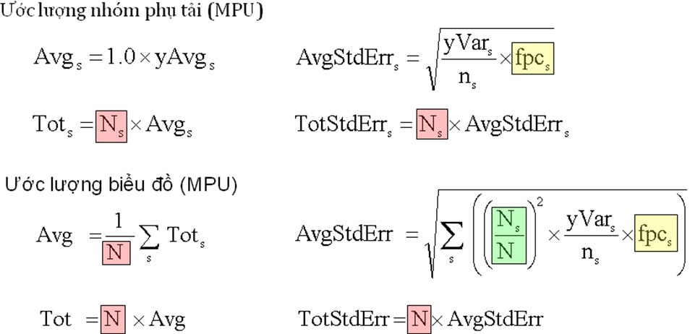
Where:
• s load range;
• c sample load;
• y target variable (kWh);
• x auxiliary variable (monthly commercial energy).
4. Separate ratio (SR)
An auxiliary variable is known to all cases in the set. In load research, the auxiliary variable might be:
- The annual production;
- The seasonal production;
- The demand for measured strata.
The ratio methods use set data and sample load data for auxiliary variables to increase the accuracy. Such methods are effective when the target variable and auxiliary variable are closely related.
Variables used for modeling, variables used for developing are usually the production of the business month or calendar month. There are 02 types of development:
- SR method using monthly production of each load group
- CR method using monthly production of each stratum.
SR method is usually used because the set production only appears in strata, not load groups.
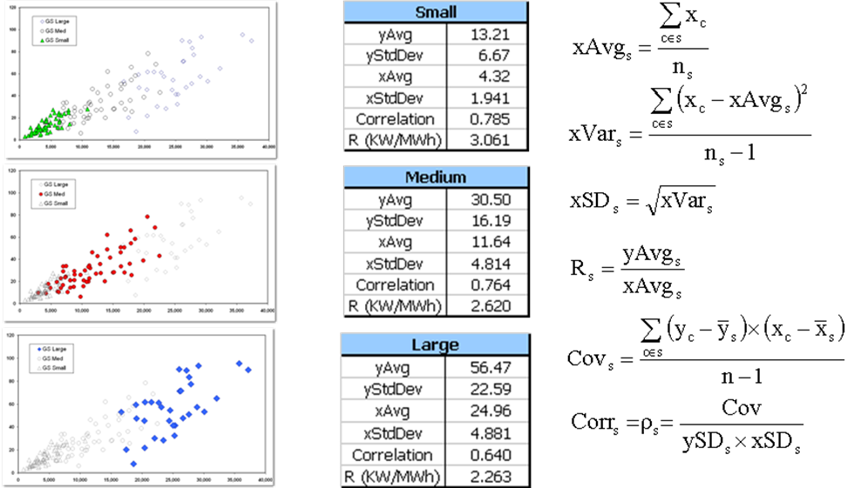
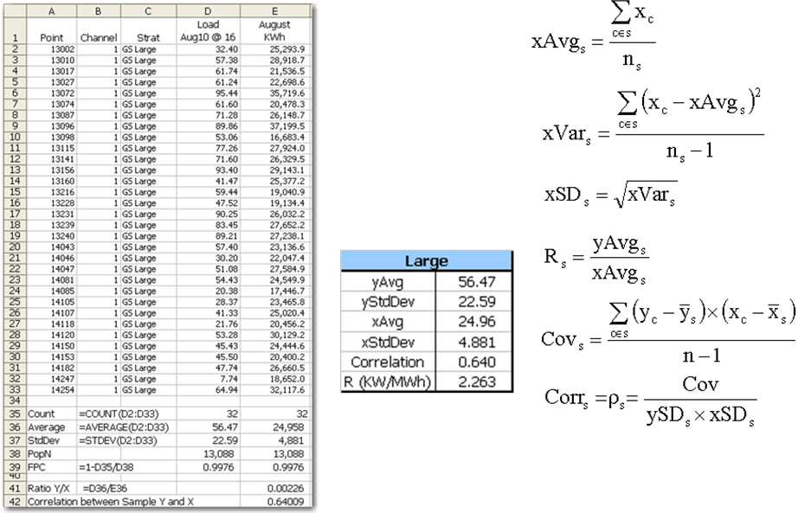
Estimation methods
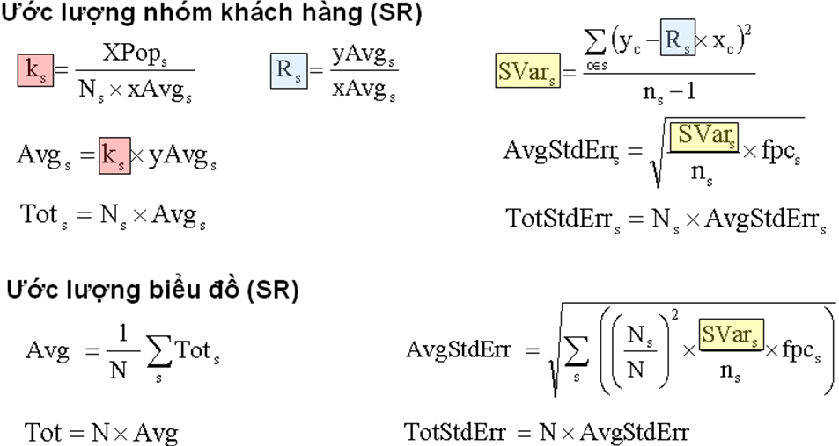
5. Combined Ratio (CR)
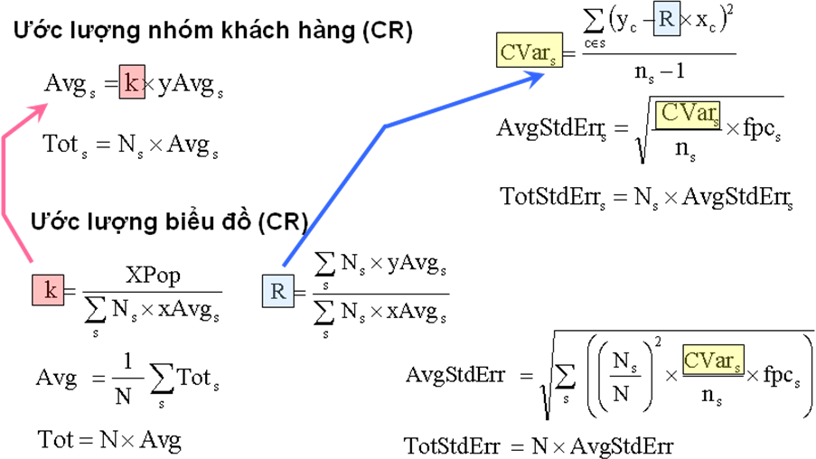

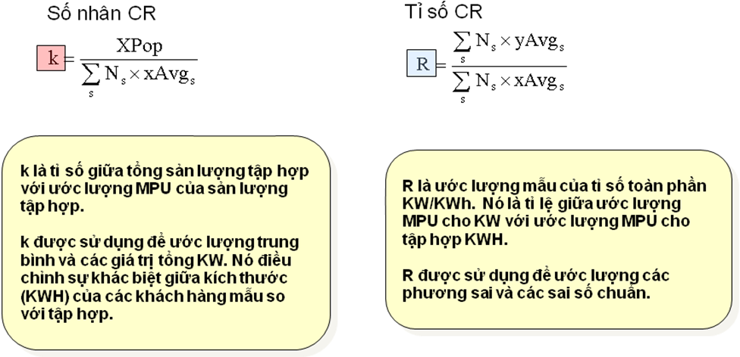
k is the ratio of set production to estimated MPU of aggregated production.
k is used to estimate the mean and values of total KW. It adjusts the difference between the size (kWh) of samples in comparison to the set
R is the ratio of estimated MPU of KW to MPU of kWh.
R is used to estimate variances and standard variations

