MINISTRY OF CONSTRUCTION  -------- | SOCIALIST REPUBLIC OF VIETNAM  Independence - Freedom - Happiness  ----------------
No. 19/2013/TT-BXD | Hanoi, October 31, 2013

CIRCULAR
PROMULGATION OF NATIONAL TECHNICAL REGULATION ON CONSTRUCTION AND INSTALLATION OF OUTDOOR ADVERTISING
Pursuant to the Law on Advertising dated June 21, 2012;
Pursuant to the Government's Decree No. 62/2013/ND-CP dated June 25, 2013 defining the functions, tasks, powers and organizational structure of the Ministry of Construction;
Pursuant to the Government's Decree No. 127/2007/ND-CP dated August 01, 2007 detailing the implementation of a number of articles of the Law on Technical regulations and standards;
At the request of the Director of the Department of Science, Technology and Environment,
The Minister of Construction issues a Circular on the promulgation of National Technical Regulation on construction and installation of outdoor advertising - QCVN 17:2013/BXD.
Article 1. QCVN 17:2013/BXD - National Technical Regulation on construction and installation of outdoor advertising is promulgated together with this Circular.
Article 2. This Circular takes effect on May 01, 2014.
Article 3. The Minister, Heads of ministerial agencies, Heads of Governmental agencies, Presidents of the People’s Committees of central-affiliated cities and provinces, relevant organizations and individuals are responsible for the implementation of this Circular./.
PP THE MINISTER
DEPUTY MINISTER
Nguyen Thanh Nghi

QCVN 17 : 2013/BXD
NATIONAL TECHNICAL REGULATIONS ON CONSTRUCTION AND INSTALLATION OF OUTDOOR ADVERTISING
Foreword
QCVN 17 : 2013/BXD is compiled by Vietnam Institute of Architecture, Urban and Rural Planning, submitted by the Department of Science, Technology and Environment, examined by the Ministry of Science and Technology, and promulgated by the Ministry of Construction together with the Circular No. 19/TT-BXD dated October 31, 2013.

TABLE OF CONTENTS
1. GENERAL PROVISIONS
1.1. Scope of regulation
1.2. Subjects of application
1.3. References
1.4. Interpretation of terms
2. TECHNICAL PROVISIONS
2.1. Rules for planning the construction and installation of outdoor advertising
2.2. Technical requirements for advertising boards
2.2.1. Suburban areas
2.2.2. Urban areas
2.3. Technical requirements for digital screens
2.4. Technical requirements for signboards and advertising boards on urban sidewalks
2.5. Technical requirements for banners
2.6. Technical requirements for advertising boards in the form of letters, shapes of symbols
2.7. Structural requirements
2.8. Requirements of materials
2.9. Lighting requirements
3. IMPLEMENTATION
Appendix A
Appendix B

NATIONAL TECHNICAL REGULATIONS ON CONSTRUCTION AND INSTALLATION OF OUTDOOR ADVERTISING
1. GENERAL PROVISIONS
1.1. Scope of regulation
1.1.1. This Regulation specifies the compulsory requirements for design, construction and installation of outdoor advertisements.
1.1.2. This Regulation is applicable to means of outdoor advertisements in the form of fixed or movable advertising works and banners, not applicable to advertisements.
1.2. Subjects of application
This Regulation is applicable to the organizations and individuals involved in the construction of means of outdoor advertising in Vietnam’s territory.
1.3. References
The references used for this Regulation are mentioned below. If one of the referred document is replaced, the new document, including amendments, shall apply:
The Law on Construction No. 16/2003/QH11 dated November 26, 2003;
To the Law on Inland Waterway Navigation No. 23/2004/QH04 dated June 15, 2004;
The Law on Electricity No. 28/2004/QH11 dated December 03, 2004;
The Law on Railway No. 35/2005/QH11 dated June 14, 2005;
The Law on Road traffic No. 23/2008/QH12 dated November 13, 2008;
The Law on Advertising No. 16/2012/QH13 dated June 21, 2012;
QCXDVN 01 : 2008/BXD - National Technical Regulation on construction planning;
QCVN 02 : 2009/BXD - National Technical Regulation on data of natural conditions used for construction;
QCVN 06 : 2010/BXD - National Technical Regulation on fire safety for houses and constructions;
QCVN 07 : 2010/BXD - National Technical Regulation on urban infrastructural works;
QCVN 41 : 2012/BGTVT - National Technical Regulation on road traffic signs.
1.4. Interpretation of terms
In this Regulation, the terms below are construed as follows:
1.4.1. Advertising
The use of various instruments to introduce profitable or non-profitable products and services to the public; the providers of introduced products and services, except for news, social policies, and personal information.
1.4.2. Advertisements
Including contents and method of advertising in the form of pictures, sounds, voices, writing, symbols, colors, lights, and similar forms.
1.4.3. Banners
Including horizontal banners and vertical banners put up along main roads in urban areas and inner cities.
1.4.4. Advertising works
Including advertising screens, signboards, advertising boards that are separated or fastened to existing constructions (Picture 1).
1.4.5. Advertising screens
The means of advertising using digital technologies to transmit advertisements, including LED, LCD screens and similar forms.
1.4.6. Signboards
The boards bearing names and addresses of socio-political organizations, manufacturers, sellers.
1.4.7. Advertising board
Used for displaying advertisements on with various sizes and materials, including: boards, billboards, advertising light boxes that are hanged, installed separately, or fastened to existing constructions.
1.4.8. Fixed advertising boards (separated or fastened to existing constructions)
Advertising boards may be fixed on the ground or a surface, lighted, and connected with a power supply.
1.4.9. Movable advertising boards
Advertising boards that can be moved, suspended or placed on the sidewalk or the median strip, lighted or not lighted.
1.4.10. Advertisement area
The part on the advertising work where the advertisement is displayed.
1.4.11. Billboards
Advertising boards of which the area of a side is 40 m² or larger.
1.4.12. Small advertising boards
Advertising boards of which the area of a side is smaller than 40 m².
1.4.13. Advertising board structure
The parts (foundation, base, frame, board surface, etc.) are assembled to create a means of outdoor advertising.
1.4.14. Road
Including roads, bridges, road tunnels, and ferry terminals.
1.4.15. Road land
Land on which road constructions are build and land along the road used for the management, maintenance and protection of road constructions.
1.4.16. Road safety corridor
The strip of land along the roadside used for assurance of road traffic safety.
1.4.17. Urban roads
The roads within the administrative boundary of an urban area.
1.4.18. Median strip
A part of the road used for dividing the road into two parts with opposite directions or separating motor vehicles and non-motorized vehicles.
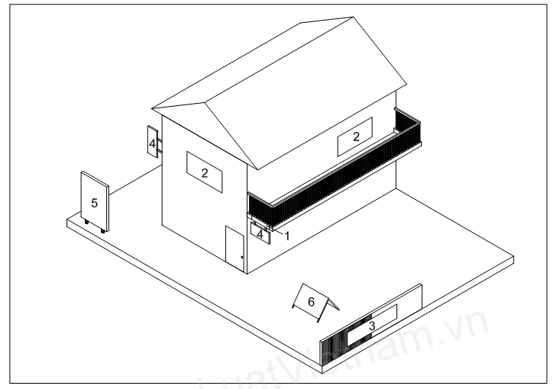
NOTES:
1. Advertising box;
2. Advertising boards on the sides of the construction (the front and the side);
3. Temporary advertising board on the fence of a construction site;
4. Signboards (horizontal and vertical);
5. Separate advertising board;
6. Movable advertising board.
Picture 1. Samples of means of outdoor advertising
2. TECHNICAL PROVISIONS
2.1. Rules for planning the construction and installation of means of outdoor advertising
2.1.1. The locations, designs, sizes, materials, and quantity of means of outdoor advertising along urban roads and suburban roads, outside the railway, inland waterway and road safety corridor must be determined.
2.1.2. The locations and management of means of outdoor advertising must comply with the Law on Advertising, the Law on Construction, the Law on Road traffic; to the Law on Inland Waterway Navigation; the Law on Electricity, the Law on Railway; QCXDVN 01:2008/BXD, and:
- Conserve the urban landscape;
- Ensure the fire safety, construction safety, social order, and fulfillment of requirements of the local government;
- Ensure the normal business, everyday life, and safety of people;
- Do not affect the vision of road users; do not affect the traffic and block road signs;
- Do not install advertising boards on lamp posts;
- Do not install advertising boards in road safety corridor at intersections and traffic circles;
- Do not install advertising works in the safety corridor of road tunnels and brides (more details in Appendix B);
- Do not install advertising works in the safety corridor of highways;
- Do not install advertising works on the land of suburban roads.
2.1.3. The license for construction issued by a local construction authority is compulsory in the following cases:
- Installing signboards or advertising boards, the area of a side of which is larger than 20 m², on a metal frame or similar materials on existing constructions;
- Making separate advertising boards of which the area of a side is 40 m² or larger;
- Making outdoor advertising screens of which the area of a side is 20 m² or larger;
The application for the license to construct advertising works must comply with local regulations on licensing and construction management.
2.2. Technical requirements for billboards
2.2.1. Suburban areas
2.2.1.1. Large advertising boards with appropriate shapes (with one or multiple sides) may be installed along suburban roads and comply with the regulations in Table 1.
Table 1. Technical requirements for large advertising boards along suburban roads
Type of road | Area of a side of the advertising board  m² | Minimum distance from the edge of road to the closest side of the board  m | Minimum height from the road surface to the lower edge of the board  m | Minimum distance between two boards along a straight segment  m | Minimum distance between two boards along a curved segment  m
Inter-provincial highways | 120 - 200 | 25 | 15 | 200 - 250 | 150 - 200
Provincial roads | 90 - 120 | 20 | 13 | 150 - 200 | 75 - 100
District roads | 40 - 100 | 15 | 8 | 100 - 150 | 75 - 100
NOTES:
1) The distance between two boards may vary depending on the road, but shall not exceed:
- ±50 m along inter-provincial highways;
- ±25 m along provincial roads;
- ±20 m along district roads;
2) Road edges are specified in Table 1, Article 4.20, QCVN 1:2012/BGTVT
2.2.1.2. Small advertising boards may be installed within the premises of industrial parks.
2.2.2. Urban areas
2.2.2.1. Small advertising boards may be installed along the sides of urban roads, pedestrian flyovers/tunnels, in the parks, and on the median strip of urban roads, provided the following regulations are complied with:
a) Along urban roadsides:
- Format: separate vertical advertising boards;
- Position: at least 5.0 m from the road edge to the closest side of the board;
- The distance from the road surface to the lower edge of the board is 5.0 m - 10 m;
- The minimum distance between two advertising boards along the same road is 100 m.
b) At the pedestrian flyover/tunnel:
- Format: fastened to the wall or banister of the pedestrian flyover/tunnel;
- Position: the inner side of the pedestrian flyover/tunnel.
c) In parks:
- Format: separate vertical advertising boards;
- Location: within the park;
- The distance from the road surface to the lower edge of the board is 5.0 m - 10 m.
NOTES: The regulations may vary depending on the actual conditions of each area.
d) On the median strip of an urban road:
- Format: separate vertical light boxes;
- Technical requirements: specified in Table 2.
2.2.2.2. Advertising boards at detached constructions/houses:
a) The advertising boards fastened on the wall of the construction/house must satisfy the requirements below:
- The height does not exceed 5 m, the length does not exceed the surface to which the board is fastened. Not more than 02 boards are installed;
- The height of the advertising board fastened on the wall of a construction/house with 4 floors or fewer must not extrude more than 1.5 m above the attic floor;
- The advertising boards must be fastened on the side wall of the construction/house having 5 floors or more.
b) Advertising boards placed at the front of the construction/house must satisfy the requirements below:
- Horizontal advertising boards:
+ Only one board is placed at a floor. The maximum height of the board is 2 m. The width of the board must not exceed the width of the construction/house; the board must not extrude more than 0.2 m from the wall;
+ Position: fastened to the balcony, the lower edge of the board is at the same level with the balcony floor or the porch.
- Vertical advertising boards:
+ The maximum width of the board is 1 m. The maximum height of the board is 4m and must not exceed the height of the storey of the construction/house to which it is fastened; the board must not extrude more than 0.2 m from the wall;
+ Position: Fastened along the vertical edge of the wall;
- Only 01 vertical board and 01 horizontal board may be fastened to the construction/house with one floor.
NOTES: The regulations may vary depending on the actual conditions of each area.
Table 2. Technical requirements for light boxes on median strips of suburban roads
Width of median strip  m | Maximum area of a side of light box  m² | Maximum distance from the surface of the median strip to the top of the light box  m | Minimum distance between two boards  m
> 15 | 12 | 5 | 120
8 - 15 | 8 | 5 | 100
6 - 8 | 6 | 5 | 80
4 - 6 | 4.5 | 5 | 60
2 - 4 | 2 | 5 | 40
NOTES:
1) If the median strip is wider than 15 m, light boxes may be alternatively placed along the sides of the median strip.
2) The width of the advertising board must be smaller than that of the median strip. The minimum distance from the outer edge of the advertising board to the curb of the median strip is 0.5 m.
2.2.2.3. Advertising boards on the sites of multistory buildings must ensure bearing safety, fire safety, safety of life, ventilation, and lighting.
Advertising boards or signboards may be installed at the top floors of multistory buildings being hotels, shopping malls, finance centers, banks, multi-purpose centers, and office buildings.
2.2.2.4. Temporary advertisements may be displayed on the fence around the construction site, provided they do not affect the construction, normal operation of adjacent buildings, and other adjacent activities.
2.2.2.5. The maximum area of advertising works in urban areas, shopping malls, supermarkets, train stations, airports, bus stations, parking lots is 40 m².
2.2.2.6. In the areas where construction is restricted, the maximum area of a light box, neon sign, trivision, or digital screen is 20 m².
2.2.2.7. Advertisements in the form of letters may be displayed at the top floor of the construction. Other formats of advertising that are placed on or block the roof are prohibited.
2.3. Technical requirements for digital screens
2.3.1. The digital screens used for advertising within the road area must not use sounds and must comply with the following regulations:
- Position: the distance from the edge of the road to the closest edge of the screen is 5.0 m;
- Maximum area of a side of the screen: 100 m²;
- The minimum distance from the road surface to the lower edge of the screen is 10 m;
- The distance between screens depends on their locations and actual conditions of the locality.
2.3.2. Digital screens in public places must comply with the following regulations:
− Area: 40 m² - 60 m²;
− Digital screens must not be positioned at intersections and must not use sounds;
− The minimum distance from road surface to upper edge of the screen is 15 m.
2.4. Technical requirements for signboards and advertising boards on urban sidewalks
2.4.1. The installation of signboards must comply with the following regulations:
- Position: at the gate or the front of the business place;
- Design: horizontal or vertical signboards;
- Size:
+ For maximum height of a horizontal signboard is 2.0 m. Its width must not exceed the width of the house;
+ The maximum width of a vertical signboard is 1.0 m. The maximum height of the board is 4 m and must not exceed the height of the storey where it is placed.
2.4.2. The signboards and advertising boards may be placed within the permissible area on the sidewalk (not used for traffic). The maximum width of a signboard or advertising board (on a sidewalk wider than 3.0 m) is 1.5 m - from the outer edge of the house (or from the red boundary line) outwards or from the edge of the curb inwards.
2.4.3. The installation of signboards and advertising boards on the sidewalk is subject to the permission of competent authorities; signboards and advertising boards must not block emergency exists, obstruct fire fighting, or affect public traffic.
2.5. Technical requirements for banners
2.5.1. Horizontal banners must be put up at fixed positions along the roads in urban areas and inner cities.
2.5.2. Horizontal banners may be hanged on lampposts.
2.5.3. The distance between banners depends on their locations and actual conditions of the locality.
2.5.4. Sizes and heights of banners are specified in Table 3.
Table 3 - Sizes and heights of banners
 | Size (width x length)  m | Distance from the road surface to the lower edge of the banner  m
Horizontal banners | 0.8 x 8.0 | ≥ 3.5
Vertical banners | (from 0.6 to 0.8) x (from 1.5 to 2.5) | ≤ 1.4
NOTES: The banner size may be adjusted to the advertisement contents and actual requirements, but such adjustment must not cause the banner area to vary more than 20% of the aforesaid size.
2.6. Technical requirements for advertising boards in the form of letters, shapes of symbols
Advertising boards in the form of letters, shapes of symbols must comply with the regulations in 2.2.
(Method of area calculation is specified in Appendix A).
2.7. Structural requirements
2.7.1. The structure of means of outdoor advertising must ensure safety and firmness, satisfy the aforesaid requirements, and stays stable through out the process of installation and use.
2.7.2. The structure must be calculated and designed in accordance with technical standards to resist negative impacts.
NOTES: loading capacity and natural conditions are specified in QCVN 02:2009/BXD.
2.7.3. The foundation, pile, bearing frame, surface, and materials of the advertising board must be able to prevent deformation, vibration, and degradation of other qualities beyond permissible limits.
2.8. Requirements of materials
2.8.1. Materials used for making advertising works must be durable, undeformed, aesthetic, meet the requirements on durability and specific technical requirements of each material.
2.8.2. The materials that make up the structure of the advertising work must be fireproof and conformable with QCVN 06:2010/BXD.
2.8.3. Every visible surface and edge of the adverting work must be made of non-corrosive materials and not be corroded by any adjacent part.
2.8.4. Coating paint, ink, decorations, etc. on the surface of the advertising work must be suitable for properties of the frame material and specifications provided by the manufacturer.
2.8.5. If the advertising work is made of materials with inconsistent thermal expansion factors, there must be a small gap between layers of these materials;
2.8.6. The adhesives used for the advertising works must suitable for the materials and satisfy technical requirements.
2.9. Lighting requirements
2.9.1. Lighting must be safe, aesthetic, not affect the traffic and other urban activities. The advertising work must be lighted from the primary view, be suitable for the lighted area and conformable with QCVN 07:2010/BXD.
2.9.2. Lighting instruments may be part of the advertising work or separate from it.
NOTES: Lighting of the advertising work may by external or internal.
2.9.3. The advertising work must be lighted by instruments with high luminance and are safe for use and management.
2.9.4. Solutions for minimizing lighting pollution by environmental impact must be adopted when powerful light sources are used, such as:
- Ensuring the minimum distance between the light source and the advertising board;
- Using light sensors;
- Using shields and lampshades.
2.9.5. The power cables that supply power to the advertising work must be insulated to avoid short-circuit under the impact of weather.
2.9.6. The connections of the lighting system inside the adverting work must be insulated and able to minimize the heat emitted from the lights that may set fire to adjacent parts.
2.9.7. The load of the lighting system for advertising works must be suitable for the protection level of the circuit breaker and cross-section of wires to prevent accidents caused by overload.
2.9.8. The advertising work must have an appropriate lighting protection system.
3. IMPLEMENTATION
3.1. The license to construct advertising works shall be issued by local competent authorities.
3.2. The construction of temporary advertising works within the road safety corridor is subject to the approval of traffic authorities.
3.3. The existing advertising works or the advertising works that are licensed but not constructed before this Regulation is promulgated:
3.3.1. If the design of a licensed advertising work is not conformable with this Regulation and the advertising work has not been constructed, the design must be adjusted before construction is commenced.
3.3.2. The existing advertising works of which the sizes or locations are not conformable with this Regulation must be removed when the license expires.
3.3.3. Owners of advertising works shall report their condition to local construction authorities. The advertising works that fail to meet the technical requirements in 2.7, 2.8 and 2.9 of this Regulation must be repaired within 06 months from the effective date of this Regulation.

APPENDIX A
METHOD OF CALCULATING AREA OF MEANS OF OUTDOOR ADVERTISING
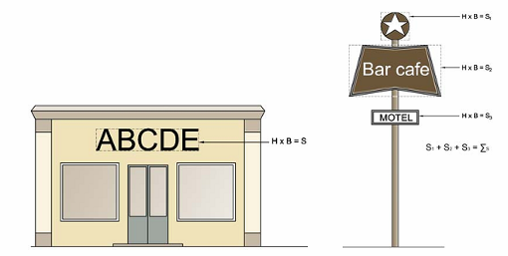
NOTES:
H: Height S: Area
B: Width ∑S: Total area
Picture A.1 - Calculation of advertising board
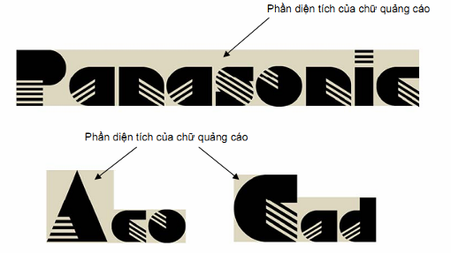
Picture A.2 - Area of advertising boards in the form of letters or symbols

APPENDIX B
AREA WITHIN SAFETY CORRIDOR OF ROAD TUNNELS AND BRIDES WHERE ADVERTISING WORKS ARE PROHIBITED
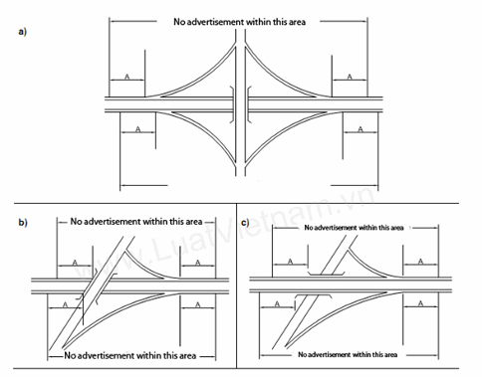
NOTES:
A: Limited distance applicable to road tunnels and bridges (according to the Government's Decree No. 11/2010/ND-CP dated February 24, 2010 on management and protection of road infrastructure)
Picture B.1 - Area within safety corridor of road tunnels and brides where advertising works are prohibited

