THE MINISTRY OF PUBLIC SECURITY  -------- | SOCIALIST REPUBLIC OF VIETNAM  Independence – Freedom - Happiness  ---------------
No. 08/2016/TT-BCA | Hanoi, December 16, 2016

CIRCULAR
REGULATIONS ON SECURITY UNIFORMS FOR AGENCIES, ENTERPRISES
Pursuant to the Decree No. 06/2013/ND-CP dated January 09, 2013 stipulating security in agencies, enterprises;
Pursuant to the Decree No. 106/2014/ND-CP dated November 17, 2014 stipulating functions, tasks, powers and organizational structure of the Ministry of Public Security;
At the request of director of the General Department of Logistics - Technology;
The Minister of Public Security has promulgated the Circular stipulating security uniforms for agencies and enterprises.
Chapter I
GENERAL PROVISIONS
Article 1. Governing scope
This Circular stipulates designs, colors, badges, epaulettes, symbols...(hereinafter referred to as 'uniforms'); useful life, dispensing and use of security uniforms in state agencies, enterprises, political organizations, socio-political and occupational organizations, social organizations that are established according to laws of Vietnam (hereinafter referred to as ‘agencies and enterprises’).
Article 2. Regulated entities
1. This Circular applies to:
a) Security forces in agencies, enterprises;
b) Vietnamese agencies, enterprises; foreign enterprises, organizations operating in the territory of Vietnam;
c) Agencies, organizations, and individuals in connection with security activities in agencies, enterprises;
2. Agencies, enterprises and security forces in agencies, enterprises under the management of the People's public security and People's Army shall not be subject to this Circular.
Article 3. Requirements for security uniforms in agencies, enterprises
1. Ensure uniformity, consistence and compliance with requirements of security tasks in agencies, enterprises;
2. Ensure quality, categories, designs are compliant with this Circular.
3. Ensure uniforms are equipped and used properly and for the right purpose;
Article 4. Regulations on designs of security uniforms for agencies, businesses
Below are designs of security uniforms used in agencies, enterprises:
1. Star (Form 01).
2. Epaulette (Form 02).
3. Badge (Form 03).
4. Name badge (Form 04).
5. Symbol (Form 05).
6. Cap (Form 06).
7. Spring and summer clothing (Form 07).
8. Autumn and winter clothing (Form 08).
9. Ties (Form 09).
10. Belt (Form 10).
11. Socks (Form 11).
12. Leather shoes (Form 12).
13. 13. Rain suit (Form 13)
Chapter II
PARTICULAR PROVISIONS
Article 5. Star
1. Design: See Form 01 enclosed herewith.
2. Structure A shield between the two pine branches; the shield is raised above the pine branches. In the middle of the shield is a star with rice flowers at two sides. The word “SECURITY” is on the silk background with a figure of the historic wheel. Rib of the leaves is raised. Veins are made along the leave curves. The rib is raised 01 mm above the edge.
3. Color: The pine branches are plated with yellow; silk strip, wheel, rice flowers, shield edge and star plated with yellow alloy; rice flower background, the word "SECURITY" with dark turquoise.
Article 6. Epaulette
1. Design: See Form 02 enclosed herewith.
2. Structure: Background is made of woven fabric with hard plastic sticks inside. A shield is embroidered in the middle of the epaulette surrounded by two rice flower branches crossed. In the middle of the shield is a star. At the pointed end of the epaulette is attached with a metal button with a star carved in relief, surrounded by rice flowers with the word “SECURITY” underneath. At the other end of the epaulette is from one to three stripes (to show ranks). Width of each strip is 6 mm and the distance between the two adjacent stripes is 5mm.
3. Color: Background is turquoise and the surrounding edge is dark yellow. The shield is blue; shield edge, two rice flowers and star are all yellow. The metal button is silver white. The stripes are fresh yellow.
Article 7. Badge
1. Design: See Form 03 enclosed herewith.
2. Structure: The badge shall be lozenge-shaped with hard plastic sticks inside. In the middle of the badge is the word “BV” (means "SECURITY") in metal.
3. Color: Background is turquoise and the word “BV” is silver white.
Article 8. Name badge
1. Design: See Form 04 enclosed herewith.
2. Structure: The name badge is made in thick stiff paper, size 9cm x 5.5cm.
- At the top of the badge is a strip displaying a security star on the left and the line (font size 10 in bold) showing names of superior governing agencies, enterprises and the line (font size 12 in bold capital) underneath showing names of employers.
- Under the strip on the left is a 2x3 photo of security staff "fan-stamped” by agencies, enterprises. On the right is the word “SECURITY” (font size 16 in bold capital), full name and number sign of the security staff, date of issue (font size 14 in bold)..
- The text used in the name badge shall be in Times New Roman – Unicode.
- The name badge shall be worn above the left chest pocket on the uniform shirt.
3. Color: Background of the name badge is in yellow; surrounding edge, strip and the word “SECURITY” are in red, the remaining text is in black.
Article 8. Symbol
1. Design: See Form 05 enclosed herewith.
2. Structure The symbol is shield-shaped with a silk strip above. On the silk strip is the word “SECURITY" between the two stars. In the middle of the symbol is the national flag (red flag with a gold star) right in the circle with surrounding light beams. Right underneath is the figure of factories, organizations, construction sites. At the bottom is the figure of half of the wheel with the word “AGENCY” or “ENTERPRISE”.
3. Color: The flag is red with a star in yellow surrounded by dark-yellow light beams. Figure of factories, organizations, construction sites is in turquoise.
Article 10. Caps
1. Design: See Form 06 enclosed herewith.
2. Structure
a) Peaked cap: Top part is flat and circular with a star at the front. Above the visor is a decorative yellow cord in plaits, each end being attached to the cap by a white-plated metal button.
b) Soft cap: The front of the cap is made of stiff plastic with a crown made of four pieces sewed together. A security star is attached at the front.
c) Hard cap: similar to North Vietnam Army pre 1975 Fiber shell headgear hat.
3. Color: Dark violet. Particularly for peaked caps, decorative cords must be in yellow and metal buttons must be in white.
Article 11. Spring and summer clothing
1. Design: See Form 07 enclosed herewith.
a) Short-sleeve shirts
- Short-sleeve shirts for men: Shirts are straight-collared with twin patch pockets (with flaps) at the upper front part. The placket is attached with a line of six plastic buttons of the same color as the cloth. Two side pleats are created in back. Sleeves are short with edges being folded from inside out. Shirt hems are made straight.
- Shirts for women: Shirts are made according to pleat style with folded collar. Twin patch pockets are created at the lower front part with diagonal openings. The placket is attached with a line of six plastic buttons of the same color as the cloth. Sleeves are short with sleeve edges being folded from inside out. Shirt hems are made straight.
b) Long-sleeve shirts
- Long -sleeve shirts for men: Shirts are straight-collared with twin patch pockets (with flaps) at the upper front part. The placket is attached with a line of six plastic buttons with the same color as the cloth. Two side pleats are created in back. Sleeves are long with dart pleated cuffs. Shirt hems are made straight.
- Shirts for women: Shirts are made according to pleat style with folded collar and two twin patch pockets at the lower front part. Pocket openings are diagonal. The placket is attached with a line of four plastic buttons of the same color as the cloth. Sleeves are long with dart pleated cuffs. Shirt hems are made straight.
c) Trousers for spring and summer
- Trousers for men: Trousers with detachable six-belt loop waistband, two diagonal side pockets and zipper fly. Side pleats are created at the front. Trouser hems are made straight.
- Trousers for women: Trousers with detachable six-belt loop waistbands, two diagonal side pockets and zipper fly. Side pleats are created at the front. Trouser hems are made straight.
2. Color:
a) Shirts are blue;
b) Trousers are in dark violet.
Article 12. Autumn and winter clothing, ties
1. Design: See Form 08, Form 09 enclosed herewith.
a) Shirts
- Shirts for men: Shirts are straight-collared, made with a patch pocket on the left chest part and a line of five plastic buttons with the same color as the cloth attached on the placket concealed inside. Two side pleats are created in back. Sleeves are long with dart pleated cuffs. Shirt hems are made straight.
- Shirts for women: Shirts are straight-collared, waisted. Placket is concealed and attached with a line of five plastic buttons with the same color as the cloth. Plain back, long-sleeved with dart pleated cuffs, shirt hems straight.
b) Jackets:
- Jackets for men: These jacket are made similar to suit jacket style with folded and K-shaped collars, two-piece back and a single vent on the back. Four patch pockets (with flaps) are created at the front. A line of four plastic buttons with the same color as the cloth is attached on the placket.
- Jackets for women: These jacket are made similar to suit jacket style with folded and K-shaped collars, two-piece back and a single vent on the back. Two patch pockets (with flaps) are created at the front. A line of four plastic buttons with the same color as the cloth is attached on the placket.
c) Coats:
- Coats for men: Made of five layers, folded collar, waist belt with plastic buckle. Two patch pockets and two slanted welt pockets are made at the upper and lower front part respectively (See picture 8.5). A line of five plastic buttons with the same color as the cloth is attached on the placket. A zipper closure is made inside. At the back side come with detachable epaulettes, waist belt loops.
- Coats for women: Made of five layers, folded collar, waist belt with plastic buckle. Two slanted welt pockets are made at the lower front part and a line of five plastic buttons with the same color as the cloth attached on the placket. A zipper closure is made inside. At the back side come with detachable epaulettes, waist belt loops.
d) Autumn, winter trousers: As stipulated in Point c, Clause 1, Article 11 hereof;
2. Color:
a) Shirts are blue;
b) Jackets, coats and trousers are in dark violet;
c) Ties are in dark violet.
Article 13. Belts, socks, leather shoes and rain suits
1. Belts
a) See Form 10 enclosed herewith.
b) Structure: Made of leather with rounded tip; Buckle is made of metal with the word “BV” carved on the front side.
c) Color: Panel is brown and buckle is yellow.
2. Socks
a) Design: See Form 11 enclosed herewith.
c) Color: Dark violet
3. Leather shoes
a) Design: See Form 12 enclosed herewith.
b) Structure:
- Feather shoes for men: Shoes are made of bosca leather. Sole is made of rubber with anti-slip surface. Shoe lace is made of polyester fibers.
- Feather shoes for women: Made of bosca leather which is soft and elastic. Sole is made of rubber with anti-slip surface. Shoe lace is made of polyester fibers.
c) Color: Black
4. Rain suits
a) Design: See Form 13 enclosed herewith.
b) Color: fade grass green, reflective panel yellow, the word “SECURITY” red.
Article 14. Useful life, dispensing and use of uniforms
1. Useful life:
No. | Name of uniforms | Unit | Quantity | Useful life (year)
1 | Peaked cap | pcs | 1 | 3
2 | Hard cap | pcs | 1 | 3
3 | Soft cap | pcs | 1 | 3
4 | Autumn, winter clothing + symbol | Set | 1 | 2
5 | Spring, summer clothing + symbol | Set | 1 | 1
6 | Coats + symbol | pcs | 1 | 4
7 | Shirts | pcs | 1 | 1
8 | Ties | pcs | 1 | 2
9 | Belts | pcs | 1 | 3
10 | Leather shoes | Pair | 1 | 1
11 | Socks | Pair | 2 | 1
12 | Epaulettes | Set | 1 | 2
13 | Badge | Set | 1 | 2
14 | Star | pcs | 1 | 3
15 | Rain suits | Set | 1 | 3
2. Dispensing and use of uniforms:
a) Depending on actual weather conditions in specific areas, heads of agencies, enteprises shall decide dispensing uniforms appropriately;
b) During performance of duties, security staff shall comply with regulations on use of security uniforms as prescribed hereof.
Article 15. Expenses for equipment of security uniforms for agencies, enterprises
1. These expenses shall be taken from agencies, enterprises' regular expenditures.
2. These expenses shall be recorded in the enterprise’ regular business cost.
Chapter III
IMPLEMENTATION
Article 16. Effect
This Circular takes effect since April 05, 2016. Regulations on security uniforms for agencies, enterprises that were in opposition to this Circular shall be hereby annulled.
Article 17. Responsibility
1. General Department of Logistics – Technology shall preside over and cooperate with General Department of Security in instructing, inspecting and speeding up the implementation of this Circular.
2. Local police agencies, authorities shall be responsible for instructing, inspecting, monitoring and reporting the implementation of this Circular by agencies and enterprises within management at the end of second and forth quarter annually to the Ministry of Public Security (through General Department of Logistics – Technology).
3. Directors, heads of units affiliated to the Ministry of Public Security, directors of fire departments of central-affiliated provinces, cities and heads of relevant agencies, enterprises and individuals shall be responsible for executing this Circular.
Difficulties that arise during the implementation of this Circular should be reported to the Ministry of Public Security for instructions./.

MINISTER
General Tran Dai Quang

DESIGNS OF SECURITY UNIFORMS USED IN AGENCIES, ENTERPRISES (Enclosed with the Circular No. 08/2016/TT-BCA)
FORM 01: STAR
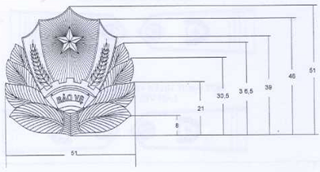
Unit: mm

FORM 02: EPAULETTE
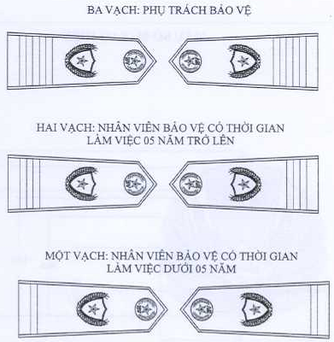

THREE STRIPES  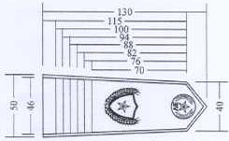 | TWO STRIPES  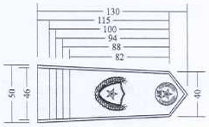
ONE STRIPE
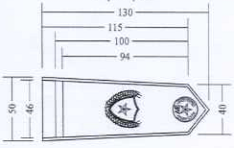

FORM 05: SYMBOL
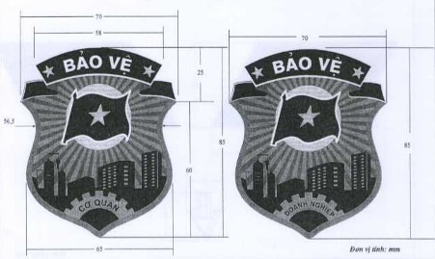

FORM 06: HAT
6.1. North Vietnam Army pre 1975 Fiber shell Head Gear hat
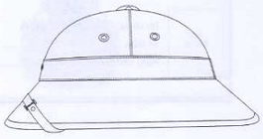

FORM 03: BADGE
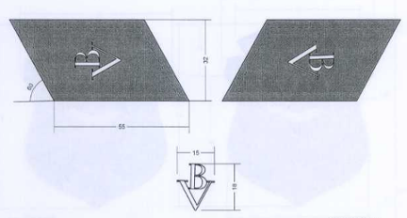
Unit: mm

Form 04: NAME BADGE
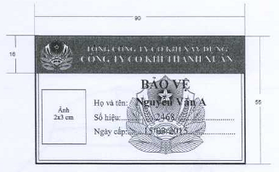
Unit: mm

6.2. Soft cap
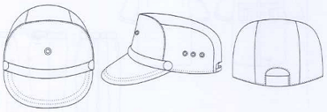

6.3. Peaked cap
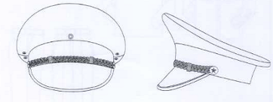

FORM 07: SPRING AND SUMMER CLOTHING
7.1. Short-sleeve shirts for men
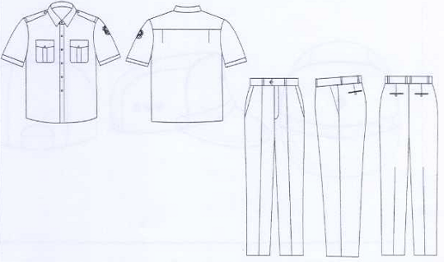

7.2. Long-sleeve shirts for men
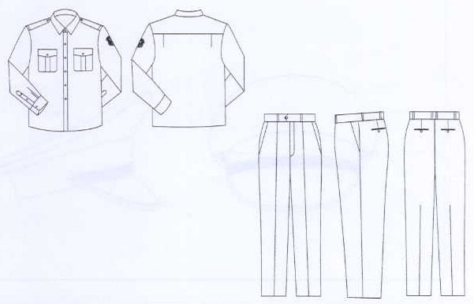

7.3. Short-sleeve shirts for women
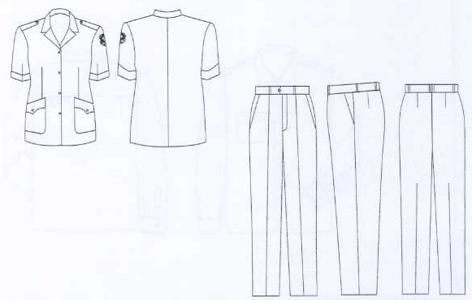

7.4. Long-sleeve shirts for women
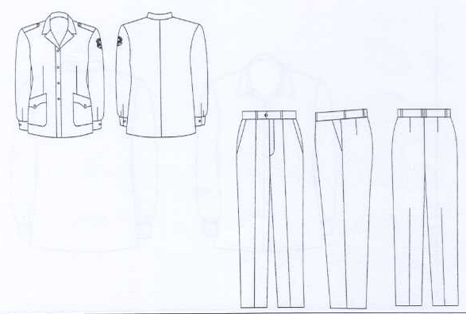

FORM 08: AUTUMN AND WINTER CLOTHING
8.1. Shirts for men
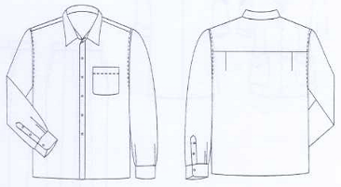

8.2. Shirts for women
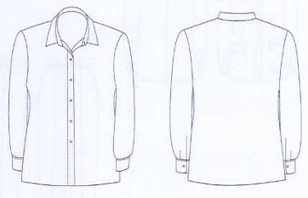

8.3. Jackets for men
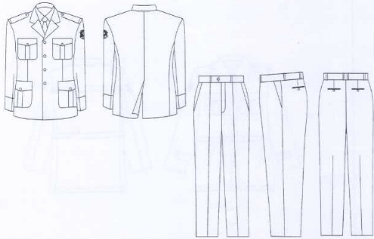

8.4. Jackets for women
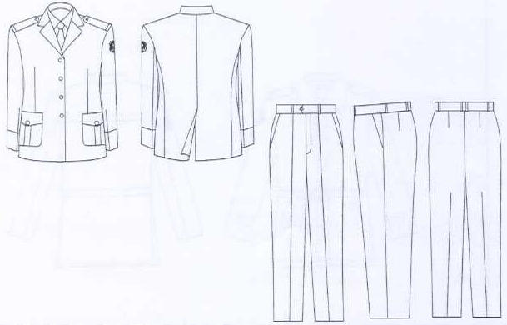

8.5. Coats for men
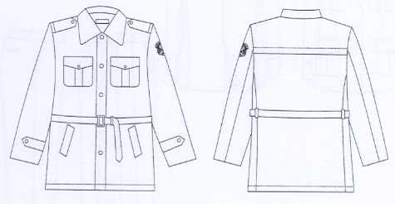

8.6.Coats for women
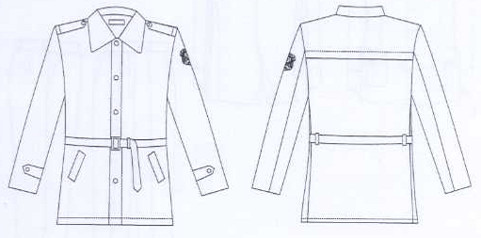

8.7. Tie
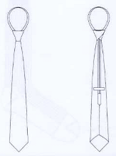

FORM 10: BELT
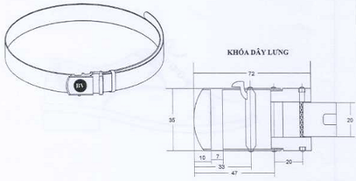
Unit: mm

FORM 11: SOCKS
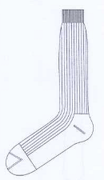

MẪU SỐ 12: GIẦY DA
12.1. Men shoes
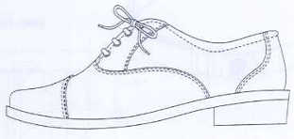

12.2. Women shoes
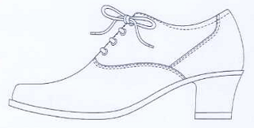

FORM 13. RAIN SUIT
