MINISTRY OF FINANCE  GENERAL DEPARTMENT OF TAXATION  ------- | SOCIALIST REPUBLIC OF VIETNAM  Independence - Freedom - Happiness  ---------------
No. 635/QD-TCT | Hanoi, May 11, 2020

DECISION
ADOPTING REGULATIONS ON COMPONENTS CONTAINING ELECTRONIC INVOICE DATA AND APPROACHES TO DATA TRANSMISSION AND RECEPTION BY TAX AUTHORITIES
GENERAL DIRECTOR
Pursuant to the Law on Tax Administration dated November 29, 2006 and the Law on Amendments and Supplements to certain Articles of the Law on Tax Administration;
Pursuant to the Law on Value-added Tax dated June 3, 2008 and the Law on Amendments and Supplements to certain Articles of the Law on Value-added Tax;
Pursuant to the Law on Information Technology dated June 29, 2006;
Pursuant to the Law on Electronic Transactions dated November 29, 2005;
Pursuant to the Government’s Decree No. 119/2018/ND-CP dated September 12, 2018, regulating electronic invoices for sale of goods and provision of services;
Pursuant to the Government's Decree No. 130/2018/ND-CP dated September 27, 2018, elaborating on the implementation of several Articles regarding digital signature and digital signature authentication service;
Pursuant to the Government’s Decree No. 165/2018/ND-CP dated December 24, 2018 on electronic financial transactions;
Pursuant to the Prime Minister's Decision No. 41/2018/QD-TTg dated September 25, 2018, defining the functions, tasks, powers and organizational structure of the General Department of Taxation subsidiary to the Ministry of Finance;
Pursuant to the Circular No. 39/2017/TT-BTTTT dated December 15, 2017 of the Ministry of Information and Communications, issuing the list of technical standards on application of information technology to activities of state regulatory authorities;
Pursuant to the Circular No. 68/2019/TT-BTC dated September 30, 2019 of the Ministry of Finance, providing guidance on several articles of the Government’s Decree No. 119/2018/ND-CP dated September 12, 2018, regulating electronic invoices for sale of goods and provision of services;
Upon the request of the Director of the Information Technology Department.
HEREBY DECIDES
Article 1. Regulations on components containing electronic invoice data and approaches to data transmission and reception by tax authorities shall be annexed hereto.
Article 2. This Decision shall enter into force from the signature date and shall be applied to enterprises, organizations, business households and individuals registering, using and providing e-invoicing solutions in accordance with regulations laid down in the Decree No. 119/2018/ND-CP and the Circular No. 68/2019/TT-BTC.
Article 3. Heads of Departments, affiliates or subsidiaries of the General Department of Taxation, Directors of Tax Departments of provinces and centrally-affiliated cities, relevant entities and persons shall be responsible for implementing this Decision./.
Article 4. If documents used as references herein are revised, amended or replaced, new versions thereof shall be applied.
In the course of implementation hereof, if there is any difficulty or query that arises, relevant units may send feedbacks to the General Department of Taxation (via the Information Technology Department) to seek its decision on any proper amendment or supplementation./.

GENERAL DIRECTOR
Cao Anh Tuan

REGULATIONS
ON COMPONENTS CONTAINING ELECTRONIC INVOICE DATA AND APPROACHES TO DATA TRANSMISSION AND RECEPTION BY TAX AUTHORITIES
(Annexed to the Decision No. 635/QD-TCT dated May 11, 2020 of the General Director of the General Department of Vietnam Customs)
Part I
GENERAL PROVISIONS
I. Scope and subjects of application
1. Scope: Requirements on technical specifications, structured format, data components and methods of e-invoice exchange between enterprises, organizations, business households, individuals or e-invoice service providers and tax authorities.
2. Subjects of application: This Circular shall apply to those covered by Article 2 in the Circular No. 68/2019/TT-BTC dated dated September 30, 2019 of the Ministry of Finance, providing guidance on several articles of the Government’s Decree No. 119/2018/ND-CP dated September 12, 2018, regulating electronic invoices for sale of goods and provision of services.
II. Legal references and citations
1. National Standard TCVN 7322: 2009 Information technology - Automatic identification and data capture techniques - Technical requirements for QR Codes 2005;
2. EMV Book 4: EMV Integrated Circuit Card Specifications for Payment Systems - Book 4 Cardholder, Attendant, and Acquirer Interface Requirements;
3. Decision No. 1928/QD-NHNN dated August 5, 2018 of the Governor of the State bank of Vietnam regarding announcement of basic standards.
III. Abbreviations
No. | Abbreviations | Description
1 | CQT | Tax authority or agency
2 | CMND | 9-digit or 12-digit (old or new) ID card
3 | GTGT | Value added tax
4 | Hóa đơn có mã | e-invoices with tax authorities' identification code numbers
5 | Hóa đơn không mã | e-invoices without tax authorities' identification code numbers
6 | NHNN | State Bank of Vietnam
7 | MST | Tax identification number
8 | NNT | Taxpayer
9 | QR Code | Quick Response Code
10 | T-VAN | Intermediary service provider of e-invoice solution
11 | TCKNGTT | Organization or enterprise selling goods or providing services having connection to transmit data to them in the direct form (not via T-VAN)
12 | STT | Ordinal number
13 | XML | eXtensible Markup Language
IV. General provisions e-invoice data components and exchanged messages
1. XML tabs and data representation
a) XML tabs
The tab’s tag is written without space and may be abbreviated according to the following principles:
- Take the capitalized first letter of each word. In particular, the last word with the capitalized first letter is written in full. Example: The tab indicating the quantity data field is abbreviated into SLuong; the tab indicating the invoice data field is abbreviated into DLHDon;
- In case of identical abbreviated tags, some characters must be added to distinguish them. Example: The Tổng tiền (Sum/total) field is abbreviated into TgTien; the Thành tiền (Sum/total) is abbreviated into ThTien.
- Common phrases can be abbreviated under the regulations of Section III of Part I.
Notes: Regulations in this section shall not apply to digital signature tabs.
b) Regulations on data representation
- Character set representation standard (Encoding): UTF-8.
- Vietnamese-language character set and encoding standard: TCVN 6909:2001.
2. Data format
a) Numeric format: Data type in the numeric format contains the maximum of 19 numeric characters, including the maximum of 4 numeric characters in the fractional part. The decimal point (.) is used for separating the integral part from the fractional part (if any), including:
- Decimal data type is described to have the maximum length as x and y (where: x denotes total numeric characters at maximum (including both the whole part and the decimal places, excluding the decimal point (.) or separator); y denotes the maximum number of numeric characters in the fractional part).
Example: The Exchange rate data type is described to have the maximum length as 7 and 2 (where: 7 is total numeric characters at maximum (including both the whole part and the decimal places); 2 is the maximum number of numeric characters in the fractional part).
- Integer data type is described to have the maximum length as x which denotes the the maximum number of numeric characters.
Example: Invoice number data type is described to have the maximum length as 8 which is the the maximum number of numeric characters.
b) Date format: In this data type, data are represented in the YYYY-MM-DD format, where: YYYY refers to 4 digits indicating the calendar year; MM refers to 2 digits indicating the calendar month; DD refers to 2 digits indicating the calendar day. This data type is adjusted to the GMT+7 (+07:00) timezone.
Example: 2020-04-24 is the 24th of April of 2020.
c) DateTime format: In this data type, data are represented in the YYYY-MM-DDThh:mm:ss format, where: YYYY means 4 digits indicating the calendar year; MM means 2 digits indicating the calendar month; T means the symbol used for separating date from hour; hh means 2 digits indicating hour (from hour 00 to hour 23; AM/PM hour format is not allowed); mm means 2 digits indicating minute; ss means 2 digits indicating second. This data type is adjusted to the GMT+7 (+07:00) timezone.
Example: 2020-04-24T18:39:30 indicates 18 hour 39 minute 30 second of the 24th of April of 2020.
Notes: Numeric, date and time format is only used for XML data. Data are represented under the provisions of the Circular No. 68/2019/TT-BTC.
d) Regulations on currency units: Regulations laid down in point c of clause 2 of Article 3 in the Circular No. 68/2019/TT-BTC shall be observed.
3. Tax authority's identification/verification code inscribed on electronic invoices
Tax authority’s identification/verification code inscribed on an e-invoice is a set or sequence of characters, including 12 numeric characters, which the tax authority’s system creates and affixes onto e-invoices with tax authority’s identification/verification codes.
Tax authority’s code exists in the N₁N₂N₃N₄N₅N₆N₇N₈N₉N₁₀N₁₁N₁₂ format (N₁ through N₁₂ is the numeric characters ranging from 0 to 9).
4. Digital signature
- Digital signature must comply with the provisions of the Law on Electronic Transactions No. 51/2005/QH11 dated November 29, 2005 and other instructional documents thereof. Digital signature specifications shall conform to XML-Signature Syntax and Processing standard prescribed in the Circular No. 39/2017/TT-BTTTT dated December 15, 2017 of the Ministry of Information and Communications, issuing the list of technical standards on application of information technology to activities of state regulatory authorities.
- Digital signature data field provides information about the signing time (the SigningTime tab put inside the following tabs: Signature\Object\SignatureProperties\SignatureProperty). The SigningTime tab contains date and time data in accordance with regulations laid down in clause 2 of Section IV in Part I.
- URI property of Reference tabs of the XML Signature Syntax and Processing standard is used for determining data fields where each datum and message needs to be digitally signed, and even the signing time is required.
5. Messages exchanged between T-VAN or TCKNGTT and tax authority
A message is formatted into 3 parts: General information (TTChung), data (DLieu) and digital signature (Signature) are described as follows:
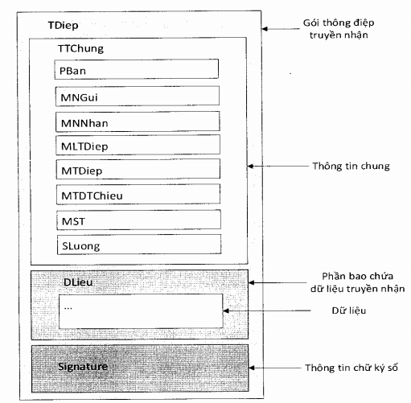
Image 1: Format of a message explained in the block chart
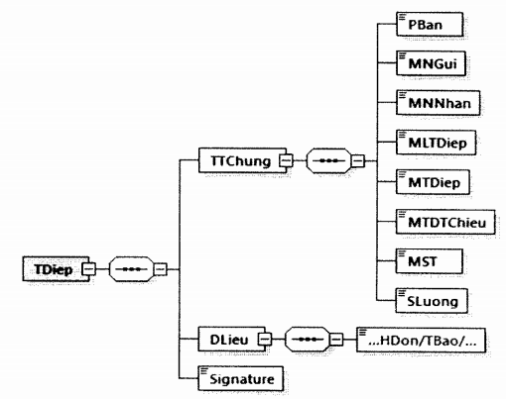
Image 2: Format of a message explained in the tree diagram
Where:
- General information (TTChung) part: Containing information about application version, sender’s code, recipient’s code, code of message type, message code, reference message code, TIN, quantity.
- Data (DLieu) part: Containing information about invoice, cancellation notice, request, chart of e-invoice data sent to tax authority, etc., which are defined in Section II herein.
- Digital signature (Signature) part: Containing information about the sender’s digital signature.
Detailed format of a message is described by the following table:
Data functions | Tabs | Maximum length | Data type | Required/optional
TDiep tab contains exchanged information, including general information, specific information and digital signature information
TDiep\TTChung tab contains general information conveyed by a message
Message version (In these Regulations, the 1.0.0 version is used) | PBan | 6 | String | Required
Sender’s code | MNGui | 13 | String | Required
Recipient’s code | MNNhan | 13 | String | Required
Message classification code | MLTDiep | 3 | Numeric | Required
Message code | MTDiep | 25 | String | Required
Reference message code | MTDTChieu | 25 | String | Optional
Tax Identification Number (Taxpayer’s TIN) | MST | 14 | String | Required
Quantity | SLuong | 7 | Numeric | Required
TDiep\DLieu tab contains the data part of a message
TDiep tab contains digital signature information (digitally signing on the entire message)
Digital signature | Signature |  |  | Required
Detailed description:
- General information (TTChung) part:
+ Sender’s code (MNGui), recipient’s code (MNNhan) is TCT with respect to a tax authority; is the taxpayer’s MST (TIN) code without the mark "-" with respect to T-VAN or TCKNGTT.
Example: Company A's MST (TIN) is 0107001729-001.
If company A sends data to a tax authority, MNGui and MNNhan will be 0107001729001 and TCT, respectively.
If the tax authority sends data to company A, MNGui and MNNhan will be TCT and 0107001729001., respectively.
+ Message classification code is the code describing the type of the sent/received message. More details shall be given in the Appendix I hereto.
+ Message code is created by the sender’s system, ensuring uniqueness across the entire system, and is formatted like: MNGui + Y₁Y₂ + N₁N₂N₃N₄N₅N₆N₇N₈N₉N₁₀N₁₁N₁₂, where: Y₁, Y₂ denotes 2 ending digits indicating the sending year; N₁ through N₁₀ denotes digits ranging from 0 to 9.
Example: Company A's MST (TIN) is 0107001729-001.
If company A sends data to a tax authority in 2021, the message code created will be 0107001729001210000000001.
If a tax authority sends data to company A in 2021, the message code created will beTCT210000000001.
+ Reference message code is created with respect to response messages and valued as an arriving message code.
Example: T-VAN A’s MST is 0107001729.
If T-VAN A sends company B’s e-invoice data to the tax authority issuing the identification/verification code in 2021, a message code will be created as 0107001729210000000001.
If a tax authority responds with an issued code, then the message code and the reference message code will be TCT210000000001 and 0107001729210000000001, respectively.
+ Tax identification number (MST) is the tax identification number of the taxpayer whose data are sent in a message.
+ Quantity (SLuong) is total number of data (total number of invoices without identification/verification codes, total number of charts of data on invoices without identification/verification codes, etc.) inside the Dlieu tab of the message.
Example: If T-VAN A concurrently sends a tax authority all of 4 e-invoices without identification/verification codes of company B in 2021, the value of the Quantity (SLuong) function in a sent message will be 4.
- Data (DLieu) part: Each message contains a particular data type of a taxpayer. Data types may be data on e-invoices with identification/verification codes, e-invoices without identification/verification codes and other data. With respect to data on invoices without identification/verification codes, each message only contains e-invoice data.
- Digital signature (Signature) part: This part contains information about the sender’s digital signature (e.g. T-VAN, TCKNGTT or tax authority) and digital signature shall be affixed onto all data of a message.
- The maximum storage capacity of a message is 2 MB.
6. QR Codes on e-invoices
a) Data represented in a QR Code
Value of a data object in a QR Code presented on the merchant side is formatted as follows:
No. | Name of data type | Definition
1 | Sequence of numeric characters | Is a format of numeric characters, including 10 characters ranging from “0” to “9”
2 | Sequence of special numeral characters | Is a format of special numeral characters regulated by EMV Book 4, including 96 characters composed of alphabetical, numeric characters and the mark (.)
3 | String | Is precomposed character sets stipulated under the Unicode character standard
Details about the representation of QR code data shall be subject to point d of clause 6 of this section.
b) Formating of QR code data objects in e-invoices
QR code data are formed as follows: Each data object is made up of three individual fields, including: (1) reference data object identification (ID) field; (2) length field that explicitly indicates the number of characters included in the value field; (3) value field. Fields are coded as follows:
- ID field is coded as a two-digit numeric value, with a value ranging from “00” to “99”;
- Length field is coded as a two-digit numeric value, with a value ranging from “01” to “99”;
- Value field has a minimum length of one character and a maximum length of 99 characters.
If the value field is blank (length is zero), ID field, length field and value field shall not be entered into QR code data.
c) Detailed description of components of QR code data
Formats, lengths, representation forms and definitions of data objects are specified in the following chart. Characters are stored in data fields in the Unicode UTF-8 format.
Field description | ID | Data types | Length | Required/optional | Remarks
QR Code Specification version | "00" | Sequence of numeric characters | 2 | Required | In this Regulation, the value of “01”
Information fields for invoice payments (if any)
Generation method | "01" | Sequence of numeric characters | 2 | Optional | Details provided at Point d of Clause 6 in this Section
Information about a merchant’s number | "02"-"03" | Sequence of special numeric characters | Max. 99 | Required (at least a data object identifying a merchant) | Details provided at Point d of Clause 6 in this Section
Information about a merchant’s number | "04"-"05"
Information about a merchant’s number | "06"-"08"
Information about a merchant’s number | "09"-"10"
Information about a merchant’s number | "11"-"12"
Information about a merchant’s number | “13"-"14"
Information about a merchant’s number | "15"-"16"
Information about a merchant’s number | "17"-"25"
Information about a merchant’s number | "26"-"51"
Globally Unique Identifier - GUID | “26-00” | Sequence of special numeric characters | Max. 32 | Required | Details provided at Point d of Clause 6 in this Section
Merchant ID | “26-01” | String | Max. 14 | Required | Details provided at Point d of Clause 6 in this Section
Merchant category code | “52” | Sequence of numeric characters | 4 | Required | Details provided at Point d of Clause 6 in this Section
Currency code | "53" | Sequence of numeric characters | 3 | Required | This field’s value conforming to ISO 4217 standard, and converted from the Invoice Currency Unit function (DVTTe tab).  Example: Vietnam Dong is represented by the value of “704”.
Transaction value | "54" | Sequence of special numeric characters | Max. 13 | Required | Details provided at Point d of Clause 6 in this Section
Country code | "58” | Sequence of special numeric characters | 2 | Required | Details provided at Point d of Clause 6 in this Section
Merchant’s name | "59" | Sequence of special numeric characters | Max. 25 | Required | Details provided at Point d of Clause 6 in this Section
City | "60" | Sequence of special numeric characters | Max. 15 | Required | Details provided at Point d of Clause 6 in this Section
Postal code | "61" | Sequence of special numeric characters | Max. 10 | Optional | Details provided at Point d of Clause 6 in this Section
Additional information | "62" | String | Max. 99 | Optional | Details provided at Point d of Clause 6 in this Section
Invoice/receipt number | “62-01” | Sequence of special numeric characters | Max. 25 | Optional | Details provided at Point d of Clause 6 in this Section
Store code | “62-03” | Sequence of special numeric characters | Max. 25 | Optional | Details provided at Point d of Clause 6 in this Section
Code of a merchant’s point of sale/terminal device | “62-07” | Sequence of special numeric characters | Max. 25 | Optional | Details provided at Point d of Clause 6 in this Section
Transaction purpose | “62-08” | Sequence of special numeric characters | Max. 25 | Optional | Details provided at Point d of Clause 6 in this Section
Request for customer’s additional data | “62-09” | Sequence of special numeric characters | Max. 3 | Optional | Details provided at Point d of Clause 6 in this Section
Information fields for invoice search (if any)
Invoice information | “99” | String | Max. 99 | Optional
Globally Unique Identifier - GUID | “99-00” | Sequence of special numeric characters | Max. 13 | Optional | This field accepts the value of the seller’s Tax Identification Number function on the invoice (MST tab inside NBan tab). In case of TIN of a branch, the mark "-" must be omitted.  Example: If the seller’s MST tab has the value of “0107001729-001”, this field’s value will be “0107001729001”.
Invoice form symbol | “99-01” | String | 1 | Optional | This field’s value is the invoice form symbol function (KHMSHDon tab). Example: 1.
Invoice symbol | “99-02” | String | 6 | Optional | This field’s value is the invoice symbol function (KHHDon tab). Example: C21TYY.
Invoice number | “99-03” | String | Max. 8 | Optional | This field’s value is the invoice number function (SHDon tab). Example: 68.
Invoice date | “99-04” | String | 8 | Optional | This field’s value is the invoicing date function (TDLap tab), using the format YYYYMMDD.  Example: 20211121.
Total payment written in numbers | “99-05” | Sequence of special numeric characters | Max. 20 | Optional | This field’s value is the function of total payment in numbers (TgTTTBSo tab).
Information fields for for checking and verification
Cyclic Redundancy Check CRC (Checksum) code | "63" | Sequence of special numeric characters | 4 | Required | Details provided at Point d of Clause 6 in this Section
The chart above providing a minimum of QR code data fields is used for invoice search and payment (where needed). Merchants may add other information in accordance with SBV’s regulations.
See examples of e-invoice QR Code in the Appendix XII hereto.
d) Details about QR Code format used in the payment sector in Vietnam
Detailed information about QR code format used in the payment sector in Vietnam is regulated under the Decision No. 1928/QĐ-NHNN (Technical specification of QR Code presented on the merchant side in Vietnam).
Part II
FORMATS OF COMPONENTS CONTAINING ELECTRONIC INVOICE DATA
I. Data components used for e-invoicing registration/change of e-invoice access information, and the on-demand request for issuance of e-invoices with tax authority's identification/verification codes
1. Format of data in the form of e-invoicing registration/the request form for change in e-invoice access information
a) The form shall be formatted as follows:
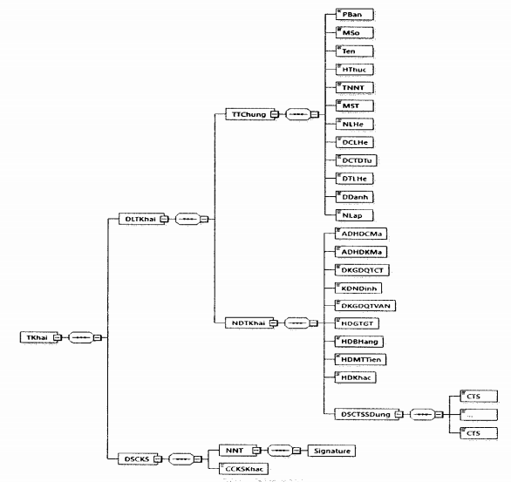
Image 3: Format of the form of e-invoicing registration/the request form for change in e-invoice access information
b) Detailed format of the form is described in the following table:
Data functions | Tab name | Maximum length | Data types | Required/optional
TKhai tab contains form data and taxpayer’s digital signature
TKhai\DLTKhai tab contains form data, including: General information and detailed information included in the form
TKhai\DLTKhai\TTChung tab contains general information of the form
XML version (In this Regulation, the value of this function is 1.0.0) | PBan | 6 | String | Optional
Form number (number of the form) | MSo | 1 | Numeric (Details proviced in Appendix III hereto). | Required
Name (Name of the form) | Ten | 100 | String | Required
Form of e-invoicing registration/change in e-invoice access information | HThuc | 1 | Numeric (1: Registration; 2: Change) | Required
Taxpayer’s name | TNNT | 400 | String | Required
Tax identification number | MST | 14 | String | Required
Contact person | NLHe | 50 | String | Required
Contact address | DCLHe | 400 | String | Required
Email address | DCTDTu | 50 | String | Required
Contact phone | DTLHe | 20 | String | Required
Place name | DDanh | 50 | String | Required
Date of issue | NLap |  | Date | Required
TKhai\DLTKhai\NDTKhai tab contains detailed information included in the form
Is this applicable to invoices with identification/verification codes? | ADHDCMa | 1 | Boolean (0: False; 1: True) | Required
Is this applicable to invoices without identification/verification codes? | ADHDKMa | 1 | Boolean (0: False; 1: True | Required
Is registration for transaction 1 made through General Department of Taxation (Is registration for transaction made through the website of the General Department of Taxation?) | DKGDQTCT | 1 | Boolean (0: False; 1: True | Required
Clause, Article, Decree (According to Clause, Article of Decree) | KDNDinh | 100 | String | Required in case of registration for transaction made through General Department of Taxation’s website
Is registration of transaction made via T-VAN? | DKGDQTVAN | 1 | Boolean (0: False; 1: True | Required
VAT invoice (Is VAT invoice used?) | HDGTGT | 1 | Boolean (0: False; 1: True | Required
Sale invoice (Is sale invoice used?) | HDBHang | 1 | Boolean (0: False; 1: True | Required
Cash register invoice (Is an invoice generated by a cash register is used?) | HDMTTien | 1 | Boolean (0: False; 1: True | Required
Other invoice (Is other invoice used?) | HDKhac | 1 | Boolean (0: False; 1: True | Required
TKhai\DLTKhai\NDTKhai\DSCTSSDung tab contains listed digital certificates in use
TKhai\DLTKhai\NDTKhai\DSCTSSDung\CTS tab contains details of the digital certificate in use
Ordinal number | STT | 3 | Numeric | Optional
Institution’s name (Name of the authority or entity authenticating/issuing/endorsing digital signatures or electronic signatures) | TTChuc | 400 | String | Required
Serial numbers of digital certificate | Seri | 40 | String | Required
From date (Digital certificate is valid from (date)…) | TNgay |  | Date and time | Required
To (date)… (Digital certificate expires on (date)) | DNgay |  | Date and time | Required
Form (Form of registration) | HThuc | 1 | Numeric (1: Add; 2: Extend; 3: Stop using) | Required
TKhai\DSCKS tab contains details of digital signature, including taxpayer’s digital signature and other (if any).
TKhai\DSCKS\NNT tab contain details of digital signature of the taxpayer or legal representative (affixed onto TKhai\DLTKhai tab)
Digital signature | Signature |  |  | Required
TKhai\DSCKS\CCKSKhac tab contains other digital signature (if any).
2. Format of data included in a notice of acceptance/rejection for use of e-invoices
a) A notice shall be formatted as follows:
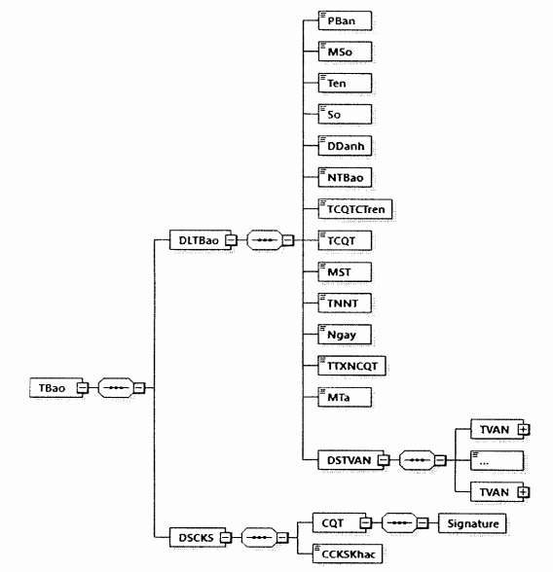
Image 4: Format of data included in a notice of acceptance/rejection for e-invoicing registration/change of e-invoice access information
b) Detailed format of the form is described in the following table:
Data functions | Tab name | Maximum length | Data types | Required/optional
TBao tab contains data included in a notice and digital signature of the tax authority
TBao\DLTBao tab contains data included in a notice
XML version (In this Regulation, the value of this function is 1.0.0) | PBan | 6 | String | Optional
Form number (Notice form number) | MSo | 1 | Numeric (Details proviced in Appendix III hereto). | Required
Name (Notice’s name) | Ten | 255 | String | Required
Number (Notice number) | So | 30 | String | Required
Place name | DDanh | 50 | String | Required
Notification date | NTBao |  | Date | Required
Supervisory tax authority’s name | TCQTCTren | 100 | String | Required
Tax authority’s name (Name of the issuing tax authority) | TCQT | 100 | String | Required
Tax identification number | MST | 14 | String | Required
Taxpayer’s name | TNNT | 400 | String | Required
Date (Date of registration/change) | Ngay |  | Date | Required
Status of tax authority’s confirmation | TTXNCQT | 1 | Numeric (Details provided in Appendix XI hereto). | Required
Remarks | MTa | 400 | String | Required
TBao\DLTBao\DSTVAN tab contains listed intermediary service providers of e-invoice solution trusted by tax authorities (if any).
TBao\DLTBao\DSTVAN\TVAN tab contains the name and registered address. This tab is repeated multiple times, depending on the number of T-VAN organizations trusted by tax authorities
Name (Name of the intermediary service provider of e-invoice solution trusted by the tax authority) | Ten | 400 | String | Required
Registered address (Registered address of the intermediary service provider of e-invoice solution trusted by the tax authority) | DCDKy | 400 | String | Required
TBao\DSCKS tab contains details of digital signature, including tax authority’s digital signature and other digital signature (if any)
TBao\DSCKS\CQT tab contains information of tax authority’s digital signature (affixed onto TBao\DLTBao tab)
Digital signature | Signature |  |  | Required
TBao\DSCKS\CCKSKhac tab contains other digital signature (if any).
3. Format of data included in a notice of expiration of an e-invoice with identification/verification code issued through the website of the General Department of Taxation/under authorization given an intermediary service provider of e-invoice solution; of ineligibility for use of e-invoices without identification/verification codes.
a) A notice shall be formatted as follows:
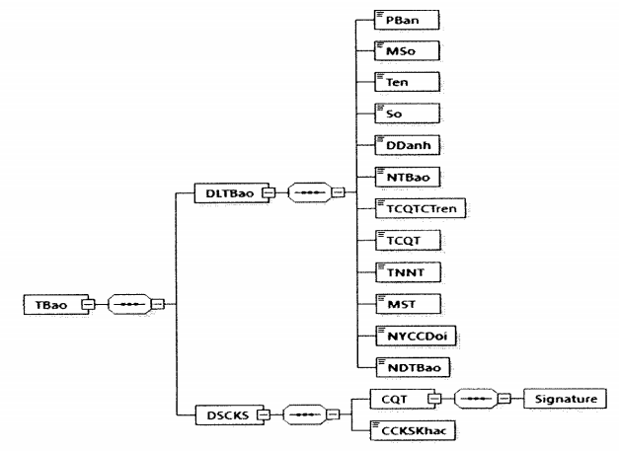
Image 5: Format of data included in a notice of expiration of an e-invoice with identification/verification code issued through the website of the General Department of Taxation/under authorization given an intermediary service provider of e-invoice solution. This format is not used for e-invoices without identification/verification codes.
b) Detailed format of a notice is described in the following table:
Function | Tab name | Maximum length | Data type | Required/optional
TBao tab contains data included in a notice of expiration of e-invoice with identification/verification code and digital signature of decision-making officer or authority
TBao\DLTBao tab contains data included in a notice
XML version (In this Regulation, the value of this function is 1.0.0) | PBan | 6 | String | Optional
Form number (Notice form number) | MSo | 1 | Numeric (Details proviced in Appendix III hereto). | Required
Name (Notice’s name) | Ten | 255 | String | Required
Number (Notice number) | So | 30 | String | Required
Place name | DDanh | 50 | String | Required
Notification date | NTBao |  | Day and month | Required
Supervisory tax authority’s name | TCQTCTren | 100 | String | Required
Tax authority’s name (Name of the issuing tax authority) | TCQT | 100 | String | Required
Taxpayer’s name | TNNT | 400 | String | Required
Tax identification number | MST | 14 | String | Required
Transformation request date | NYCCDoi |  | Day and month | Required
Notice contents | NDTBao | 400 | String | Required
TBao\DSCKS tab contains details of digital signature, including tax authority’s digital signature and other digital signature (if any).
TBao\DSCKS\CQT tab contains information of tax authority’s digital signature (affixed onto TBao\DLTBao tab)
Digital signature | Signature |  |  | Required
TBao\DSCKS\CCKSKhac tab contains other digital signatures (if any).
4. Format of data of an on-demand request for issuance of e-invoice with identification/verification code
a) The request shall be formatted as follows:
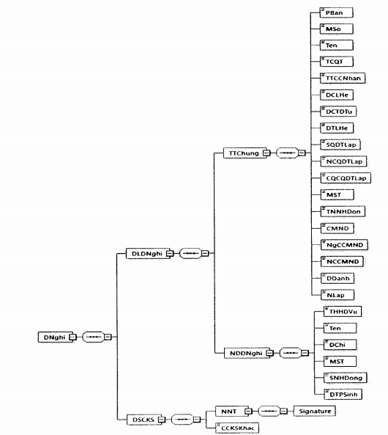
Image 6: Format of data of an on-demand request for issuance of e-invoice with identification/verification code
b) Detailed format of the request is described in the following table:
Function | Tab name | Maximum length | Data type | Required/optional
DNghi tab contains data of the on-demand request for issuance of e-invoice with identification/verification code and taxpayer’s digital signature
DNghi\DLDNghi tab contains data of the on-demand request for issuance of e-invoice with identification/verification code, and details of the request
DNghi\DLDNghi\TTChung tab contains general information
XML version (In this Regulation, the value of this function is 1.0.0) | PBan | 6 | String | Optional
Form number (number of the request form) | MSo | 1 | Numeric (Details provided in Appendix III hereto). | Required
Title (Request title) | Ten | 100 | String | Required
Tax authority’s name (Name of the issuing tax authority) | TCQT | 100 | String | Required
Name of the requesting organization or individual | TTCCNhan | 400 | String | Required
Contact address | DCLHe | 400 | String | Required
Email address | DCTDTu | 50 | String | Required
Contact phone | DTLHe | 20 | String | Required
Number of establishment decision (Number of the decision on establishment of the requesting organization) | SQDTLap | 50 | String | Optional
Date of establishment decision (Date of issuance of decision on establishment of the requesting organization) | NCQDTLap |  | Date | Optional
Authority granting establishment decision | CQCQDTLap | 200 | String | Optional
Tax identification number | MST | 14 | String | Optional
Invoice recipient’s name | TNNHDon | 50 | String | Required
ID card (Number of invoice recipient’s ID card) | CMND | 12 | String | Required
Date of issuance of ID card (Date of issuance of invoice recipient’s ID card) | NgCCMND |  | Date | Required
Place of issuance of ID card (Place of issuance of invoice recipient’s ID card) | NCCMND | 100 | String | Required
Place name | DDanh | 50 | String | Required
Request date | NLap |  | Date
DNghi\DLDNghi\NDDNghi tab contains contents of the request
Description of invoiced goods and services | THHDVu | 500 | String | Required
Name (Name of commodity or service buyer) | Ten | 400 | String | Required
Address (Address of commodity or service buyer) | DChi | 400 | String | Required
Tax identification number (Tax identification number of commodity or service buyer) | MST | 14 | String | Optional
Number and date of contract (Number and date of commodity and service sale and purchase contract) | SNHDong | 150 | String | Optional
Revenue earned | DTPSinh | 19,4 | Numeric | Required
DNghi\DSCKS tab contains details of digital signature, including taxpayer’s digital signature and other digital signature (if any).
DNghi\DSCKS\NNT tab contains information about taxpayer’s digital signature (affixed onto DLDNghi tab)
Taxpayer’s digital signature | Signature |  |  | Required
DNghi\DSCKS\CCKSKhac tab contains other digital signature (if any).
5. Notification message of expiration of an e-invoice with identification/verification code issued through the website of the General Department of Taxation/under authorization given an intermediary service provider of e-invoice solution; of ineligibility for use of e-invoices without identification/verification codes.
a) The message shall be formatted as follows:
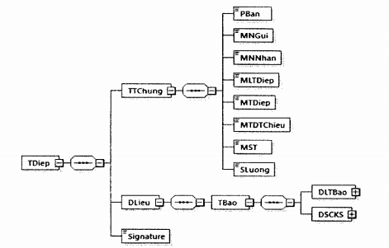
Image 7: Format of a notification message of expiration of an e-invoice with identification/verification code issued through the website of the General Department of Taxation/under authorization given an intermediary service provider of e-invoice solution; of ineligibility for use of e-invoices without identification/verification codes.
- Notification message of expiration of an e-invoice with identification/verification code issued through the website of the General Department of Taxation/under authorization given an intermediary service provider of e-invoice solution; of ineligibility for use of e-invoices without identification/verification codes.
- General format of the message is described in clause 5 of section IV in Part I.
b) Detailed format of a notification message of expiration of an e-invoice with identification/verification code issued through the website of the General Department of Taxation/under authorization given an intermediary service provider of e-invoice solution is described in clause 3 of section I in Part II.
II. Data components applicable to the process for issuing and sending e-invoices to tax authorities
1. General e-invoice format
An e-invoice shall be formatted as follows:
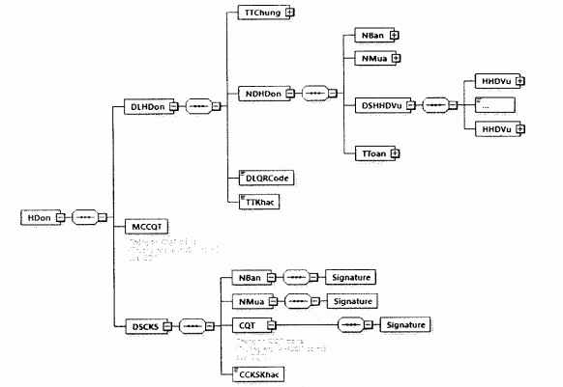
Image 8: E-invoice format
Each e-invoice is composed of the following data components:
- <HDon> tab contains all data included in an e-invoice.
- <HDon> tab is structured into the following sections:
+ <DLHDon/> tab contains data of the e-invoice issued by the seller:
<TTChung> tab contains general information of the invoice (e.g. invoice title, invoice form symbol, invoice symbol and number, invoice date, ...)
<NDHDon> tab contains information about contents of the invoice (e.g. seller, buyer, goods or services, payment,…)
DLQRCode tab contains QR Code data serving the purposes of searching and paying e-invoices (if any). Details about the format of this tab is provided in clause 6 of section IV in Part I.
■ <TTKhac> tab contains taxpayer’s additional information (if any). The tab has the maximum storage capacity of 500 characters. <TTKhac> tab can be put in multiple positions inside <DLHDon> tab. The format of <TTKhac> tab shall be as follows:
<TTKhac>
<TTin>
<TTruong>Mã hàng hóa (commodity code)</TTruong>
<KDLieu>string</KDLieu>
<DLieu>MHH01</DLieu>
</TTin>
……
</TTKhac>
Where:
<TTruong> tab contains the name of the data field that need to be presented on the e-invoice.
<KDLieu> tab contains types of data on information that needs to be displayed (e.g. string/numeric,…)
<DLieu> tab contains data to be presented.
Detailed format of other part of information is described in the following table:
Function description | Tab name | Data type | Required/optional
Field title | TTruong | String | Required
Data type | KDLieu | String (Details provided in Appendix III hereto). | Required
Data | DLieu | String | Required
+ <MCCQT> tab contains data of tax authority’s code, is created by the tax authority and applied to e-invoices with identification/verification codes (This tab does not appear in invoices that taxpayers send to tax authorities to apply for their identification/verification codes). Details about this tab are regulated in clause 3 of section IV in Part I.
+ <DSCKS> tab contains data of the digital signature of the seller, buyer and tax authority (with respect to e-invoices with identification/verification codes) and other digital signature (if any). Where:
■ <NBan> tab contains the seller/vendor’s digital signature affixed onto all data inside <DLHDon> tab.
■ <NMua> tab contains data of the buyer/purchaser’s digital signature put inside the information part of digital signature <DSCKS>. The buyer’s digital signature is not required.
■ Other digital signature (if any) may be defined and managed by taxpayers, and put inside CCKSKhac tab.
Detailed information put inside <DLHDon/>, <MCCQT/> and <DSCKS/> tabs are defined in detail under clause 2 of section II in Part II.
2. Electronic data formatting
a) Value added tax invoice
Function description | Tab name | Maximum length | Data type | Required/optional
Hdon tab contains e-invoice data and digital signature information
HDon\DLHDon tab contains general information, detailed information about invoice, QR Code data and other information defined by sellers on their own
HDon\DLHDon\TTChung tab contains general information about an invoice
XML version (In this Regulation, the value of this function is 1.0.0) | PBan | 6 | String | Optional
Invoice title | THDon | 50 | String | Required (except those cases specified in Article 3 in the Circular No. 68/2019/TT-BTC)
Invoice form symbol | KHMSHDon | 1 | Numeric (Details provided in Appendix II hereto). | Required (except those cases specified in Article 3 in the Circular No. 68/2019/TT-BTC)
Invoice symbol | KHHDon | 6 | String | Required (except those cases specified in Article 3 in the Circular No. 68/2019/TT-BTC)
Invoice number | SHDon | 8 | Numeric | Required (except those cases specified in Article 3 in the Circular No. 68/2019/TT-BTC)
Invoice date | TDLap |  | Date | Required
Currency unit | DVTTe | 3 | String (details provided in clause 2 of section IV in Part I) | Required
Forex rate | TGia | 7,2 | Numeric | Required (except those cases specified in Article 3 in the Circular No. 68/2019/TT-BTC)
HDon\DLHDon\TTChung\TTKhac tab contains other information (Details shall be provided in clause 1 of section II in Part II)
HDon\DLHDon\NDHDon tab contains invoice contents, including: Information about seller, buyer, indexed commodities and services, and payment details on an invoice
HDon\DLHDon\NDHDon\Nban tab contains name, address and TIN of the seller
Name | Ten | 400 | String | Required
Tax identification number | MST | 14 | String | Required
Address | DChi | 400 | String | Required
HDơn\DLHDon\NDHDon\NBan\TTKhac tab contains other information (Details shall be provided in clause 1 of section II in Part II)
HDon\DLHDon\NDHDon\NMua tab contains name, address and TIN of the buyer
Name | Ten | 400 | String | Required (except those cases specified in Article 3 in the Circular No. 68/2019/TT-BTC)
Tax identification number | MST | 14 | String | Required (except those cases specified in Article 3 in the Circular No. 68/2019/TT-BTC)
Address | DChi | 400 | String | Required (except those cases specified in Article 3 in the Circular No. 68/2019/TT-BTC)
HDon\DLHDon\NDHDon\NMua\TTKhac tab contains other information (Details shall be provided in clause 1 of section II in Part II)
HDon\DLHDon\NDHDon\DSHHDVu tab contains indexed commodities or services
HDon\DLHDon\NDHDon\DSHHDVu\HHDVu tab contains details of 01 line of commodity or service
Attributes/characteristics | TChat | 1 | Numeric (Details provided in Appendix IV hereto) | Optional
Ordinal number | STT | 4 | Numeric | Optional
Name | Ten | 500 | String | Required
Unit | DVTinh | 50 | String | Required (except those cases specified in Article 3 in the Circular No. 68/2019/TT-BTC)
Quantity | SLuong | 19,4 | Numeric | Required (except those cases specified in Article 3 in the Circular No. 68/2019/TT-BTC)
Unit price | DGia | 19,4 | Numeric | Required (except those cases specified in Article 3 in the Circular No. 68/2019/TT-BTC)
Discount rate (used in case of presenting discount information in columns corresponding to specific commodities or services) | TLCKhau | 6,4 | Numeric | Required (except those cases specified in Article 3 in the Circular No. 68/2019/TT-BTC)
Discount amount (used in case of presenting commission information in columns corresponding to specific commodities or services) | STCKhau | 19,4 | Numeric | Required (except those cases specified in Article 3 in the Circular No. 68/2019/TT-BTC)
Total (Amount before VAT) | ThTien | 19,4 | Numeric | Required (except those cases specified in Article 3 in the Circular No. 68/2019/TT-BTC)
Tax rate (VAT tax rate) | TSuat | 5 | String (Details provided in Appendix V hereto). | Required (except those cases specified in Article 3 in the Circular No. 68/2019/TT-BTC)
HDon\DLHDon\NDHDon\DSHHDVu\HHDVu\TTkhac tab contains other information (Details shall be provided in clause 1 of section II in Part II)
HDon\DLHDon\NDHDon\TToan tab contains invoice payment information
HDon\DLHDon\NDHDon\TToan\THTTLTSuat tab contains information of all e-invoices specific to tax rates
HDon\DLHDon\NDHDon\TToan\THTTLTSuat\LTSuat tab contains detailed information of all e-invoices specific to tax rates
Tax rate (VAT tax rate) | TSuat | 5 | String (Details provided in Appendix V hereto). | Required
Total (Amount before VAT) | ThTien | 19,4 | Numeric | Required
Tax amount (VAT amount) | TThue | 19,4 | Numeric | Required
HDon\DLHDon\NDHDon\TToan tab contains information about invoiced payment amount and tax amount
Total before tax (Total amount before VAT) | TgTCThue | 19,4 | Numeric | Required
Total tax (Total VAT amount) | TgTThue | 19,4 | Numeric | Required
HDon\DLHDon\NDHDon\TToan\DSLPhi tab contains listed fees and charges (if any)
HDon\DLHDon\NDHDon\TToan\DSLPhi\Lphi tab contains details of specific fees and charges. This tab may be repeated multiple times, depending on the number of fees and charges.
Description | TLPhi | 100 | String | Required (except those cases specified in Article 3 in the Circular No. 68/2019/TT-BTC)
Amount | TPhi | 19,4 | Numeric | Required (except those cases specified in Article 3 in the Circular No. 68/2019/TT-BTC)
The following functions are put inside HDon\DLHDon\NDHDon\TToan tab
Total discount | TTCKTMai | 19,4 | Numeric | Optional
Total written in numbers | TgTTTBSo | 19,4 | Numeric | Required
Total written in words | TgTTTBChu | 255 | String | Required
HDon\DLHDon\VDHDon\TToan\TTKhac tab contains other information (Details shall be provided in clause 1 of section II in Part II)
The following functions are put inside HDon\DLHDon tab and placed behind NDHDon tab
QR Code data (details provided in clause 6 of section IV in Part I) | DLQRCode | 512 | String | Optional
HDon\DLHDon\TTKhac tab contains other information (Details shall be provided in clause 1 of section II in Part II)
If any e-invoice with identification/verification code conforms to requirements for grant of identification/verification codes, the tax authority’s system shall return to the function of tax authority’s Code on e-invoice (MCCQT tab put inside Hdon tab)
Tax authority’s identification/verification code (Tax authority’s identification/verification code presented on e-invoice) | MCCQT | 12 | String | Required
HDon\DSCKS tab contains details of digital signature, including digital signature of the seller, the buyer, the tax authority and other digital signature (if any).
HDon\DSCKS\NBan tab contains information about the seller’s digital signature
Seller’s digital signature (subject to regulations laid down in point dd of clause 1 of Article 3 in the Circular No. 68/2019/TT-BTC) | Signature |  |  | Required (Except those cases specified in Article 3 in the Circular No. 68/2019/TT-BTC)
HDon\DSCKS\NMua tab contains information about the buyer’s digital signature (if any)
Buyer’s digital signature (subject to regulations laid down in point dd of clause 1 of Article 3 in the Circular No. 68/2019/TT-BTC) | Signature |  |  | Optional
If any e-invoice conforms to requirements for grant of identification/verification codes, the tax authority’s system shall return to the e-invoice function and add CQT tab (put inside HDon\DSCKS tab) containing information about the digital signature of the tax authority (affixed onto HDon\MCCQT tab and HDon\DLHDon tab)
Tax authority’s digital signature | Signature |  |  | Required
HDon\DSCKS\CCKSKhac tab contains other digital signature (if any).
- In order to replace any faulty e-invoice, the substitute e-invoice must add the following information to the <TTChung/> tab and after the <TDLap/> tab:
Function description | Tab name | Maximum length | Data type | Required/optional
Replaced invoice type | HTHDBTThe | 1 | Numeric (Details provided in Appendix VI hereto) | Optional
Replaced invoice date | TDLHDBTThe |  | Date | Required
Replaced invoice form symbol | KHMSHDBTThe | 11 | String (Details provided in Appendix II hereto). | Required (Except those cases specified in Article 3 in the Circular No. 68/2019/TT-BTC)
Replaced invoice symbol | KHHDBTThe | 8 | String | Required (Except those cases specified in Article 3 in the Circular No. 68/2019/TT-BTC)
Replaced invoice number | SHDBTThe | 8 | String | Required (Except those cases specified in Article 3 in the Circular No. 68/2019/TT-BTC)
b) E-invoices for sale of goods
Function description | Tab name | Maximum length | Data type | Required/optional
HDon tab contains information about e-invoice data and digital signature
HDon\DLHDon tab contains general information, detailed contents of an e-invoice, QR Code data and other information defined by the seller on their own
HDon\DLHDon\TTChung tab contains general information about an invoice
XML version (In this Regulation, the value of this function is 1.0.0) | PBan | 6 | String | Optional
Invoice title | THDon | 50 | String | Required (Except those cases specified in Article 3 in the Circular No. 68/2019/TT-BTC)
Invoice form symbol | KHMSHDon | 1 | Number (Details provided in Appendix II hereto). | Required (Except those cases specified in Article 3 in the Circular No. 68/2019/TT-BTC)
Invoice symbol | KHHDon | 6 | String | Required (Except those cases specified in Article 3 in the Circular No. 68/2019/TT-BTC)
Invoice number | SHDon | 8 | Numeric | Required (Except those cases specified in Article 3 in the Circular No. 68/2019/TT-BTC)
Invoice date | TDLap |  | Date | Required
Currency unit | DVTTe | 3 | String (Details provided in clause 2 of section IV in Part I) | Required
Forex rate | TGia | 7,2 | Numeric | Required (Except those cases specified in Article 3 in the Circular No. 68/2019/TT-BTC)
HDon\DLHDon\TTChung\TTKhac tab contains other information (Details shall be provided in clause 1 of section II in Part II)
HDon\DLHDon\NDHDon tab contains invoice contents, including: Information about seller, buyer, indexed commodities and services, and payment details of the e-invoice
HDon\DLHDon\NDHDon\Nban tab contains name, address and TIN of the seller
Name | Ten | 400 | String | Required
Tax identification number | MST | 14 | String | Required
Address | DChi | 400 | String | Required
HDon\DLHDon\NDHDon\NBan\TTKhac tab contains other information (Details shall be provided in clause 1 of section II in Part II)
HDon\DLHDon\NDHDon\NMua tab contains name, address and TIN of the buyer
Name | Ten | 400 | String | Required (Except those cases specified in Article 3 in the Circular No. 68/2019/TT-BTC)
Tax identification number | MST | 14 | String | Required (Except those cases specified in Article 3 in the Circular No. 68/2019/TT-BTC)
Address | DChi | 400 | String | Required (Except those cases specified in Article 3 in the Circular No. 68/2019/TT-BTC)
HDon\DLHDon\NDHDon\NMua\TTKhac tab contains other information (Details shall be provided in clause 1 of section II in Part II)
HDon\DLHDon\NDHDon\DSHHDVu tab contains indexed commodities or services
HDon\DLHDon\NDHDon\DSHHDVu\HHDVu tab contains details of 01 line of commodity or service
Attributes/characteristics | TChat | 1 | Numeric (Details provided in Appendix IV hereto) | Optional
Ordinal number | STT | 4 | Numeric | Optional
Name | Ten | 500 | String | Required
Unit | DVTinh | 50 | String | Required (Except those cases specified in Article 3 in the Circular No. 68/2019/TT-BTC)
Quantity | SLuong | 19,4 | Numeric | Required (Except those cases specified in Article 3 in the Circular No. 68/2019/TT-BTC)
Unit price | DGia | 19,4 | Numeric | Required (Except those cases specified in Article 3 in the Circular No. 68/2019/TT-BTC)
Discount rate (used in case of presenting discount information in columns corresponding to specific commodities or services) | TLCKhau | 6,4 | Numeric | Required (Except those cases specified in Article 3 in the Circular No. 68/2019/TT-BTC)
Discount amount (used in case of presenting commission information in columns corresponding to specific commodities or services) | STCKhau | 19,4 | Numeric | Required (Except those cases specified in Article 3 in the Circular No. 68/2019/TT-BTC)
Total amount | ThTien | 19,4 | Numeric | Required (Except those cases specified in Article 3 in the Circular No. 68/2019/TT-BTC)
HDon\DLHDon\NDHDon\DSHHDVu\HHDVu\TTkhac tab contains other information (Details shall be provided in clause 1 of section II in Part II)
HDon\DLHDon\NDHDon\TToan tab contains information about invoiced payment amount
Total sum of invoiced goods or services | TgTHHDVu | 19,4 | Numeric | Required
HDon\DLHDon\NDHDon\TToan\DSLPhi tab contains listed fees and charges (if any)
HDon\DLHDon\NDHDon\TToan\DSLPhi\Lphi tab contains details of specific fees and charges. This tab may be repeated multiple times, depending on the number of fees and charges.
Description | TLPhi | 100 | String | Required (Except those cases specified in Article 3 in the Circular No. 68/2019/TT-BTC)
Amount | TPhi | 19,4 | Numeric | Required (Except those cases specified in Article 3 in the Circular No. 68/2019/TT-BTC)
The following functions are put inside HDon\DLHDon\NDHDon\TToan tab
Total discount | TTCKTMai | 19,4 | Numeric | Optional
Total written in numbers | TgTTTBSo | 19,4 | Numeric | Required
Total written in words | TgTTTBChu | 255 | String | Required
HDon\DLHDon\NDHDon\TToan\TTKhac tab contains other information (Details shall be provided in clause 1 of section II in Part II)
The following functions are put inside HDon\DLHDon tab and placed behind NDHDon tab
QR Code data (details provided in clause 6 of section IV in Part I) | DLQRCode | 512 | String | Optional
HDon\DLHDon\TTKhac tab contains other information (Details shall be provided in clause 1 of section II in Part II)
If any e-invoice with identification/verification code conforms to requirements for grant of identification/verification codes, the tax authority’s system shall return to the function of tax authority’s Code on e-invoice (MCCQT tab put inside HDon tab)
Tax authority’s identification/verification code (Tax authority’s identification/verification code presented on e-invoice) | MCCQT | 12 | String | Required
HDon\DSCKS tab contains details of digital signature, including digital signature of the seller, the buyer, the tax authority and other digital signature (if any).
HDon\DSCKS\NBan tab contains information about the seller’s digital signature
Seller’s digital signature (subject to regulations laid down in point dd of clause 1 of Article 3 in the Circular No. 68/2019/TT-BTC) | Signature |  |  | Required (Except those cases specified in Article 3 in the Circular No. 68/2019/TT-BTC)
HDon\DSCKS\NMua tab contains information about the buyer’s digital signature (if any)
Buyer’s digital signature (subject to regulations laid down in point dd of clause 1 of Article 3 in the Circular No. 68/2019/TT-BTC) | Signature |  |  | Optional
If any e-invoice conforms to requirements for grant of identification/verification codes, the tax authority’s system shall return to the e-invoice function and add CQT tab (put inside HDon\DSCKS tab) containing information about the digital signature of the tax authority (affixed onto HDon\MCCQT tab and HDon\DLHDon tab)
Tax authority’s digital signature | Signature |  |  | Required
HDon\DSCKS\CCKSKhac tab contains other digital signature (if any).
- In order to replace any faulty e-invoice, the substitute e-invoice must add the following information to the <TTChung/> tab and after the <TDLap/> tab:
Function description | Tab name | Maximum length | Data type | Required/optional
Replaced invoice types | HTHDBTThe | 1 | Numeric (Details provided in Appendix VI hereto) | Optional
Replaced invoice date | TDLHDBTThe |  | Date | Required
Replaced invoice form symbol | KHMSHDBTThe | 11 | String (Details provided in Appendix II hereto). | Required (Except those cases specified in Article 3 in the Circular No. 68/2019/TT-BTC)
Replaced invoice symbol | KHHDBTThe | 8 | String | Required (Except those cases specified in Article 3 in the Circular No. 68/2019/TT-BTC)
Replaced invoice number | SHDBTThe | 8 | String | Required (Except those cases specified in Article 3 in the Circular No. 68/2019/TT-BTC)
c) Electronic dispatch and delivery/transfer/consignment notes (hereinafter referred to as electronic dispatch notes)
Function description | Tab name | Maximum length | Data type | Required/optional
HDon tab contains information presented on an electronic dispatch note, including information about the dispatch note and digital signature
HDon\DLHDon tab contains general information about a dispatch note, detailed contents of an dispatch note and other information defined by the seller on their own
HDon\DLHDon\TTChung tab contains general information about a dispatch note, including:
XML version (In this Regulation, the value of this function is 1.0.0) | PBan | 6 | String | Optional
Invoice title | THDon | 50 | String | Required
Invoice form symbol | KHMSHDon | 1 | Numeric (Details provided in Appendix II hereto). | Required
Invoice symbol | KHHDon | 6 | String | Required
Invoice number | SHDon | 8 | Numeric | Required
Invoice date | TDLap |  | Date | Required
Currency unit | DVTTe | 3 | String (details provided in clause 2 of section IV in Part I) | Required
Forex rate | TGia | 7,2 | Numeric | Required (Except those cases specified in Article 3 in the Circular No. 68/2019/TT-BTC)
HDon\DLHDon\TTChung\TTKhac tab contains other information (Details shall be provided in clause 1 of section II in Part II)
HDon\DLHDon\NDHDon tab contains invoice data, including information about the seller, buyer, indexed commodities and services, and payment details of the e-invoice
HDon\DLHDon\NDHDon\NBan tab contains name, address and TIN of the consignor
Name (Consignor’s name) | Ten | 400 | String | Required
Tax identification number (consignor’s TIN) | MST | 14 | String | Required
Internal dispatch instruction | LDDNBo | 255 | String | Required
Address (Departure warehouse) | DChi | 400 | String | Required
Carrier’s name | TNVChuyen | 400 | String | Required
Means of transport | PTVChuyen | 50 | String | Required
HDon\DLHDon\NDHDon\NBan\TTKhac tab contains other information (Details shall be provided in clause 1 of section II in Part II)
HDon\DLHDon\NDHDon\NMua tab contains the consignee’s information
Name (Consignee’s name) | Ten | 400 | String | Required (Except those cases specified in Article 3 in the Circular No. 68/2019/TT-BTC)
Tax identification number (consignee’s TIN) | MST | 14 | String | Required (Except those cases specified in Article 3 in the Circular No. 68/2019/TT-BTC)
Address (Arrival warehouse) | DChi | 400 | String | Required (Except those cases specified in Article 3 in the Circular No. 68/2019/TT-BTC)
HDon\DLHDon\NDHDon\NMua\TTKhac tab contains other information (Details shall be provided in clause 1 of section II in Part II)
HDon\DLHDon\NDHDon\DSHHDVu tab contains indexed commodities or services
HDon\DLHDon\NDHDon\DSHHDVu\HHDVu tab contains details of 01 line of commodity or service
Attributes/characteristics | TChat | 1 | Numeric (Details provided in Appendix IV hereto) | Optional
Ordinal number | STT | 4 | Numeric | Optional
Name | Ten | 500 | String | Required
Unit | DVTinh | 50 | String | Required
Quantity | SLuong | 19,4 | Numeric | Required
Unit price | DGia | 19,4 | Numeric | Required
Total amount | ThTien | 19,4 | Numeric | Required
HDon\DLHDon\NDHDon\DSHHDVu\HHDVu\TTKhac tab contains other information (Details shall be provided in clause 1 of section II in Part II)
HDon\DLHDon\TTKhac tab contains other information (Details shall be provided in clause 1 of section II in Part II)
The following functions are put inside HDon\DLHDon tab and placed behind NDHDon tab
QR Code data (details provided in clause 6 of section IV in Part I) | DLQRCode | 512 | String | Optional
If any e-invoice with identification/verification code conforms to requirements for grant of identification/verification codes, the tax authority’s system shall return to the function of tax authority’s Code on e-invoice (MCCQT tab put inside HDon tab)
Tax authority’s identification/verification code (Tax authority’s identification/verification code presented on e-invoice) | MCCQT | 12 | String | Required
HDon\DSCKS tab contains details of digital signature, including consignor’s digital signature and other digital signature (if any).
HDon\DSCKS\NBan tab contains information about the consignor’s digital signature (affixed onto DLHDon tab)
Consignor’s digital signature (subject to regulations laid down in point dd of clause 1 of Article 3 in the Circular No. 68/2019/TT-BTC) | Signature |  |  | Required
HDon\DSCKS\NMua tab contains information about the consignee’s digital signature (if any)
Consignee’s digital signature (subject to regulations laid down in point dd of clause 1 of Article 3 in the Circular No. 68/2019/TT-BTC) | Signature |  |  | Optional
If any e-invoice conforms to requirements for grant of identification/verification codes, the tax authority’s system shall return to the e-invoice function and add CQT tab (put inside HDon\DSCKS tab) containing information about the digital signature of the tax authority (affixed onto HDon\MCCQT tab and HDon\DLHDon tab)
Tax authority’s digital signature | Signature |  |  | Required
HDon\DSCKS\CCKSKhac tab contains other digital signature (if any).
- In order to replace any faulty electronic dispatch note, the substitute note must add the following information to the <TTChung/> tab and after the <TDLap/> tab:
Function description | Tab name | Maximum length | Data type | Required/optional
Replaced invoice form (Form of replaced dispatch note) | HTHDBTThe | 1 | Numeric (Details provided in Appendix VI hereto) | Optional
Replaced invoice date | TDLHDBTThe |  | Date | Required
Replaced invoice form symbol | KHMSHDBTThe | 11 | String (Details provided in Appendix II hereto). | Required (Except those cases specified in Article 3 in the Circular No. 68/2019/TT-BTC)
Replaced invoice symbol | KHHDBTThe | 8 | String | Required (Except those cases specified in Article 3 in the Circular No. 68/2019/TT-BTC)
Replaced invoice number | SHDBTThe | 8 | String | Required (Except those cases specified in Article 3 in the Circular No. 68/2019/TT-BTC)
d) Bill-cum-VAT declaration forms
Function description | Tab name | Maximum length | Data type | Required/optional
HDon parent tab contains information about e-invoice data and digital signature
HDon\DLHDon tab contains general information, detailed contents of an e-invoice, QR Code data and other other information defined by the seller on their own
HDon\DLHDon\TTChung tab contains general information about an e-invoice, including:
XML version (In this Regulation, the value of this function is 1.0.0) | PBan | 6 | String | Optional
Invoice title | THDon | 50 | String | Required (Except those cases specified in Article 3 in the Circular No. 68/2019/TT-BTC)
Invoice form symbol | KHMSHDon | 1 | Numeric (Details provided in Appendix II hereto). | Required (Except those cases specified in Article 3 in the Circular No. 68/2019/TT-BTC)
Invoice symbol | KHHDon | 6 | String | Required (Except those cases specified in Article 3 in the Circular No. 68/2019/TT-BTC)
Invoice number | SHDon | 8 | Numeric | Required (Except those cases specified in Article 3 in the Circular No. 68/2019/TT-BTC)
Invoice date | TDLap |  | Date | Required
Currency unit | DVTTe | 3 | String (Details provided in clause 2 of section IV in Part I) | Required
Forex rate | TGia | 7,2 | Numeric | Required (Except those cases specified in Article 3 in the Circular No. 68/2019/TT-BTC)
HDon\DLHDon\TTChung\TTKhac tab contains other information (Details shall be provided in clause 1 of section II in Part II)
HDon\DLHDon\NDHDon tab contains invoice contents, including: Information about seller, buyer, indexed commodities and services, and payment details on the e-invoice
HDon\DLHDon\NDHDon\NBan tab contains name, TIN and address of the seller/vendor (enterprise)
Name (selling entity’s name) | Ten | 400 | String | Required
Tax identification number | MST | 14 | String | Required
Address | DChi | 400 | String | Required
HDon\DLHDon\NDHDon\NBan\TTKhac tab contains other information (Details shall be provided in clause 1 of section II in Part II)
HDon\DLHDon\NDHDon\NMua tab contains the customer’s information
Name (Full name) | Ten | 100 | String | Required (Except those cases specified in Article 3 in the Circular No. 68/2019/TT-BTC)
Passport (Passport/other entry-exit document) number | SHChieu | 20 | String | Required (Except those cases specified in Article 3 in the Circular No. 68/2019/TT-BTC)
Passport (Passport/other entry-exit document) issuance date | NCHChieu |  | Date | Required (Except those cases specified in Article 3 in the Circular No. 68/2019/TT-BTC)
Passport (Passport/other entry-exit document) expiry date | NHHHChieu |  | Date | Required (Except those cases specified in Article 3 in the Circular No. 68/2019/TT-BTC)
Nationality | QTich | 50 | String | Required (Except those cases specified in Article 3 in the Circular No. 68/2019/TT-BTC)
HDon\DLHDon\NDHDon\NMua\TTKhac tab contains other information (Details shall be provided in clause 1 of section II in Part II)
HDon\DLHDon\NDHDon\DSHHDVu tab contains indexed commodities or services
HDon\DLHDon\NDHDon\DSHHDVu\HHDVu tab contains details of 1 line of commodity or service
Attributes/characteristics | TChat | 1 | Numeric (Details provided in Appendix IV hereto) | Optional
Ordinal number | STT | 4 | Numeric | Optional
Name | Ten | 500 | String | Required
Unit | DVTinh | 50 | String | Required (Except those cases specified in Article 3 in the Circular No. 68/2019/TT-BTC)
Quantity | SLuong | 19,4 | Numeric | Required (Except those cases specified in Article 3 in the Circular No. 68/2019/TT-BTC)
Unit price | DGia | 19,4 | Numeric | Required (Except those cases specified in Article 3 in the Circular No. 68/2019/TT-BTC)
Discount rate (used in case of presenting discount information in columns corresponding to specific commodities or services) | TLCKhau | 6,4 | Numeric | Required (Except those cases specified in Article 3 in the Circular No. 68/2019/TT-BTC)
Discount amount (used in case of presenting commission information in columns corresponding to specific commodities or services) | STCKhau | 19,4 | Numeric | Required (Except those cases specified in Article 3 in the Circular No. 68/2019/TT-BTC)
Total amount (Amount before VAT) | ThTien | 19,4 | Numeric | Required (Except those cases specified in Article 3 in the Circular No. 68/2019/TT-BTC)
Tax rate (VAT tax rate) | TSuat | 5 | String (Details provided in Appendix V hereto). | Required (Except those cases specified in Article 3 in the Circular No. 68/2019/TT-BTC)
Tax amount (VAT amount) | TThue | 19,4 | Numeric | Required (Except those cases specified in Article 3 in the Circular No. 68/2019/TT-BTC)
After-tax amount (After-VAT amount) | ThTCThue | 19,4 | Numeric | Required (Except those cases specified in Article 3 in the Circular No. 68/2019/TT-BTC)
HDon\DLHDon\NDHDon\DSHHDVu\HHDVu\TTKhac tab contains other information (Details shall be provided in clause 1 of section II in Part II)
HDon\DLHDon\NDHDon\TToan tab contains invoice payment information
HDon\DLHDon\NDHDon\TToan\THTTLTSuat tab contains general information of all e-invoices specific to tax rates
HDon\DLHDon\NDHDon\TToan\THTTLTSuat\LTSuat tab contains detailed information of all e-invoices specific to tax rates
Tax rate (VAT tax rate) | TSuat | 5 | String (Details provided in Appendix V hereto). | Required
Total amount (Amount before VAT) | ThTien | 19,4 | Numeric | Required
Tax amount (VAT amount) | TThue | 19,4 | Numeric | Required
HDon\DLHDon\NDHDon\TToan tab contains information about invoiced payment amount and tax amount
Total before tax (Total amount before VAT) | TgTCThue | 19,4 | Numeric | Required
Total tax (Total VAT amount) | TgTThue | 19,4 | Numeric | Required
HDon\DLHDon\NDHDon\TToan\DSLPhi tab contains listed fees and charges (if any)
HDon\DLHDon\NDHDon\TToan\DSLPhi\Lphi tab contains details of specific fees and charges. This tab may be repeated multiple times, depending on the number of fees and charges.
Description | TLPhi | 100 | String | Required (Except those cases specified in Article 3 in the Circular No. 68/2019/TT-BTC)
Amount | TPhi | 19,4 | Numeric | Required (Except those cases specified in Article 3 in the Circular No. 68/2019/TT-BTC)
The following functions are put inside HDon\DLHDon\NDHDon\TToan tab
Total discount | TTCKTMai | 19,4 | Numeric | Optional
Total written in numbers | TgTTTBSo | 19,4 | Numeric | Required
Total written in words | TgTTTBChu | 255 | String | Required
HDon\DLHDon\NDHDon\TToan\TTKhac tab contains other information (Details shall be provided in clause 1 of section II in Part II)
The following functions are put inside HDon\DLHDon tab and placed behind NDHDon tab
QR Code data (details provided in clause 6 of section IV in Part I) | DLQRCode | 512 | String | Optional
HDon\DLHDon\TTKhac tab contains other information (Details shall be provided in clause 1 of section II in Part II)
If any e-invoice with identification/verification code conforms to requirements for grant of identification/verification codes, the tax authority’s system shall return to the function of tax authority’s Code on e-invoice (MCCQT tab put inside HDon tab)
Tax authority’s identification/verification code (Tax authority’s identification/verification code presented on e-invoice) | MCCQT | 12 | String | Required
HDon\DSCKS tab contains details of digital signature, including digital signature of the seller, the buyer, the tax authority and taxpayer’s digital signature (if any)
HDon\DSCKS\NBan tab contains information about the seller’s digital signature
Seller’s digital signature (subject to regulations laid down in point dd of clause 1 of Article 3 in the Circular No. 68/2019/TT-BTC) | Signature |  |  | Required (Except those cases specified in Article 3 in the Circular No. 68/2019/TT-BTC)
HDon\DSCKS\NMua tab contains information about the buyer’s digital signature (if any)
Buyer’s digital signature (subject to regulations laid down in point dd of clause 1 of Article 3 in the Circular No. 68/2019/TT-BTC) | Signature |  |  | Optional
If any e-invoice conforms to requirements for grant of identification/verification codes, the tax authority’s system shall return to the e-invoice function and add CQT tab (put inside HDon\DSCKS tab) containing information about the digital signature of the tax authority (affixed onto HDon\MCCQT tab and HDon\DLHDon tab)
Tax authority’s digital signature | Signature |  |  | Required
HDon\DSCKS\CCKSKhac tab contains other digital signature (if any).
- In order to replace any faulty e-invoice, the substitute e-invoice must add the following information to the <TTChung/> parent tab and after the <TDLap/> tab:
Function description | Tab name | Maximum length | Data type | Required/optional
Replaced invoice type | HTHDBTThe | 1 | Numeric (Details provided in Appendix VI hereto) | Optional
Replaced invoice date | TDLHDBTThe |  | Date | Required
Replaced invoice form symbol | KHMSHDBTThe | 11 | String (Details provided in Appendix II hereto). | Required (Except those cases specified in Article 3 in the Circular No. 68/2019/TT-BTC)
Replaced invoice symbol | KHHDBTThe | 8 | String | Required (Except those cases specified in Article 3 in the Circular No. 68/2019/TT-BTC)
Replaced invoice number | SHDBTThe | 8 | String | Required (Except those cases specified in Article 3 in the Circular No. 68/2019/TT-BTC)
e) Other bills or invoices
Including e-stamps, e-tickets, e-cards, e-receipts or other electronic documents bearing different names, but having contents the same as those of e-invoice under clause 3 of Article 3 in the Circular No. 68/2019/TT-BTC dated dated September 30, 2019 of the Ministry of Finance, providing guidance on implementation of several articles of the Government’s Decree No. 119/2018/NĐ-CP dated September 12, 2018.
Function description | Tab name | Maximum length | Data type | Required/optional
HDon parent tab contains e-invoice information, including e-invoice data. CQT (Tax authority), other supporting and administrative information, and digital signature
HDon\DLHDon tab contains general or detailed information of the e-invoice, QR Code data and other other information defined by the seller on their own
HDon\DLHDon\TTChung tab contains general information about the e-invoice
XML version (In this Regulation, the value of this function is 1.0.0) | PBan | 6 | String | Optional
Invoice title | THDon | 50 | String | Required
Invoice form symbol | KHMSHDon | 1 | Numeric (Details provided in Appendix II hereto). | Required (Except those cases specified in Article 3 in the Circular No. 68/2019/TT-BTC)
Invoice symbol | KHHDon | 6 | String | Required (Except those cases specified in Article 3 in the Circular No. 68/2019/TT-BTC)
Invoice number | SHDon | 8 | Numeric | Required (Except those cases specified in Article 3 in the Circular No. 68/2019/TT-BTC)
Invoice date | TDLap |  | Date | Required
Currency unit | DVTTe | 3 | String (Details provided in clause 2 of section IV in Part I) | Required
Forex rate | TGia | 7,2 | Numeric | Required (Except those cases specified in Article 3 in the Circular No. 68/2019/TT-BTC)
HDon\DLHDon\TTChung\TTKhac tab contains other information (Details shall be provided in clause 1 of section II in Part II)
HDon\DLHDon\NDHDon tab contains invoice contents, including: Information about seller, buyer, indexed commodities and services, and payment details on an e-invoice
HDon\DLHDon\NDHDon\Nban tab contains name, address and TIN of the seller
Name | Ten | 400 | String | Required
Tax identification number | MST | 14 | String | Required
Address | DChi | 400 | String | Required
HDon\DLHDon\NDHDon\NBan\TTKhac tab contains other information (Details shall be provided in clause 1 of section II in Part II)
HDon\DLHDon\NDHDon\NMua tab contains name, address and TIN of the buyer
Name | Ten | 400 | String | Required (Except those cases specified in Article 3 in the Circular No. 68/2019/TT-BTC)
Tax identification number | MST | 14 | String | Required (Except those cases specified in Article 3 in the Circular No. 68/2019/TT-BTC)
Address | DChi | 400 | String | Required (Except those cases specified in Article 3 in the Circular No. 68/2019/TT-BTC)
HDon\DLHDon\NDHDon\NMua\TTKhac tab contains other information (Details shall be provided in clause 1 of section II in Part II)
HDon\DLHDon\NDHDon\DSHHDVu tab contains indexed commodities or services
HDon\DLHDon\NDHDon\DSHHDVu\HHDVu tab contains details of 1 line of commodity or service
Attributes/characteristics | TChat | 1 | Numeric (Details provided in Appendix IV hereto) | Optional
Ordinal number | STT | 4 | Numeric | Optional
Name | Ten | 500 | String | Required
Unit | DVTinh | 50 | String | Required (Except those cases specified in Article 3 in the Circular No. 68/2019/TT-BTC)
Quantity | SLuong | 19,4 | Numeric | Required (Except those cases specified in Article 3 in the Circular No. 68/2019/TT-BTC)
Unit price | DGia | 19,4 | Numeric | Required (Except those cases specified in Article 3 in the Circular No. 68/2019/TT-BTC)
Discount rate (used in case of presenting discount information in columns corresponding to specific commodities or services) | TLCKhau | 6,4 | Numeric | Required (Except those cases specified in Article 3 in the Circular No. 68/2019/TT-BTC)
Discount amount (used in case of presenting commission information in columns corresponding to specific commodities or services) | STCKhau | 19,4 | Numeric | Required (Except those cases specified in Article 3 in the Circular No. 68/2019/TT-BTC)
Total amount (Amount before VAT) | ThTien | 19,4 | Numeric | Required (Except those cases specified in Article 3 in the Circular No. 68/2019/TT-BTC)
Tax rate (VAT tax rate) | TSuat | 5 | String (Details provided in Appendix V hereto). | Required (Except those cases specified in Article 3 in the Circular No. 68/2019/TT-BTC)
HDon\DLHDon\NDHDon\DSHHDVu\HHDVu\TTKhac tab contains other information (Details shall be provided in clause 1 of section II in Part II)
HDon\DLHDon\NDHDon\TToan tab contains invoice payment information
HDon\DLHDon\NDHDon\TToan\THTTLTSuat tab contains general information of all e-invoices specific to tax rates (if any)
HDon\DLHDon\NDHDon\TToan\THTTLTSuat\LTSuat tab contains detailed information of all e-invoices specific to tax rates
Tax rate (VAT tax rate) | TSuat | 5 | String (Details provided in Appendix V hereto). | Required
Total amount (Amount before VAT) | ThTien | 19,4 | Numeric | Required
Tax amount (VAT amount) | TThue | 19,4 | Numeric | Required
HDon\DLHDon\NDHDon\TToan tab contains information about invoiced payment amount and tax amount
Total before tax (Total amount before VAT) | TgTCThue | 19,4 | Numeric | Required (Except those cases specified in Article 3 in the Circular No. 68/2019/TT-BTC)
Total tax (Total VAT amount) | TgTThue | 19,4 | Numeric | Required (Except those cases specified in Article 3 in the Circular No. 68/2019/TT-BTC)
HDon\DLHDon\NDHDon\TToan\DSLPhi tab contains listed fees and charges (if any)
HDon\DLHDon\NDHDon\TToan\DSLPhi\Lphi tab contains details of specific fees and charges. This tab may be repeated multiple times, depending on the number of fees and charges.
Description | TLPhi | 100 | String | Required (Except those cases specified in Article 3 in the Circular No. 68/2019/TT-BTC)
Amount | TPhi | 19,4 | Numeric | Required (Except those cases specified in Article 3 in the Circular No. 68/2019/TT-BTC)
The following functions are put inside HDon\DLHDon\DLHDon\TToan tab
Total discount | TTCKTMai | 19,4 | Numeric | Optional
Total written in numbers | TgTTTBSo | 19,4 | Numeric | Required
Total written in words | TgTTTBChu | 255 | String | Required (Except those cases specified in Article 3 in the Circular No. 68/2019/TT-BTC)
HDon\DLHDon\NDHDon\TToan\TTKhac tab contains other information (Details shall be provided in clause 1 of section II in Part II)
The following functions are put inside HDon\DLHDon tab and placed behind NDHDon tab
QR Code data (details provided in clause 6 of section IV in Part I) | DLQRCode | 512 | String | Optional
HDon\DLHDon\TTKhac tab contains other information (Details shall be provided in clause 1 of section II in Part II)
If any e-invoice with identification/verification code conforms to requirements for grant of identification/verification codes, the tax authority’s system shall return to the function of tax authority’s Code on e-invoice (MCCQT tab put inside HDon tab)
Tax authority’s identification/verification code (Tax authority’s identification/verification code presented on e-invoice) | MCCQT | 12 | String | Required
HDon\DSCKS tab contains details of digital signature, including digital signature of the seller, the buyer, the tax authority and other digital signature (if any).
HDon\DSCKS\NBan tab contains information about the seller’s digital signature
Seller’s digital signature (subject to regulations laid down in point dd of clause 1 of Article 3 in the Circular No. 68/2019/TT-BTC) | Signature |  |  | Required (Except those cases specified in Article 3 in the Circular No. 68/2019/TT-BTC)
HDon\DSCKS\NMua tab contains information about the buyer’s digital signature (if any)
Buyer’s digital signature (subject to regulations laid down in point dd of clause 1 of Article 3 in the Circular No. 68/2019/TT-BTC) | Signature |  |  | Optional
If any e-invoice conforms to requirements for grant of identification/verification codes, the tax authority’s system shall return to the e-invoice function and add CQT tab (put inside HDon\DSCKS tab) containing information about the digital signature of the tax authority (affixed onto HDon\MCCQT tab and HDon\DLHDon tab)
Tax authority’s digital signature | Signature |  |  | Required
HDon\DSCKS\CCKSKhac tab contains other digital signature (if any).

- In order to replace any faulty e-invoice, the substitute e-invoice must add the following information to the <TTChung/> parent tab and after the <TDLap/> tab:
Function description | Tab name | Maximum length | Data type | Required/optional
Replaced invoice type | HTHDBTThe | 1 | Numeric (Details provided in Appendix VI hereto) | Optional
Replaced invoice date | TDLHDBTThe |  | Date | Required
Replaced invoice form symbol | KHMSHDBTThe | 11 | String (Details provided in Appendix II hereto). | Required (Except those cases specified in Article 3 in the Circular No. 68/2019/TT-BTC)
Replaced invoice symbol | KHHDBTThe | 8 | String | Required (Except those cases specified in Article 3 in the Circular No. 68/2019/TT-BTC)
Replaced invoice number | SHDBTThe | 8 | String | Required (Except those cases specified in Article 3 in the Circular No. 68/2019/TT-BTC)
3. Messages about notification of sending of e-invoices to tax authorities to request grant of identification/verification codes
A message about notification of sending of an e-invoice to a tax authority to request the grant of an identification/verification code shall be formatted as follows:
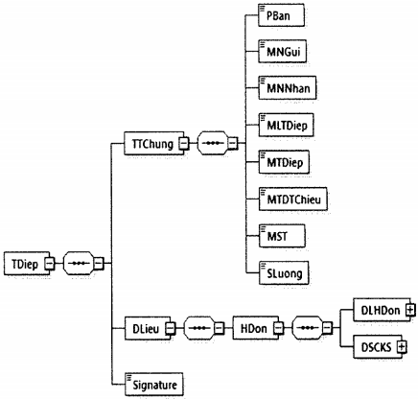
Image 9: Format of the message about notification of sending of an e-invoice to a tax authority for an identification/verification code request
- General format of the message is described in clause 5 of section IV in Part I.
- Data of the e-invoice needing the code are put inside the DLieu tab of the message.
- Each message only contains data of an e-invoice. In that e-invoice, MCCQT tab has not yet been made available.
- Details about the format of an e-invoice with the identification/verification code is described in clause 2 of section II in Part II.
4. Notification message of results/decisions of grant of tax authority's identification/verification code
The message shall be formatted as follows:
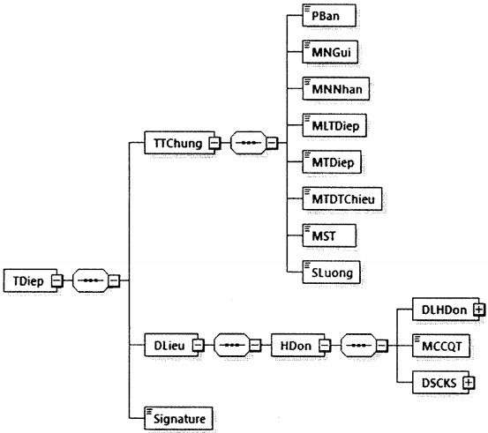
Image 10: Format of the notification message of results/decisions of grant of tax authority's identification/verification code
- General format of the message is described in clause 5 of section IV in Part I.
- Data of the e-invoice needing the code are put inside the DLieu tab of the message.
- Each message only contains data of an e-invoice. The message is exported from the e-invoice containing the tax authority’s information (MCCQT tab).
- The format of the e-invoice with identification/verification code is described in clause 2 of section II in Part II.
5. Notification messages of transmission/transfer of e-invoices without identification/verification codes to tax authorities
A notification message of transmission/transfer of an e-invoice without identification/verification code to a tax authority shall be formatted as follows:
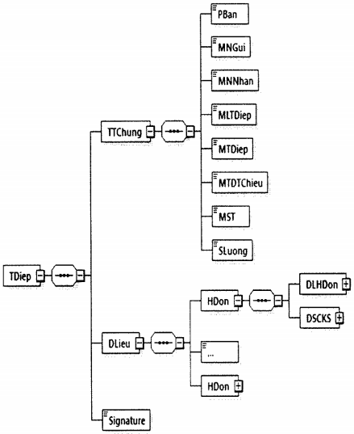
Image 11: Format of the notification message of transmission of an e-invoice without identification/verification code to a tax authority
- General format of the message is described in clause 5 of section IV in Part I.
- Data of the e-invoice without identification/verification code are put inside the DLieu tab of the message.
- Details about the format of an e-invoice without identification/verification code are described in clause 2 of section II in Part II.
III. Data components applicable to the handling of faulty e-invoices
1. Format of data of the notification message of cancellation/revocation of faulty e-invoices
a) Format of a notification message of cancellation/revocation of a faulty e-invoice
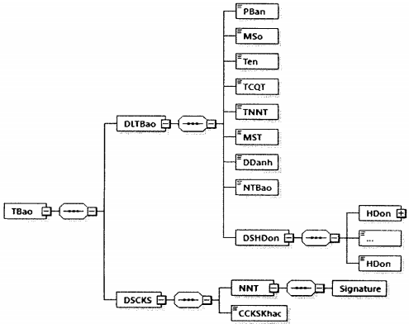
Image 12: Format of data of the notification message of cancellation/revocation of faulty e-invoice
b) Detailed format of the request is described according to the following table:
Function description |  | Tab name |  | Maximum length |  | Data type | Required/optional
TBao tab contains data of the notification message of cancellation/revocation of an e-invoice, including: Taxpayer’s general information, indexed revoked/cancelled e-invoices and taxpayer’s digital signature
TBao\DLTBao tab contains data of the notification message of cancellation/revocation of an e-invoice, including taxpayer’s information and listed revoked/cancelled e-invoices
XML version (In this Regulation, the value of this function is 1.0.0) |  | PBan |  | 6 |  | String | Optional
Form number (Notice form number) |  | MSo |  | 1 |  | Numeric (Details provided in Appendix III hereto). | Required
Name (Notice’s name) |  | Ten |  | 255 |  | String | Required
Tax authority’s name |  | TCQT |  | 100 |  | String | Required
Taxpayer’s name |  | TNNT |  | 400 |  | String | Required
Tax identification number (taxpayer’s TIN) |  | MST |  | 14 |  | String | Required
Place name |  | DDanh |  | 50 |  | String | Required
Notification date |  | NTBao |  |  |  | Date | Required
Listed revoked/cancelled invoices are put inside TBao\DLTBao\DSHDon tab
TBao\DLTBao\DSHDon\HDon tab contains detailed information of each revoked/cancelled e-invoice
Ordinal number |  | STT |  | 4 |  | Numeric | Optional
Invoice form symbol |  | KHMSHDon |  | 11 |  | String (Details provided in Appendix II hereto). | Required (Except those cases specified in Article 3 in the Circular No. 68/2019/TT-BTC)
Invoice symbol |  | KHHDon |  | 8 |  | String | Required (Except those cases specified in Article 3 in the Circular No. 68/2019/TT-BTC)
Invoice number (E-invoice number) |  | SHDon |  | 8 |  | String | Required (Except those cases specified in Article 3 in the Circular No. 68/2019/TT-BTC)
Date (Invoice date) |  | Date |  |  |  | Date | Required
E-invoice type to be used |  | LADHDDT |  | 1 |  | Numeric (Details provided in Appendix VI hereto) | Required
Notice purpose (Cancellation/explanatory notice) |  | TCTBao |  | 1 |  | Numeric (Details provided in Appendix IX hereto). | Required
Reasons |  | LDo |  | 255 |  | String | Optional
TBao\DSCKS tab contains details of digital signature, including taxpayer’s digital signature and other digital signature (if any).
TBao\DSCKS\NNT tab contains information of taxpayer’s digital signature (affixed onto DLTBao tab)
Taxpayer’s digital signature | Signature |  |  |  |  |  |  | Required
TBao\DSCKS\CCKSKhac tab contains other digital signature (if any).
2. Format of data of the notification message of e-invoices needing review
a) The notification message shall be formatted as follows:
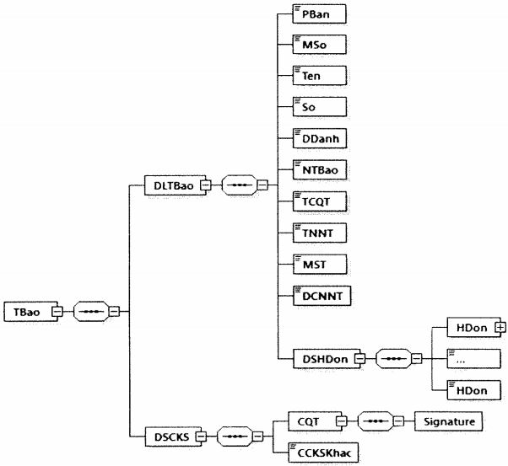
Image 13: Format of data of the notification message of e-invoice needing review
b) Detailed format of the notification message is described according to the following table:
Function description | Tab name | Maximum length | Data type | Required/optional
TBao tab contains the notification message of e-invoice needing review, including notification data and digital signatures of decision-making officers or authorities
TBao\DLTBao tab contains data of the notification message, including general information of notification message and listed e-invoices of taxpayer needing review
XML version (In this Regulation, the value of this function is 1.0.0) | PBan | 6 | String | Optional
Form number (Notice form number) | MSo | 1 | Numeric (Details provided in Appendix III hereto). | Required
Name (Notice’s name) | Ten | 255 | String | Required
Number (Notice number) | So | 30 | String | Required
Place name | DDanh | 50 | String | Required
Notification date | NTBao |  | Day and month | Required
Tax authority’s name | TCQT | 100 | String | Required
Taxpayer’s name | TNNT | 400 | String | Required
Tax identification number | MST | 14 | String | Required
Taxpayer’s address | DCNNT | 255 | String | Required
TBao\DLTBao\DSHDon tab contains listed e-invoices needing review
TBao\DLTBao\DSHDon\HDon tab contains detailed information of each e-invoice needing review
Ordinal number | STT | 4 | Numeric | Optional
Invoice form symbol | KHMSHDon | 1 | Numeric (Details provided in Appendix II hereto). | Required (Except those cases specified in Article 3 in the Circular No. 68/2019/TT-BTC)
Invoice symbol | KHHDon | 6 | String | Required (Except those cases specified in Article 3 in the Circular No. 68/2019/TT-BTC)
Invoice number | SHDon | 8 | Numeric | Required (Except those cases specified in Article 3 in the Circular No. 68/2019/TT-BTC)
Invoice date | Ngay |  | Date | Required
E-invoice type to be used | LADHDDT | 1 | Numeric (Details provided in Appendix VI hereto) | Required
Reasons (Reasons for review) | LDo | 255 | String | Required
TBao\DSCKS tab contains details of digital signature, including tax authority’s digital signature and other digital signature (if any)
TBao\DSCKS\CQT tab contains information of tax authority’s digital signature (affixed onto TBao\DLTBao tab)
Digital signature | Signature |  |  | Required
TBao\DSCKS\CCKSKhac tab contains other digital signature (if any).
3. Notification messages of cancellation/revocation of faulty e-invoices
A notification message of cancellation/revocation of e-invoice shall be formatted as follows:
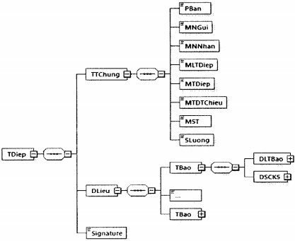
Image 14: Format of a notification message of cancellation/revocation of the faulty e-invoice
- General format of the message is described in clause 5 of section IV in Part I.
- Each message contains data of one or more notification messages sent by a MST (TIN).
- Details about the format of a notification message of cancellation/revocation is described in clause 1 of section II in Part II.
4. Notification messages of e-invoices needing review
A notification message of e-invoice needing review shall be formatted as follows:
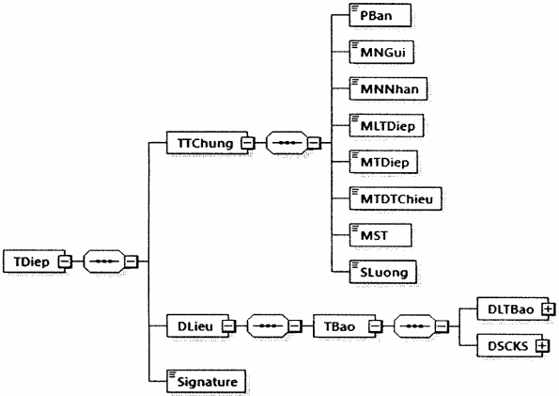
Image 15: Format of a notification message of e-invoice needing review
- Notification of the e-invoice needing review is put inside DLieu tab of the message.
- General format of the message is described in clause 5 of section IV in Part I.
- Details about the format of a notification message of e-invoice needing review is described in clause 2 of section II in Part II.
IV. Data components applicable to the process for formulating and transmitting data of the data collection chart to the tax authority
1. Format of data of the e-invoice data collection chart sent or transmitted to the tax authority
a) Data collection chart shall be formatted as follows:
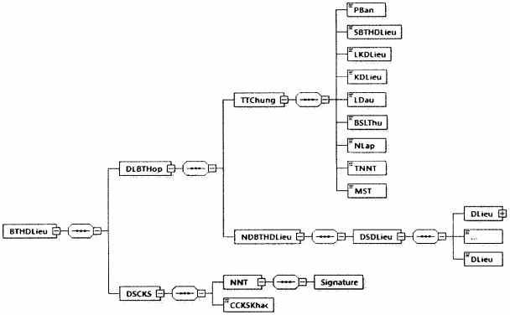
Image 16: Format of data of the e-invoice data collection chart submitted to the tax authority
b) Detailed format of the chart is described according to the following table:
Function description | Tab name | Maximum length | Data type | Required/optional
BTHDLieu parent tab contains information of the e-invoice data collection chart, including data of the data collection chart and taxpayer’s digital signature
BTHDLieu\DLBTHop tab contains data of the data collection chart, including general and detailed information
BTHDLieu\DLBTHop\TTChung tab contains general information
XML version (In this Regulation, the value of this function is 1.0.0) | PBan | 6 | String | Optional
Number of the data collection chart (Ordinal number of the data collection chart) | SBTHDLieu | 5 | Numeric | Required
Data acquisition period type | LKDLieu | 1 | String (Details provided in Appendix X hereto). | Required
Data acquisition period | KDLieu | 7 | String (Details provided in Appendix X hereto). | Required
Initial acquisition | LDau | 1 | Boolean (1: true; 0: false) | Required
Supplementary acquisition | BSLThu | 3 | Numeric | Required
Tabulation date | NLap |  | Date | Required
Taxpayer’s name | TNNT | 400 | String | Required
Taxpayer’s TIN | MST | 14 | String | Required
BTHDLieu\DLBTHop\NDBTHDLieu tab contains details of the e-invoice data collection chart
BTHDLieu\DLBTHop\NDBTHDLieu\DSDLieu tab contains data listed in the data collection chart
BTHDLieu\DLBTHop\NDBTHDLieu\DSDLieu\Dlieu tab contains details of 01 data line (may be repeated multiple times, depending on data included in the data collection chart)
Ordinal number | STT | 6 | Numeric | Optional
Invoice form or invoice symbol (in the form of serial numbers) | KHHDon | 7 | String | Required (Except those cases specified in Article 3, 16 and Appendix II in the Circular No. 68/2019/TT-BTC)
Invoice number | SHDon | 8 | Numeric | Required (Except those cases specified in Article 3, 16 and Appendix II in the Circular No. 68/2019/TT-BTC)
Invoice date | NLap |  | Date | Required
Buyer’s name | TNMua | 400 | String | Required (Except those cases specified in Article 3, 16 and Appendix II in the Circular No. 68/2019/TT-BTC)
Buyer’s tax identification number/customer’s ID code | MSTNMua | 14 | String | Required (Except those cases specified in Article 3, 16 and Appendix II in the Circular No. 68/2019/TT-BTC)
Description of goods or services | THHDVu | 500 | String | Required (Except those cases specified in Article 3, 16 and Appendix II in the Circular No. 68/2019/TT-BTC)
Unit | DVTinh | 50 | String | Required (Except those cases specified in Article 3, 16 and Appendix II in the Circular No. 68/2019/TT-BTC)
Quantity | SLuong | 19,4 | Numeric | Required (Except those cases specified in Article 3, 16 and Appendix II in the Circular No. 68/2019/TT-BTC)
Total sales before VAT | TTCThue | 19,4 | Numeric | Required (Except those cases specified in Article 3, 16 and Appendix II in the Circular No. 68/2019/TT-BTC)
Tax rate (VAT rate) | TSuat | 5 | String (Details provided in Appendix V hereto). | Required (Except those cases specified in Article 3, 16 and Appendix II in the Circular No. 68/2019/TT-BTC)
Total tax (total VAT amount) | TgTThue | 19,4 | Numeric | Required (Except those cases specified in Article 3, 16 and Appendix II in the Circular No. 68/2019/TT-BTC)
Total payment amount | TgTTToan | 19,4 | Numeric | Required (Except those cases specified in Article 3, 16 and Appendix II in the Circular No. 68/2019/TT-BTC)
Notes | GChu | 255 | String | Optional
BTHDLieu\DSCKS\NNT tab contains data of taxpayer’s digital signature (affixed onto BTHDLieu\DLBTHop tab)
Taxpayer’s digital signature | Signature |  |  | Required
BTHDLieu\DSCKS\CCKSKhac tab contains other digital signature (if any).
2. Notification messages of transmission/submission of e-invoice data collection charts to tax authorities.
A notification message of transmission/submission of a data collection chart shall be formatted as follows:
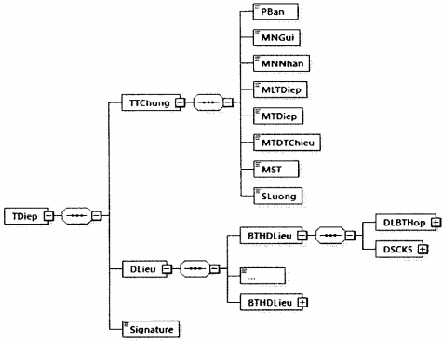
Image 17: Format of a notification message of transmission of an e-invoice data collection chart to a tax authority
- General format of all notification messages of this kind is described in clause 5 of section IV in Part I.
- Data included in the chart of e-invoices without identification/verification codes are put inside DLieu tab of the message.
- Detailed format of the chart of data acquired from e-invoices without tax authority’s identification/verification codes is described in clause 1 of section IV in Part II.
V. Data components applicable to the process for transmission/submission of e-invoice data to tax authorities during the transitory period
E-invoice data declaration forms and evidencing document on goods or services sold (Form No. 03 annexed to the Decree No. 119/2018/NĐ-CP) shall be formatted as follows:
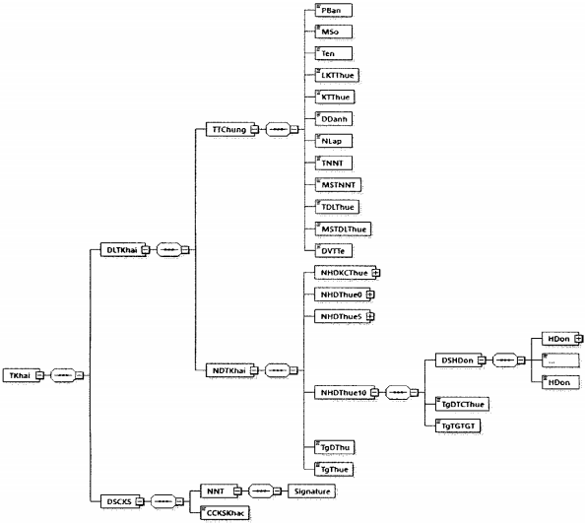
Image 18: Format of data of e-invoice data declaration form and evidencing document on goods or services sold
Detailed format thereof is described according to the following table:
Function description | Tab name | Maximum length | Data type | Required/optional
TKhai parent tab contains information of a declaration form, including form data and taxpayer’s digital signature
TKhai\DTTKhai tab contains form data, including general and detailed information of the form
TKhai\DLTKhai\TTChung tab contains general information of the form
XML version (In this Regulation, the value of this function is 1.0.0) | PBan | 6 | String | Optional
Form number (number of the form) | MSo | 1 | Numeric (Details provided in Appendix III hereto). | Required
Name (Name of the form) | Ten | 100 | String | Required
Type of taxation period | LKTThue | 1 | String (Details provided in Appendix VII hereto). | Required
Taxation period | KTThue | 7 | String (Details provided in Appendix VII hereto). | Required
Place name | DDanh | 50 | String | Required
Issuing date | NLap |  | Date | Required
Taxpayer’s name | TNNT | 400 | String | Required
Taxpayer’s TIN | MSTNNT | 14 | String | Required
Tax agency’s name | TDLThue | 400 | String | Optional
Tax agency’s tax identification number | MSTDLThue | 14 | String | Optional
Currency unit | DVTTe | 3 | String (Details provided in clause 2 of section IV in Part I) | Required
TKhai\DLTKhai\NDTKhai tab contains data of the declaration form, including listed e-invoices and evidencing documents on goods or services sold which are specific to tax rates
TKhai\DLTKhai\NDTKhai\NHDKCThue tab contains groups of e-invoices of VAT-exempt goods or services (if any)
TKhai\DLTKhai\NDTKhai\NHDKCThue\DSHDon tab contains listed e-invoices of VAT-exempt goods or services
TKhai\DLTKhai\NDTKhai\NHDKCThue\DSHDon\HDon tab contains details of 1 line of e-invoices
Ordinal number | STT | 6 | Numeric | Optional
Function description | Tab name | Maximum length | Data type | Required/optional
Invoice form symbol | KHMSHDon | 11 | String (Details provided in Appendix II hereto). | Required
Invoice symbol | KHHDon | 8 | String | Required
Invoice number | SHDon | 8 | String | Required
Invoice date (issuing day, month, year) | NLap |  | Date | Required
Buyer’s name | TNMua | 400 | String | Optional
Buyer’s tax identification number | MSTNMua | 14 | String | Optional
Revenue before VAT | DTCThue | 19,4 | Numeric | Required
Notes | GChu | 255 | String | Optional
TKhai\DLTKhai\NDTKhai\NHDKCThue tab contains data of total revenue before VAT
Revenue before VAT | TgDTCThue | 19,4 | Numeric | Required
TKhai\DLTKhai\NDTKhai\NHDThue0 tab contains data of groups of e-invoices of zero-rated goods or services (if any)
TKhai\DKTKhai\NDTKhai\NHDThue0\DSHDon tab contains listed e-invoices of zero-rated goods or services (if any)
TKhai\DLTKhai\NDTKhai\NHDThue0\DSHDon\HDon tab contains details of 01 e-invoice line
Ordinal number | STT | 6 | Numeric | Optional
Invoice form symbol | KHMSHDon | 11 | String (Details provided in Appendix II hereto). | Required
Invoice symbol | KHHDon | 8 | String | Required
Invoice number | SHDon | 8 | String | Required
Invoice date (issuing day, month, year) | NLap |  | Date | Required
Buyer’s name | TNMua | 400 | String | Optional
Buyer’s tax identification number | MSTNMua | 14 | String | Optional
Revenue before VAT | DTCThue | 19,4 | Numeric | Required
Notes | GChu | 255 | String | Optional
TKhai\DLTKhai\NVDTKhai\NHDThue0 tab contains data of total revenue before VAT
Total revenue before VAT | TgDTCThue | 19,4 | Numeric | Required
Total VAT amount | TgTGTGT | 19,4 | Numeric | Required
TKhai\DLTKhai\NDTKhai\NHDThue5 tab contains data of groups of e-invoices of 5%-rated goods or services (if any)
TKhai\DLTKhai\NDTKhai\NHDThue5\DSHDon tab contains data of listed e-invoices of goods or services subject to VAT
TKhai\DLTKhai\NDTKhai\NHDThue5\DSHDon\HDon tab contains details of 01 e-invoice line
Ordinal number | STT | 6 | Numeric | Optional
Invoice form symbol | KHMSHDon | 11 | String (Details provided in Appendix II hereto). | Required
Invoice symbol | KHHDon | 8 | String | Required
Invoice number | SHDon | 8 | String | Required
Invoice date (issuing day, month, year) | NLap |  | Date | Required
Buyer’s name | TNMua | 400 | String | Optional
Buyer’s tax identification number | MSTNMua | 14 | String | Optional
Revenue before VAT | DTCThue | 19,4 | Numeric | Required
VAT | TGTGT | 19,4 | Numeric | Required
Notes | GChu | 255 | String | Optional
TKhai\DLTKhai\NDTKhai\NHDThue5 tab contains data of total revenue before VAT and total VAT amount
Total revenue before VAT | TgDTCThue | 19,4 | Numeric | Required
Total VAT amount | TgTGTGT | 19,4 | Numeric | Required
TKhai\DLTKhai\NDTKhai\NHDThue10 tab contains data of groups of e-invoices of 10%-rated goods or services (if any)
TKhai\DLTKhai\NDTKhai\NHDThue10\DSHDon tab contains data of listed e-invoices of 10%-rated goods or services
TKhai\DLTKhai\NDTKhai\NHDThue10\DSHDon\HDon tab contains details of 01 e-invoice line
Ordinal number | STT | 6 | Numeric | Optional
Invoice form symbol | KHMSHDon | 11 | String (Details provided in Appendix II hereto). | Required
Invoice symbol | KHHDon | 8 | String | Required
Invoice number | SHDon | 8 | String | Required
Invoice date (issuing day, month, year) | NLap |  | Date | Required
Buyer’s name | TNMua | 400 | String | Optional
Buyer’s tax identification number | MSTNMua | 14 | String | Optional
Revenue before VAT | DTCThue | 19,4 | Numeric | Required
VAT | TGTGT | 19,4 | Numeric | Required
Notes | GChu | 255 | String | Optional
TKhai\DLTKhai\NDTKhai\NHDThue10 tab contains data of total revenue before VAT and total VAT amount
Total revenue before VAT | TgDTCThue | 19,4 | Numeric | Required
Total VAT amount | TgTGTGT | 19,4 | Numeric | Required
TKhai\DLTKhai\NDTKhai tab contains information about total revenue generated from sale of goods or services subject to VAT and total VAT amount
Total sales before VAT | TgDThu | 19,4 | Numeric | Required
Total VAT on goods or services sold | TgThue | 19,4 | Numeric | Required
TKhai\DSCKS tab contains details of digital signature, including taxpayer’s digital signature and other digital signature (if any).
TKhai\DSCKS\NNT tab contains data of taxpayer’s digital signature (affixed onto DLTKhai tab)
Taxpayer’s digital signature | Signature |  |  | Required
TKhai\DSCKS\CCKSKhac tab contains other digital signature (if any).
Part III
TECHNICAL SPECIFICATIONS OF METHOD OF EXCHANGING E-INVOICE DATA WITH TAX AUTHORITIES
I. Regulations on transmission channels
Standards | Regulations | Description
1. Applicable to T-VAN
Type of transmission channel | MPLS VPN layer 3 | Making connection to the General Department of Taxation through the network infrastructure MPLS VPN Layer3 ofa network service provider  The connection between terminal devices of T-VAN and the network service provider is an OSI-model layer 3 connection. IP addresses used for two end points’ connections are provided according to the network service provider’s planning scheme.
Cable type | Optic cable
Security mechanism | IPSec support | Connecting device at T-VAN’s end point provides support for IPSec function.
Quantity of channels | 03 | Including 01 main channel and 02 standby channels (01 channel at the main data center and 01 channel at a standby data center)  Main channel and standby channels at the main data center belong to 02 network service providers
Bandwidth | Min. 10 Mbps | Each data transmission channel has the minimum bandwidth of 10 Mbps
2. Applicable to TCKNGTT
Type of transmission channel | MPLS VPN layer 3 or private leased channel | Making connection to the General Department of Taxation through the network infrastructure MPLS VPN Layer3 or private leased channel of a network service provider
Cable type | Optic cable
Security mechanism | IPSec support | Connecting device at TCKNGTT’s end point provides support for IPSec function.
Quantity of channels | 02 | Including 01 main channel and 01 standby channel (available at a standby data center)  Main channel and standby channel belong to 02 network service providers
Bandwidth | Min. 05 Mbps | Each data transmission channel has the minimum bandwidth of 05 Mbps
II. Regulations on connection protocol
Properties | Regulations | Description
1. Web service
Packet security protocol | https | Data are kept secure during the process of transmission/receipt in the network environment.
Service communication protocol | SOAP v1.2 | Web service communication protocol
Service safety standard | WS-Security v1.1 | Web service security
Service safety standard | WS-Policy v1.5 | Web service policy management
Service safety standard | WS-Addressing v1.0 | Description of web service routing
Service safety standard | WS-Web ReliableMessaging v1.2 | Transmission quality assurance
Service definition | WSDL v1.2
2. Queue
Exchange/interchange protocol | Message Queue (MQ)
Queue channel service security | TLS v1.2
Service definition | XML schema
Type of channel | Sender-receiver

APPENDIX I
LIST OF MESSAGES
(Annexed to Regulations on components containing electronic invoice data and approaches to data transmission and reception by tax authorities under the Decision No. 635/QĐ-TCT dated May 11, 2020 of the Director of the General Department of Taxation)
No. | Message classification code | Description | Remarks
Group of messages serving the needs of the e-invoicing registration/change of e-invoice access information, and the on-demand request for issuance of e-invoices with tax authority's identification/verification codes
1 | 100 | Notification message of expiration of an e-invoice with identification/verification code issued through the website of the General Department of Taxation/under authorization given an intermediary service provider of e-invoice solution; of ineligibility for use of e-invoices without identification/verification codes.
Group of messages serving the needs of issuance and submission/transfer of e-invoices to tax authorities
2 | 200 | Messages of sending of e-invoices to tax authorities to request grant of identification/verification codes
3 | 201 | Notification message of results/decisions of grant of tax authority's identification/verification codes
4 | 202 | Notification messages of transmission/transfer of e-invoices without identification/verification codes to tax authorities
Group of messages for the handling of faulty e-invoices
5 | 300 | Notification messages of faulty e-invoice cancellation/revocation or explanation
6 | 301 | Notification messages of e-invoices needing review
Group of notification messages of transmission/submission of e-invoice data collection charts to tax authorities
7 | 400 | Notification message of transmission/submission of e-invoice data collection chart to tax authority.

APPENDIX II
LIST OF INVOICE FORM SYMBOLS
(Annexed to Regulations on components containing electronic invoice data and approaches to data transmission and reception by tax authorities under the Decision No. 635/QĐ-TCT dated May 11, 2020 of the Director of the General Department of Taxation)
1. With respect to e-invoices under the Decree No. 119/2018/NĐ-CP, the following list shall be used:
No. | Invoice form symbol | Title/Description
1 | 1 | Indicating a particular type of value added tax invoice
2 | 2 | Indicating a particular type of sales invoice
3 | 3 | Indicating a particular type of electronic dispatch cum transport/delivery/transfer note
4 | 4 | Indicating other e-invoices, including electronic stamps, electronic tickets, electronic cards, electronic receipts, or electronic evidencing documents which carry other names, but have e-invoice-like contents in accordance with Article 3 of the Decree No. 68/2019/TT-BTC.
2. Invoices prescribed in the Decree No. 51/2010/NĐ-CP and the Decree No. 04/2014/NĐ-CP shall be subject to regulations laid down in this Decree and other instructional documents.

APPENDIX III
LIST OF DATA OF OTHER INFORMATION PART
(Annexed to Regulations on components containing electronic invoice data and approaches to data transmission and reception by tax authorities under the Decision No. 635/QĐ-TCT dated May 11, 2020 of the Director of the General Department of Taxation)
No. | Value | Description
1 | string | Sequence of characters
2 | numeric | Numbers
3 | dateTime | Date and time
4 | date | Date

APPENDIX IV
LIST OF (COMMODITY OR SERVICE) ATTRIBUTES/CHARACTERISTICS ENTRIES
(Annexed to Regulations on components containing electronic invoice data and approaches to data transmission and reception by tax authorities under the Decision No. 635/QĐ-TCT dated May 11, 2020 of the Director of the General Department of Taxation)
Attributes/characteristics entries shall be used for making distinction between ordinary goods or services, promotion, trade discount, and remarks or explanatory notes. Details are given as follows:
No. | Value | Description
1 | 1 | Goods or services
2 | 2 | Promotion
3 | 3 | Trade discount (used in case of presenting discount information in lines)
4 | 4 | Remarks or explanatory remarks

APPENDIX V
LIST OF TAX RATES
(Annexed to Regulations on components containing electronic invoice data and approaches to data transmission and reception by tax authorities under the Decision No. 635/QĐ-TCT dated May 11, 2020 of the Director of the General Department of Taxation)
No. | Value | Description
1 | 0% | Zero-rated
2 | 5% | 5%-rated
3 | 10% | 10%-rated
4 | KCT | VAT-exempt or not subject to VAT
5 | KKKNT | No declaration, computation and payment of VAT obligations
6 | KHAC | In other cases

APPENDIX VI
LIST OF REPLACED INVOICE TYPES/E-INVOICE TYPES TO BE USED
(Annexed to Regulations on components containing electronic invoice data and approaches to data transmission and reception by tax authorities under the Decision No. 635/QĐ-TCT dated May 11, 2020 of the Director of the General Department of Taxation)
No. | Value | Description
1 | 1 | Electronic invoices prescribed in the Decree No. 119/2018/NĐ-CP
2 | 2 | Electronic invoices with tax authority’s identification/verification codes stipulated in the Decision No. 1209/QĐ-BTC dated June 23, 2015 and the Decision No. 2660/QĐ-BTC dated December 14, 2016 of the Ministry of Finance (invoices with tax authority’s identification/verification codes prescribed in the Decree No. 51/2010/NĐ-CP and the Decree No. 04/2014/NĐ-CP)
3 | 3 | Types of invoice stipulated in the Decision No. 51/2010/NĐ-CP and the Decree No. 04/2014/NĐ-CP (except e-invoices with tax authority’s identification/verification codes prescribed in the Decision No. 1209/QĐ-BTC and the Decision No.2660/QĐ-BTC)

APPENDIX VII
LIST OF TAXATION PERIOD TYPES AND TAXATION PERIODS
(Annexed to Regulations on components containing electronic invoice data and approaches to data transmission and reception by tax authorities under the Decision No. 635/QĐ-TCT dated May 11, 2020 of the Director of the General Department of Taxation)
1. List of taxation period types:
No. | Value | Description
1 | T | Taxation month
2 | Q | Taxation quarter
2. Format of taxation period field: N₁N₂/Y₁Y₂Y₃Y₄
Where:
- N₁N₂ denotes 2 digits indicating a taxation month if a taxation period is T, or a maximum of 2 digits indicating a taxation quarter if a taxation period is Q.
- Y₁Y₂Y₃Y₄ denotes 4 digits indicating a taxation year.
Example 1: December 2020 as a taxation period is represented by the following tabs: LKTThue = T; KTThue = 12/2020
Example 2: The 3rd quarter of 2020 as a taxation period is represented by the following tabs: LKTThue = Q; KTThue = 3/2020

APPENDIX VIII
LIST OF DECLARATION, NOTIFICATION AND REQUEST FORM NUMBERS,
(Annexed to Regulations on components containing electronic invoice data and approaches to data transmission and reception by tax authorities under the Decision No. 635/QĐ-TCT dated May 11, 2020 of the Director of the General Department of Taxation)
No. | Value | Description
1 | 1 | Declaration form of e-invoicing registration/change in e-invoice access information
2 | 2 | Notice form of acceptance/rejection for use of e-invoices
3 | 3 | Declaration form of data of e-invoices and evidencing documents on goods or services sold
4 | 4 | Notice form of cancellation/revocation of e-invoices
5 | 5 | Notice form of e-invoices needing review
6 | 6 | (On-demand) request form for issuance of e-invoices with identification/verification codes
7 | 7 | Notice form of expiration of e-invoices with identification/verification codes issued through the website of the General Department of Taxation/under authorization given an intermediary service provider of e-invoice solution; of ineligibility for use of to e-invoices without identification/verification codes.

APPENDIX IX
LIST OF NOTIFICATION PURPOSES
(Annexed to Regulations on components containing electronic invoice data and approaches to data transmission and reception by tax authorities under the Decision No. 635/QĐ-TCT dated May 11, 2020 of the Director of the General Department of Taxation)
Applicable to the form No. 04 annexed to the Decree No. 119/2018/NĐ-CP.
No. | Value | Description
1 | 1 | Explanation
2 | 2 | Revocation/cancellation with replacement e-invoices
3 | 3 | Revocation/cancellation without replacement e-invoices

APPENDIX X
LIST OF DATA ACQUISITION PERIOD TYPES AND DATA ACQUISITION PERIODS
(Annexed to Regulations on components containing electronic invoice data and approaches to data transmission and reception by tax authorities under the Decision No. 635/QĐ-TCT dated May 11, 2020 of the Director of the General Department of Taxation)
1. List of data acquisition period types:
No. | Value | Description
1 | T | Data acquisition month
2 | Q | Data acquisition quarter
2. Format of data acquisition period field: N₁N₂/Y₁Y₂Y₃Y₄
Where:
- N₁N₂ denotes 2 digits indicating a taxation month if the data acquisition period is T, or a maximum of 2 digits indicating a taxation quarter if the data acquisition period is Q.
- Y₁Y₂Y₃Y₄ denotes 4 digits indicating a year.
Example 1: December 2020 as a data acquisition period is represented by the following tabs: LKDLieu = T; KDLieu = 12/2020
Example 2: The 3rd quarter of 2020 as a data acquisition quarter is represented by the following tabs: LKDLieu = Q; KDLieu = 3/2020

APPENDIX XI
LIST OF STATUS OF TAX AUTHORITY’S CONFIRMATION REGARDING ACCEPTANCE/REFUSAL OF USE OF E-INVOICES
(Annexed to Regulations on components containing electronic invoice data and approaches to data transmission and reception by tax authorities under the Decision No. 635/QĐ-TCT dated May 11, 2020 of the Director of the General Department of Taxation)
No. | Value | Description
1 | 1 | In case of acceptance of taxpayer’s access to e-invoices.
2 | 2 | In case of refusal of enterprise’s access to e-invoices.
3 | 3 | In case of authorization given intermediary service providers of e-invoice solution, tax authorities will notify taxpayers registering free-of-charge use of e-invoices for their transactions through these service providers.

APPENDIX XII
EXAMPLES OF E-INVOICE QR CODES
(Annexed to Regulations on components containing electronic invoice data and approaches to data transmission and reception by tax authorities under the Decision No. 635/QĐ-TCT dated May 11, 2020 of the Director of the General Department of Taxation)
Data fields included in QR Codes presented on e-invoices are used for facilitating domesticand international payment, and search for invoice information:
Field title | Example | Explanation
QR Code Specification version | 000201 | ID: 00  Length: 02  Value: 01
Generation method | 010212 | ID: 01  Length: 02  Value: 12 (Dynamic QR Code)
Information about merchant’s number | 021426578954265489 | ID: 02  Length: 14  Value: 26578954265489 (PAN Visa)
Information about merchant’s number | 041415682654895154 | ID: 04  Length: 14  Value: 15682654895154 (PAN Mastercard)
Information about merchant’s number | 26280010A000000  77501100107001729 | ID: 26  Length: 28  Value:  0010A00000077501100107001729  Sub-ID: 00  Length: 10  Value: A000000775 (Globally Unique Identifier – GUID)  Sub-ID: 01  Length: 10  Value: 0107001729 (Merchant ID / TIN)
Merchant category code | 52045499 | ID: 52  Length: 04  Value: 5499 (Specialty fruit and food store)
Currency code | 5303704 | ID: 53  Length: 03  Value: 704 (Vietnam dong)
Transaction value | 5406120000 | ID: 54  Length: 06  Value: 120000
Country code | 5802VN | ID: 58  Length: 02  Value: VN
Merchant’s name | 5905DNXYZ | ID: 59  Length: 05  Value: DNXYZ
City of merchant’s business | 6005HANOI | ID: 60  Length: 05  Value: HANOI
Additional information | 62400115S757CK5 HTIE918E0307SH OPXYZ0706XYZ001 | ID: 62  Length: 40  Value:  0115S757CK5HTIE918E0307SHOPXY Z0706XYZ001  Sub-ID: 01  Length: 15  Value: S757CK5HTIE918E (Invoice/receipt number)  Sub-ID: 03  Length: 07  Value: SHOPXYZ (Store code)  Sub-ID: 07  Length: 06  Value: XYZ001 (Code of a merchant’s point of sale/terminal device)
Invoice information | 9960001301070017 29001010110206C 21TYY0302680408 202111210506120000 | ID: 99  Length: 60  Value:  00130107001729001010110206C21TYY 0302680408202111210506120000  Sub-ID: 00  Length: 13  Value: 0107001729001 (seller’s TIN)  Sub-ID: 01  Length: 01  Value: 1 (invoice form symbol)  Sub-ID: 02  Length: 06  Value: C21TYY (invoice form symbol)  Sub-ID: 03  Length: 02  Value: 68 (invoice number)  Sub-ID: 04  Length: 08  Value: 20211121 (Invoice date)  Sub-ID: 05  Length: 06  Value: 120000 (Total amount written in numbers)
CRC | 63041177 | ID: 63  Length: 04  Value: 1177
Data components (put inside <DLQRCode> tab) and QR Code image are displayed as follows:
- Data components:
00020101021202142657895426548904141568265489515426280010A000000775 0110010700172952045499530370454061200005802VN5905 DNXYZ6005HANOI 62400115S757CK5HTIE918E0307SHOPXYZ0706XYZ00199600013010700172 9001010110206C21TYY030268040820211121050612000063041177
- QR Code image shown on e-invoices:


